Responsive Web Design: 50 Examples and Best Practices
Responsive DesignEditorial • January 02, 2021 • 39 minutes READ
The number of handheld devices operating worldwide is growing exponentially. According to stats, more than 90% of adults own a cell phone, whereas almost 50% of smartphone users admit that they could not live without their devices. What can we say; the mobile web is a huge thing these days. That why in this post we write about responsive web design and show some good examples from the industry.
On the one hand, it is a good thing since we have an opportunity to address issues quickly and efficiently, locating information on the spot. On the other hand, this reality has created a challenge for all those who provide users with information.
The deal is, in the late 2000s, serving information for users was a piece of cake. You just needed several versions of the same website: one for mobile phones, the other one for desktops. However, in the 2020’s we cannot commit to supporting each new user agent with its own bespoke experience since each year, we witness new dimensions and screen sizes.
Creating styles for each screen size is time-consuming, resource-consuming, and expensive. Even if you manage to cover all the breakpoints in the World, this will seriously overload the website and ipso facto decrease performance that drastically worsens conversions and user’s engagement with the brand, to say nothing about investing lots of money without decent ROI. So, how can entrepreneurs avoid this fate and successfully meet the fast-changing realms of digital expanses? The answer is simple – adopt responsive design.
Investing in a website whose pages are responsive and accessible, regardless of the browser, platform, or screen that your reader must use to access, is the only way to stay afloat these days. Responsive web design is no longer a tendency; it is a standard that we need to enforce to make the web a better place.
Let us take a moment to walk through the essentials of a responsive website to understand better why it is important and what you need to do to ensure your site responds to the device’s capabilities it is viewed on perfectly to let users enjoy the excellent visual experience.
Table of Contents hide
What is Responsive Web Design?
Benefits of Responsive Web Design
Why is Responsive Web Design Important?
Core Principles of Responsive Web Design
How Does Responsive Web Design Work?
Difference between Responsive Design and Mobile-friendly Design
How to Create a Responsive Design – 3 Popular Approaches
Responsive Website Builders
Grid Systems
CMS
Best Practices for Responsive Designs
5 Top Responsive Web Design Testing Tools
Responsive Web Design Examples

What is Responsive Web Design?
So, what is a responsive website? What does it look and feel like?
According to Wikipedia, responsive web design is an approach that ensures all the pages of the website look, work and feel perfectly on any device. Whether it is a tiny old cell phone with a screen width of 320px, a modern phablet with 7 inches screen, a big iPad, or a TV with a massive diagonal line, all the main aspects such as content, design, and especially functionality should perform consistently to provide users with an excellent user experience.
In technical terms, responsive web design implies a set of instructions that help web pages change their layout and appearance to meet different screen widths and resolutions.
The concept of a responsive website appeared due to non-effective and ill-suited ways of handling screen sizes. Originally, pages were built to target a particular device. This approach implied creating a range of designs for each responsive tier resulting in different versions of the same page. However, with the mobile web becoming a reality and more and more devices with non-standard resolutions appeared, this approach has quickly become irrelevant since it could not handle this variety efficiently.
In the early 2010s, largely thanks to a gifted Ethan Marcotte, developers started to switch from popular adaptive design (an approach that implied creating several versions of one design) to responsive design (an approach that suggested only one yet flexible version of a website that stretched or shrunk to fit the screen). Although that technique was pretty new and untested, nevertheless its benefits were hard to ignore. Even now, those advantages prove to everyone that a responsive website is the only way out. Let us consider them.

Benefits of Responsive Web Design
The main benefits of using a responsive website are
- consistent visual experience;
- better user experience;
- no need for redirects;
- lower bounce rates;
- lower maintenance needs;
- high web page loading speed;
- no extra fees for creating and maintaining different versions;
- easy analytics reporting.
Even though responsive design is not flawless, it has its cons, for example,
- It is not fully optimized;
- It can slow performance;
- It may suffer from web browser incompatibility;
- It makes it challenging to run advertising campaigns;
- It makes it challenging to offer different things to different users depending on the device used;
Nevertheless, it had and has significant advantages over other solutions. Therefore, nowadays, responsive web design is a standard for websites.
If you still doubt responsive web design, let us find out why it is important.

Happy Responsiveness by Alejandro Ramirez

Why is Responsive Web Design Important?
The rise of responsive design has to do much with the rise of mobile devices, tablets, and smart devices like Kindle, game consoles, etc. The modern-day user expects to be able to access any website with a vast range of devices. Your website should be ready to handle any scenario. You cannot ignore these demands because numbers do not lie: according to recent studies,
- more than 80% of users surf through the internet using mobile devices in 2019;
- more than 60% of Google’s visits are done via a mobile device;
- mobile devices accounted for more than 50% of website traffic worldwide.
Your brand cannot neglect this tendency. If you cannot meet these expectations and growing demands by quickly adapting to the new reality, then you are doomed to failure, and your brand is doomed to extinction.
Let us consider some good reasons why responsive web design is important:
- Google gives priority to websites that display well on smartphones and other mobile devices. Since 2015, a responsive design with mobile-friendly behavior is a must-have for those who care about ranks in search engines.
- Consistent user experience across all devices reinforces engagement, amplifies lead generation, and boosts sales and conversions. According to studies, one in two people has gone to a competitor’s website after a poor mobile experience.
- Without a good responsive website, you may lose out on new leads and sales from the mobile web.
- It lets you reach customers and deliver messages on all types of devices (tablets, phablets, smartphones), thereby widening your target audience.
- It builds positive brand recognition and trust with consumers. According to stats, people are more likely to recommend a business with a well-designed mobile website.
- It keeps prospects on your website longer by providing a consistent experience and bringing them value on the spot.
- It is cost-effective. Responsive design offers a lower cost than creating various versions of the same website to meet multiple screen sizes. In addition, it is easier to maintain. You do not need to hire a whole agency to handle your multi-version platform.
- Last but not least, you can get a chance to stay ahead of your competition since almost 50% of companies all around the World still ignore mobile behavior and responsive layout.
Although initially responsive web design was chosen as a recommended solution due to lack of proper alternative, it has proved to everyone that it is a reliable approach with lots of benefits for the brand over the past years. It can cope with various situations and scenarios, providing a solid foundation for developers to build on and entrepreneurs to run their marketing campaigns to generate revenue and help businesses stay afloat.

Core Principles of Responsive Web Design
To understand better responsive design, it is important to familiarize yourself with its essentials and core principles.
So, first things first – let’s find out how does responsive web design works.

How Does Responsive Web Design Work?
The idea behind responsive web design lies in building a flexible website whose content and design behave like water that fills the container, aka a device that customers use to visit the website. All elements of the website undergo changes to feel comfortable inside the screen. If it is necessary, they shrink to perfectly fit into smaller spaces or, on the contrary, stretch to occupy every inch of space. Everything scales up or down automatically to match the device.
A responsive website’s key point is to understand that its primary task is to provide a comfortable user experience for anyone. This requires ensuring good readability, proper visual experience, a certain level of accessibility, as well as maintaining consistent functionality from device to device.
In practice, responsive web design works through CSS and sometimes JavaScript plugins to cope efficiently with screen size, orientation, resolution, color capability, and other user’s device characteristics. The most popular CSS properties that help realize responsive web design are the viewport and media queries.
Key Features of Responsive Web Design
Coined by Ethan Marcotte in 2010, responsive design implied three key features that are still considered the main pillars of this concept. They are:
- Flexible layout;
- Flexible images;
- Media Queries.
We will add one more key feature: responsive typography since the content is a king that requires its dose of attention.
If you think you can do without one or another feature, then you are wrong. It may work for some scenarios; however, you could not manage to provide universal access regardless of the situation without this quartet. That is the whole point of creating a responsive web design.
Remember, not only do you need to accommodate various screen sizes, but you should also take into account device orientation since people adore switching from portrait orientation to landscape in an instant. It is here where the flexibility of all details comes in handy. Each one plays its essential role in properly serving information.
Therefore, these four features are necessary to ensure you have a fully responsive website design.
Let us consider them closely to understand better their roles, why they are so crucial, and how to bring them to life.
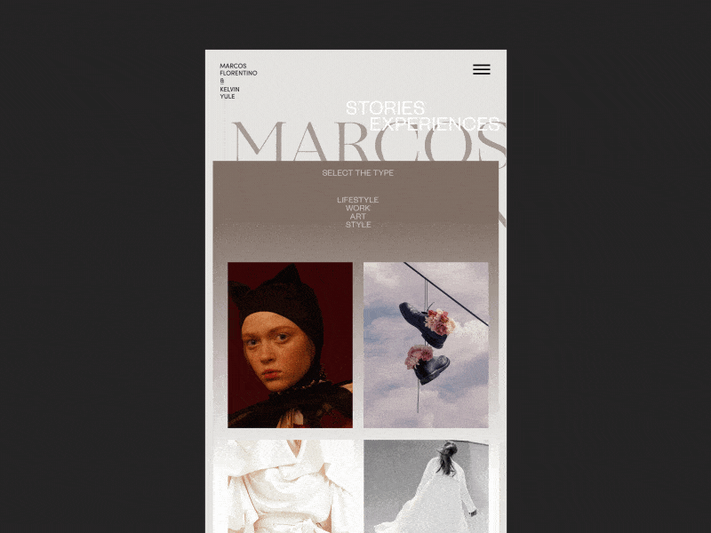
Responsive Animation Zhenya Rynzhuk
Flexible Layout
A flexible layout is the heart and soul of the design. As a rule, it is a flexible grid built with the relative units of measurement like percentages or em’s, rather than absolute units like pixels or points.
It is important to understand the ideology of a flexible grid that states that you need to add in a breakpoint when the content starts to look bad instead of covering all differently sized devices.
There are two general ways to implement this.
Ethan Marcotte suggested one of the legacy layout methods that was increasingly popular last decade. Its principle was to scale up or down the grid elements using the simple mathematical formula: Target size/context = relative size. This formula underlies the mechanics of layout sizes and spacing. It is applied to all child elements within your grid, making all page elements in relative units that are changed due to the course of events. While this method was pretty reliable and time-tested, there were still some imperfections.
Therefore, nowadays, developers prefer modern technologies that offer more polished, elegant, and clean solutions, like multiple-column layout, Flexbox, and Grid. While the first option requires you some extensive coding, the latter two will shrink and distribute space between the items on their own, giving you clean, hassle-free tools to create flexible layouts.
Last but not least.
It is vital to remember ordering, reordering, nesting of rows and columns to align content perfectly.
To realize this in practice, you can use grid systems like Bootstrap that already has a fluid grid or define your parameters for columns, spacing, and containers. With the invention of Flexbox, the latter option has become preferable since it gives you freedom, helps to create a lightweight skeleton, keeps your code clean, and saves you from messing with other premade solutions that can be difficult to adjust to your own needs due to restrictive use of CSS classes and styles that are hard to superimpose.

Topway Institutional Project by Arthur Cardozo
Flexible Images
Images have been an obstacle to implementing truly adaptable responsive pages since the dawn.
The deal is, use of a flexible grid in the project made us abandon our beloved pixels and replace them with relative units of measurement. This means that all elements inside the grid should follow this lead. Images are no exception. More so, by playing a crucial role in visual communication and user experience, they should first obey this principle.
However, this is not easy. To play along, images (photos, illustrations, and other graphical units) should be flexible. They should move and scale along with a flexible grid, container, or column instead of overflowing it. In addition, they should maintain their sharpness and quality. So, this is a hard nut to crack. However, there is a way out.
For the past decade, developers have come up with several techniques to resize images proportionately or show images that perfectly fit the screen without sacrificing quality; let us consider them.
Multiple Versions of the Same Image
The first method implies adding multiple versions of the image on the server. The simplest, the easiest, and the oldest but unfortunately not the most efficient way to handle this situation; nevertheless, it works.
This approach’s core principle lies in the fact that you need to upload multiple versions of the same image and dynamically serve the appropriately sized version depending on the user agent. The main flaw of this method is, of course, overload. Modern websites are visually heavy. There are hundreds of images on websites, and this number grows exponentially. Although this approach served the community in the past pretty well, today, it can be used either in limited projects or in tandem with other modern techniques that help to optimize images and use as few of them as possible.
Use of CSS’s Max-width
The second method was suggested by Ethan Marcotte and was warmly accepted by the community in the early 2010s. It makes the most out of CSS’s max-width. The idea behind that is you deliver images at the maximum size and let the browser resize the pictures deciding on their relative size based on the CSS guide.
There are two significant considerations about this approach. First of all, some browser versions do not support this CSS property, especially the infamous IE. However, the share of IE usage across the World slowly but surely is becoming negligible; therefore, you might not worry about this issue soon.
The second big issue is download times that is a much serious problem than the previous one. If the original image size is big since it is meant for large devices at the first outset, it may take extra time to adjust to smaller screens. As a result, it can significantly slow down the website and worsen the overall performance, leading to a higher bounce rate.
Nevertheless, this approach is a popular option that is pretty much reliable despite these two significant considerations.
Responsive Images
The third method implies the imitation of responsive images. This technology has been with us for many years. Therefore, there are several ways for implementing it:
- Depending on the viewport size or screen-density, you can choose the appropriate web-optimized picture from the collection and show it to the customer by using the srcset attribute in <img>.
- Depending on the screen’s device CSS width, you can choose the same image with a different cut and focus on the image’s meaningful part by capitalizing on the <picture> attribute.
- Use of image() function that allows cropping the picture differently, depending on the CSS viewport width size.
SVG
The fourth method implies using SVG. Although it does not work for photography, nevertheless the rest of the visuals, such as illustrations, icons, logotypes, etc., greatly benefit from this technology.
Each method has its own merits. Each one has its cons and difficulties in implementation. Therefore, you might find that you benefit from one or another depending on the project you need to create. What’s more, you may find yourself in situations when the best way to handle images is to turn off all of them and focus mainly on the content – believe it or not, that is also a viable way to handle this situation.

Responsive Device Animation by Miguel Cardona
Last but not least
When it comes to flexibility in images, there is one significant consideration to take into account: to find a way to adjust gracefully to new screen size and save the quality of the picture. That sometimes can be pretty challenging. You need to balance between keeping the quality and reducing the file size not to jeopardize page speed, load time, and website weight.
On top of that, you need to consider the difference between CSS Resolution and Screen Resolution. It exists on all mobile screens and even on some desktop screens. The problem is, to display sharp images to users with high-resolution screens, you need to upload an image that is up to several times wider than the regular one, aka retina-ready image. This may weigh down the project considerably. Add to this slow mobile internet connection, and you may end up with a rather frustrated and confusing user who is waiting for your image to load. Therefore, when choosing the method for creating flexible images, make sure you consider all the crucial moments. Play smart.
Media Queries
The third key ingredient of a responsive website is media queries.
Media queries allow building different layouts within one project by tweaking your whole design or parts to best suit the screen size. With them, you can re-arrange and reorder existing elements like columns, rows, and containers using basic CSS. Based on the user agent’s features, such as the browser window’s size, orientation (landscape or portrait), screen resolution, etc., they provide different responsive tiers with a bunch of unique styles.
The great thing is that you can create multiple style sheets and define basic layout alterations to fit ranges of widths simply by combining different media queries. And they can be dropped right into a single style sheet.
A common approach with media queries is to show a multicolumn layout for large screens and reduce the number of columns one by one to fit the smaller screens. In the end, on mobile devices, the website should have one column and slide-out navigation.
Last but not least.
Note one thing. Although browsers widely support media queries, there are still some older versions that do not recognize them. To address this particular issue, you can use the JavaScript library (css3-mediaqueries.js) that helps these browsers to support this feature.
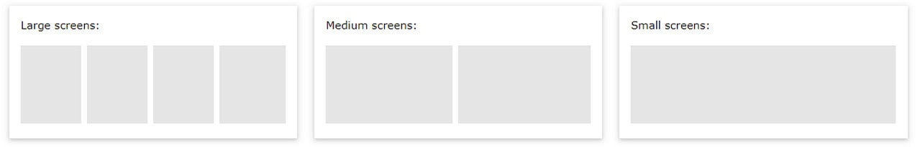
Media Queries
Responsive Typography
Although modern websites are rich in visuals, still web design is all about shaping the written information. Content is a king. No one could argue against that. Therefore, typography, as a prime tool to serve it, is increasingly important.
In the early 2010s, when the mobile web was still new, no one thought about making typography responsive since everyone was busy trying to master fluid grids and images. Today in the early 2020’s it is a crucial part of the larger puzzle.
Check out our guide Responsive Typography in Web Design: Understanding and Using to understand it better.
Indeed, if you are up to a fully responsive website that meets all current demands and needs of the market, then scalable, fluid typography across multiple breakpoints and predefined font sizes is simply obligatory. It is just should be here, no question asked. It ensures the content legible and appealing on all devices and improves accessibility delivering information to all readers’ groups.
However, there is a catch. People tend to believe that the larger the screen size is, the larger typeface has to be. And vice versa, the smaller the screen size is, the smaller typeface has to be. At some point, this principle works excellent, but there are situations when it does not work as intended doing more harm than good.
For instance, when it comes to small screens like ones on cell phones, you need to make the typeface bigger since it is very difficult to make out words set in small font size. Apple recommends sticking to 16px size instead of the expected 12px since it provides better readability. The same goes for large monitors and TVs. You cannot increase font size infinitely; you need to find the best font size for your audience to hit optimal readability.
In a word, typography can be tricky. It certainly requires your attention. You need to invest in responsive typography as much as any other key element of a responsive website.
The good news is, even though responsive typography is relatively new and there are no standards or one-size-fits-all solution, it is still easy to handle. There are different approaches in the wild that you can try and see what works best for your project. Let us consider the two most popular solutions.
Ways to Create Responsive Typography
One of the popular and widely acknowledged ways to create scalable typography is to use well-supported browser features, basic algebra, and automation through Sass. Making the most out of simple mathematical formula, aka linear equation definition and CSS calc(), you can easily bring to life the trendline equation and ensure typography smoothly scales with your layout. If you are familiar with Sass, you can automate it simply by using a code snippet. Check out Fluid Responsive Typography With CSS Poly Fluid Sizing on Smashing Magazine for more good math-based solutions.
Another method is to use viewport units. These relatively new CSS features are incredibly handy. Just set the font size in viewport units and let the browser do its job
For those concerned about browser compatibility, the latter is pretty promising for viewports units and calc() function but still is not flawless; there is another popular and time-proven way of creating responsive typography. It uses breakpoints that you may already have in your flexible layout to set typeface in the preferable size depending on the resolution, thereby controlling this situation manually.
Whatever way you choose, make sure your responsive typography provides the best readability and user experience across devices.

STRETCH by Mat Voyce
Last but not least, responsive web design is about best practices.
Responsive web design is not just about plugging these key features in and being done. Neither is it a separate technology. It is a set of the best practices used to create a website that responds to the device, including pages that instantly adapt to a reader’s needs.
Therefore, it means you need to follow the modern technologies and employ practices that cope with the task better than the others do. The vivid proof of that is the slide-out menu. Along with the hamburger button, the slide-out menu has become a standard for responsive designs, overthrowing other old yet time-proven solutions simply by offering the best flexibility for the ever-growing mobile market.
In addition, along with seeking the best solutions for current demands, you need to test and analyze methods that you have already implemented to see whether they fit the bill since the situation is changing rapidly.

Difference between Responsive Design and Mobile-friendly Design
There are two basic options when deciding how you want your website to look on small devices (cell phones and phablets): responsive web design or mobile-friendly design. While some people believe that these two are the same thing, in fact, they are not. So, who is who?
Responsive website changes depending on the screen size. It uses a dynamic grid, responsive images, and typography to adapt perfectly to whatever resolution is coming its way. It gracefully refits the content to each change in screen size.
Mobile-friendly design functions the same way regardless of the device: it just does not change. Simply put, it is a mobile version of the website. Although it stays relatively neutral to screen size changes, it still has some significant benefits over responsive design. First and foremost, a mobile-friendly website is made with mobile users in mind. It means it provides the best user experience, taking into account even the tiniest details. For example, it has a navigation that is “thumb-friendly,” buttons and links that are easily tappable, graphics that is large, uncluttered design with fewer features, etc.
So, which one to choose? Well, everything depends on your brand, target market, and most importantly, marketing goals. Answer these three essential questions to get some hints on direction:
- What is the purpose of your website? This helps define what information is essential and what information can be eliminated to provide quick access to crucial details.
- What will visitors do on your website? This helps define what functionality is vital and how to make it easily accessible on each screen size.
- What devices do your target market use most of the time? This helps to focus on the most viewed version and provides the best user experience for customers.
Finally, bear in mind that your website should take your visitors on a smooth, frictionless, valuable, and enjoyable journey. If this journey targets mostly audiences on the mobile web, then the mobile-friendly design is your option. However, if you are up to a broad audience from various devices, then responsive design is the only way out.
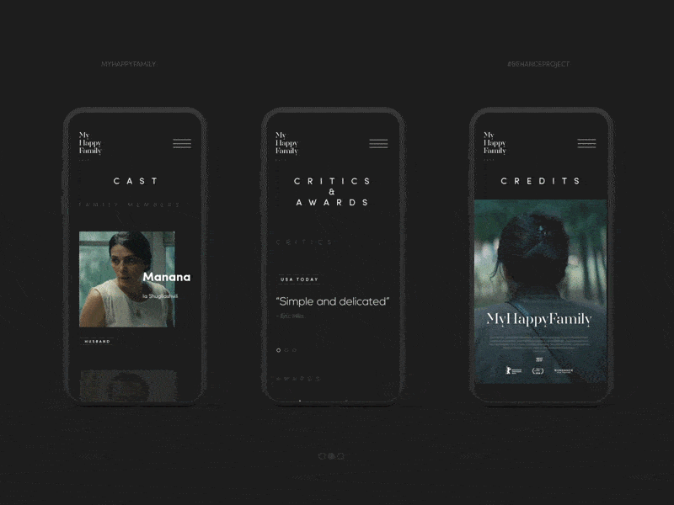
My Happy Family by Shota

How to Create a Responsive Design – 3 Popular Approaches
Designing a universal website accessible to everyone and adaptable to various screen sizes flawlessly and graciously sounds bold and daring. However, no obstacle is insurmountable since the web developers’ community is always searching for the best solutions to address users’ needs and wishes efficiently.
So, what can we do? There are some excellent options in the stock for both tech and non-tech-savvy people. Let us consider the most popular universal approaches to creating responsive designs these days.

Responsive Website Builders
Website builders are a quick, easy, and flexible way to create a responsive website. They fit both tech and non-tech-savvy people by providing a comfortable environment where you can build a website from scratch without writing a single line of code. Some of them focus mainly on responsive behavior, while others take into account mobile-friendliness, offering tools for creating a fully optimized website for mobile devices.
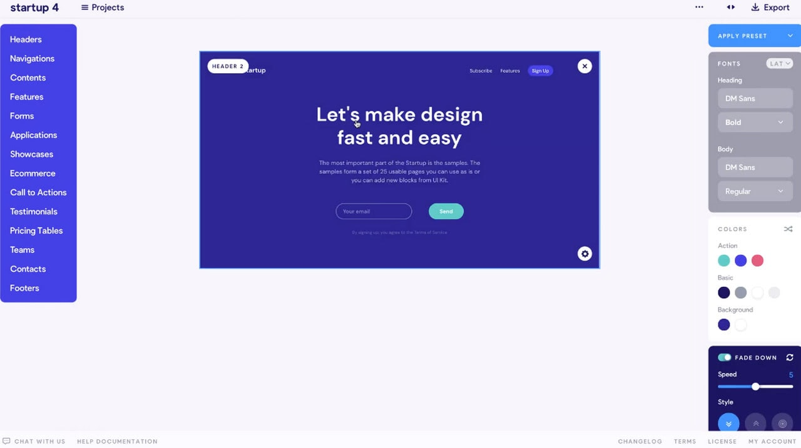
One of the bright representatives is Startup. This award-winning website builder includes more than 300 blocks with modern styles, excellent responsive behavior and mobile-friendly features, a browser-based drag and drop editor that anyone can easily handle, and powerful customization options.

Grid Systems
If you love to code or create everything from scratch controlling each stage of development, then responsive grid systems may be right up your alley. They already have everything you may need: containers, columns, rows, classes for ordering, arranging, and nesting, some basic styles that smoothly adapt to screen sizes thanks to media queries and a range of popular breakpoints. As a rule, developers use them as a solid foundation to build on.
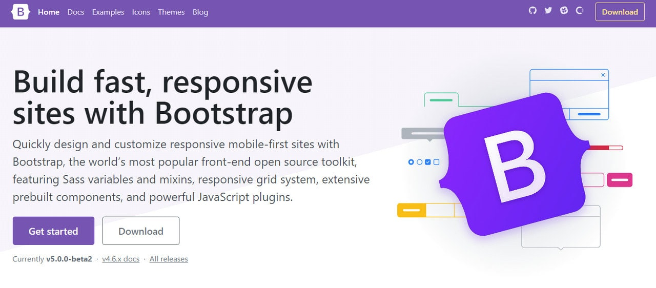
There are a dozen responsive grid systems in the wild: some are simple and primitive, while others are complex and all-embracing. The most notable representative of this direction is, of course, Bootstrap. It is regularly updated to use the best features of modern technologies. By now, it offers a mobile-first flexbox grid to build layouts of all shapes and sizes and a dozen of helpful utilities and assets that make the coding pleasant and enjoyable.

CMS
Last but not least. One of the ready solutions that, much like website builders, can be easily handled by non-tech-savvy people is CMS like WordPress, Shopify, etc.
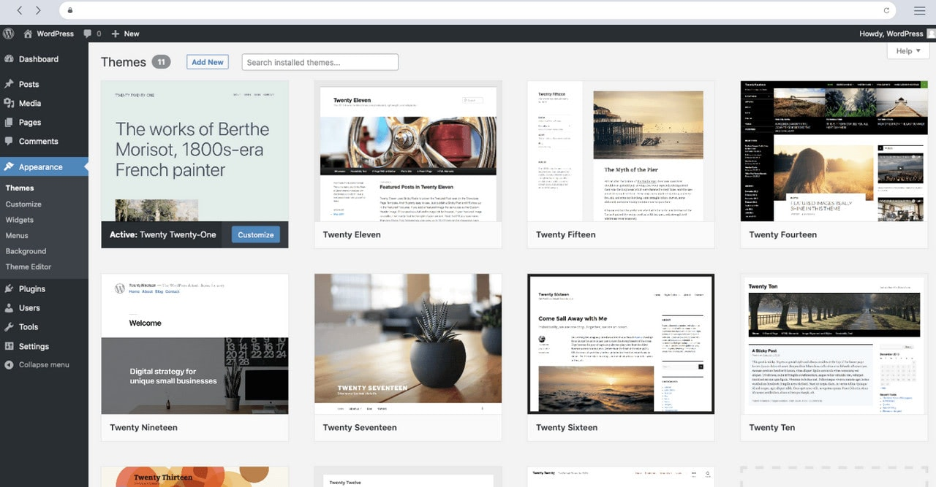
Popular content management systems do not stay aside from the current demands of the web audience. Although, by default, they do not offer responsive behavior, however, those who create themes for these frameworks certainly take this into account, providing responsive templates that are partially or sometimes even fully optimized for mobile devices.

Best Practices for Responsive Designs
As we have already said, a responsive website is not a separate technology with a one-size-fits-all solution. To nail it, you need to use techniques that bring about the best result for your brand, audience, and marketing goals. This implies capitalizing on the key features such as flexible layout, flexible images, media queries, and responsive typography, as well as introducing some time-proven tips and solutions. Let us walk through some good practices that may help you create a fully responsive website that meets all your users’ expectations.
- Design the mobile website first and work your way up to the desktop version. According to stats, the mobile web is prevailing over the desktop one. Therefore, chances are your users will visit your website using handheld devices. Prioritize the mobile version and use it as a foundation to build on. More so, it is easier to scale up design rather than scale it down.
- Know popular screen resolutions. According to GlobalStats, almost 25% of visitors use small cell phones with 360px wide screens, and only 12% use laptops with standard 1366px widescreens. In addition, there is no one preferable size in each niche. This means you need to find the perfect responsive tier in each category. Use Statcounter to define what devices your target market use to determine the best responsive tiers.
- Cater to resolutions that are gaining popularity to create a future-proof user experience that will work even when the market share changes.
- Know web browser market share. Responsive design is also about adapting to the capabilities of the device hardware and web browser. Seamless experience requires your website to work flawlessly across all platforms. The harsh truth is, the World of web browsers is not perfect. There are still browser versions that do not support even the popular CSS features, to say nothing about such modern and pioneering methods like calc() or Flexbox. In this case, you cannot rely blindly on your solution. You need to adjust it according to the browsers that your audience use. In addition, it is highly recommended to provide a fallback if you want to widen your target market and serve content to every customer regardless of the web browser he or she might use.
- Take into account physical differences in using the website on a small screen and a large one. Mobile World is all about designing for thumbs. At a minimum, it means that
  - the buttons should be big;
  - the links should be easily tappable;
  - sliders should be swipeable;
  - interactive elements, key details, and navigation should be within easy reaching distance of thumbs;
  - navigation should be at the bottom;
  - search should be responsive.
  - fingers should not block the view of the content when trying to reach navigation;
  - target area should be enlarged to accommodate touching ideally.
- Do not be obsessed with the F-shape pattern. While on desktop versions, it rules the roost, when it comes to small screens like cell-phones, it is useless. People prefer exploring interfaces in other ways. As a rule, mobile users look at the center of the screen first. It is also the easiest place for them to reach. Therefore, the most critical information, including CTAs and navigation, should be there. However, when it comes to tablets and mid-sized devices, the screen’s central part is not easy to reach. Here you need to place navigation and crucial details on sides.
- Make sure you are not embarrassed with what happens in between breakpoints. Remember, not all people are going to maximize their windows to surf through your website. Your interface should be ready for such a scenario. The layout should naturally adapt as the browser resizes.
- Do not ignore landscape orientation since it is the main hindrance to achieving optimal usability and accessibility.
- Avoid bombarding the user at the small screen with all the content. Eliminate friction and focus on vital information. Do not scale down the whole design since you will end up with a long-long page that is difficult to read on small screens. Also, according to stats, mobile users are usually after quick answers. They should locate information in no time. Otherwise, they will leave. Therefore, display only what matters most to users and give them the controls to find the rest.
- Do not cling to the past. Follow the trends. Sometimes modern approaches may meet current demands more efficiently than old and time-proven ones. As proof, it is highly recommended these days to use scalable vector graphics, aka SVG. While there are various ways to ensure your images are responsive and adapt gracefully to new sizes, but why not benefit from the format that already knows how to behave in such a situation. Furthermore, SVGs often have a small file size so that they do not overload the website nor compromise the website’s speed, and most importantly, they save the quality of the visuals.
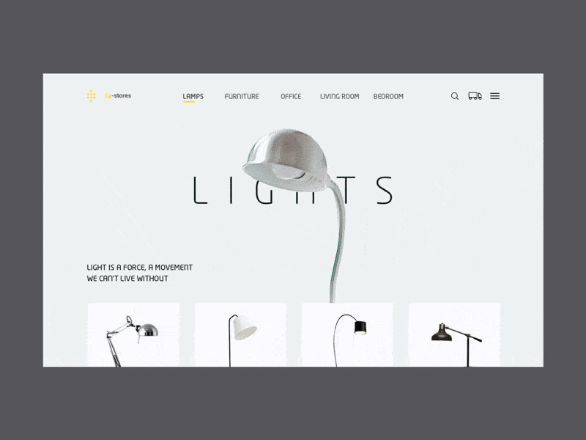
Lamps by Augustus

5 Top Responsive Web Design Testing Tools
We have acquainted with the basic principles of responsive design; however, that is only the first step. The theory is one thing, and practice is another. The next step is to grab some good tools that provide a well-crafted virtual environment where physical devices are perfectly emulated. They will help you define whether your project is responsive and give you some hints on what breakpoints to use and what elements should undergo changes to work and look excellent on selected resolutions.
Check out these 5 top responsive web design testing tools.
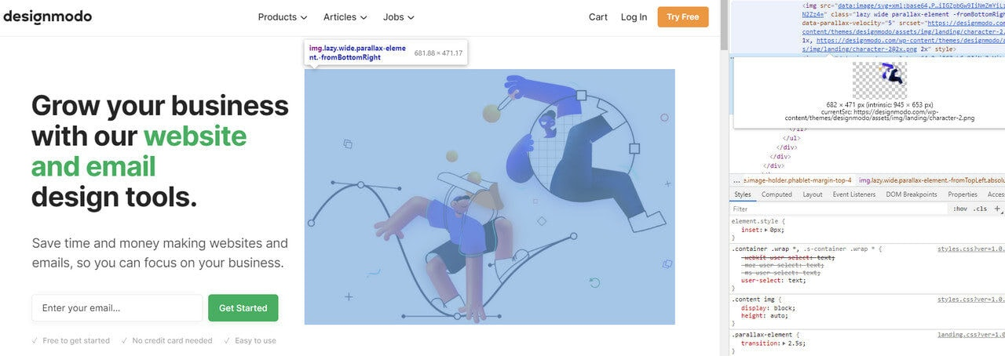
Inspect Tool on Chrome
The first tool in our collection of 5 top responsive web design testing tools is, of course, Inspect Tool in Chrome (it is also available in Firefox and Opera). Although this tool is not for non-tech-savvy people, it is still easy to use: the interface is intuitive, and the panel for inspecting responsiveness is easily accessible.
The device toolbar shows you how the page looks and performs on different devices. It has two modes: mobile viewport mode and responsive viewport mode. While the first one offers you a selection of popular cell phones that let simulate a specific mobile device’s dimensions, the second option is much more powerful. It allows you to play with size by stretching out or narrowing down the working area to catch the breakpoints when the layout becomes broken or content becomes difficult to read.

Mobile-friendly Test by Google
This is another tool from the Google team designed to help fellow developers to improve their online estates. Unlike the previous one, which is quite extensive and powerful in what information it can provide, this one focuses only on one type of information. It helps to find out how mobile-friendly your site is according to Google’s principles. It investigates and measures how easily users can access, read, and navigate the site on mobile devices. It grants you a score and offers some suggestions for improvements.
The tool considers such vital parameters as viewport issues, speed issues, load time, horizontal scrolling, scalability and readability of the content, touch elements, etc. Even though developers criticized the tool several years ago, today, it has many improvements and serves as a reliable platform to get insights on the mobile version of your website.
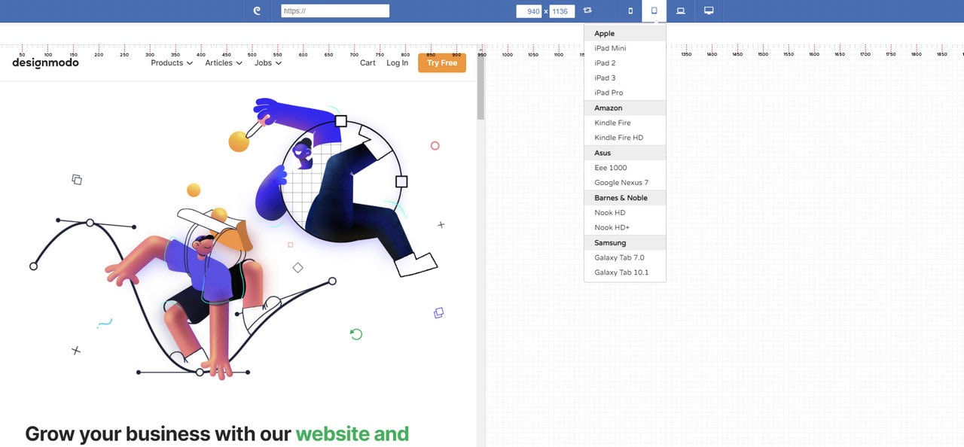
Responsive Test Tool by Designmodo
The beauty of the Responsive Test tool by Designmodo lies in its simplicity, even though it is pretty powerful. It has an intuitive interface that can be handled by non-tech-savvy people to see whether their current websites look great across popular devices and platforms. All they need to do is to type in the web page’s URL, and the tool shows how a web page renders in the different screen shapes and sizes.
Here, you can find a wide range of cell-phones, phablets, tablets, laptops, and desktops so that you can target and inspect every popular and not-so-popular device. Also, you can set your dimension and see how your web page looks in a custom size.
Last but not least. The great advantage of the Responsive Test tool that many developers find extremely useful is that it allows interacting with pages and inspecting dynamic details of the interface like navigation, sliders, tabs, etc. You can click on links, activate slide-out navigation, type into the search field, etc., to detect minor problems with the interface.
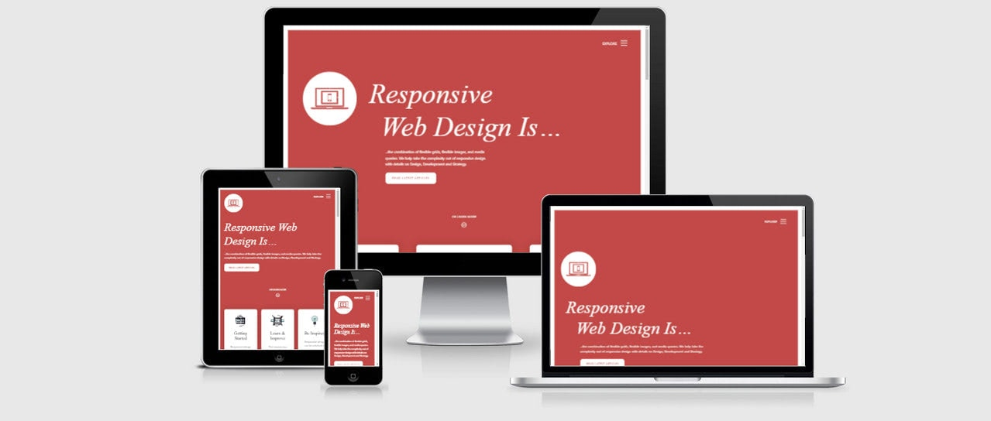
Am I Responsive?
“Am I Responsive?” is perhaps one of the oldest responsive test tools on the web. Unlike the previously mentioned here, it has a more static answer to the issue. All it does is show your web page on four popular devices: desktop, laptop, tablet (portrait mode), and cell phone. The surprising thing is, you can interact with every frame. You can open the menu, click on links, scroll down, etc.
Of course, this is not enough for developers. Still, it is a good alternative for non-tech-savvy people who want to find out how their websites render on different devices and tech-savvy people who want to take screenshots of local development URLs for reporting.
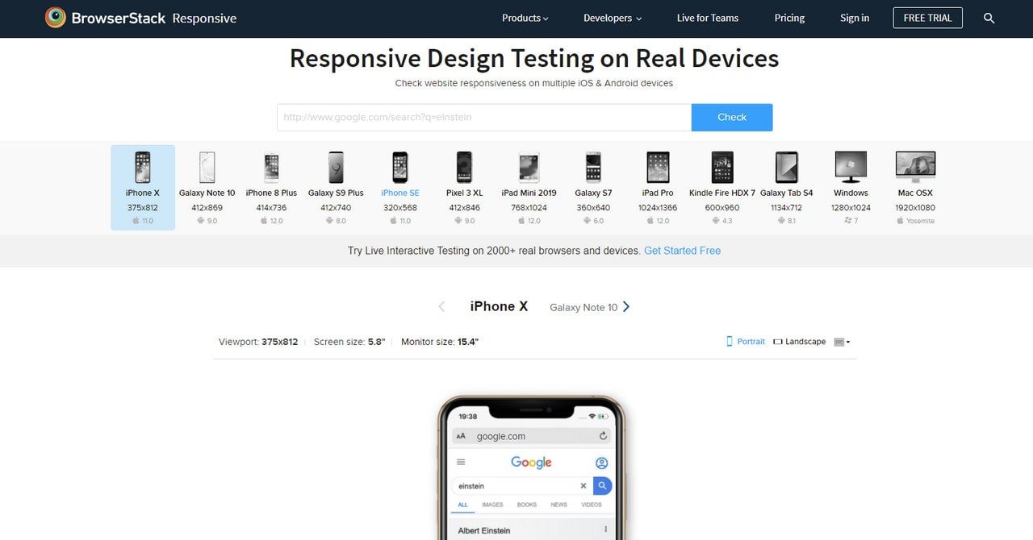
Responsive Testing
Responsive testing, a free tool from BrowserStack, shows your website on an assortment of iOS and Android devices, including mobile phones, tablets, and laptops. iPhone X, Galaxy S9 Plus, iPad Mini, iPad Pro, MacOSX, and even Kindle – the selection is pretty good. It is a great instrument to verify if a website is being displayed correctly.
Although you do not have such freedom as in Responsive Tool by Designmodo – you cannot interact with each version, and the only thing you get is a screenshot – nevertheless, it helps to get the overall picture of the online estate.

Responsive Web Design Examples
Responsive web design term is related to the concept of developing a website design in a manner that helps the layout to get changed according to the user’s computer screen resolution. More precisely, the concept allows for an advanced 4 column layout 1292 pixels wide, on a 1025 pixel width screen, that auto-simplifies into 2 columns. Also, it suitably fixes on the smartphone and computer tablet screen. This particular designing technique we call “responsive design”.
Responsive website designing is an entirely different designing version than traditional web designing, and developers (especially fresher) must know about the pros and cons of responsive web designing. This blog is a mighty example of the approach so we will reveal a few facts about the uses of responsive web designing. The basic instinct might be to choose media queries to develop a responsive site. However, the hassle one faces with media queries is that new queries can pop up from moment to moment; each time, the user experiences sudden and drastic changes to the look and organization of the site. Experts suggest using some CSS transitions to ease the jump.
Pages that include data tables pose a special challenge to the responsive web designer. Data tables are extremely wide by default, and when someone zooms out to see the whole table, it becomes too small to read. When one tries to zoom in to make it readable, he or she is supposed to scroll both horizontally and vertically to look through it. Well, there are several ways to avoid this problem. Reformatting the data table as a pie or mini-graph is an approved solution. The mini-graph fixes even in narrow screens.
Images in responsive web designs are called context-aware. This particular technique serves the purpose of responsive designing in true sense as the images serve at different resolutions, ranging from larger screens to smaller ones. The scaled images appear to change fluidly with the help of updated developer tools and coding languages, allowing designs to look sharp in every context.
Responsive web designing is remarkably different from traditional designing in terms of technical and creative issues, and careful use of this can do wonders while designing.

Designmodo
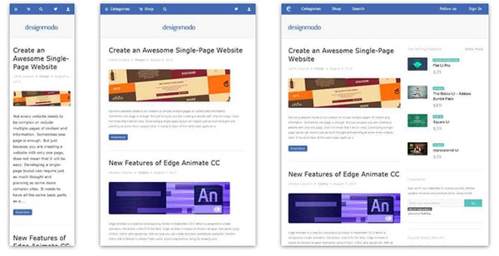
Designmodo has a very clean and clear design with a perfect responsive design interface. The images and the text scaled perfectly on different mobile screens sizes.

Simon Collison
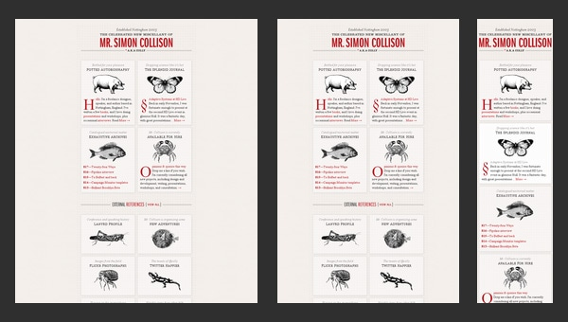
Though nowadays this greyish grid-style static website looks a bit boring and dull, however when it was released it caused some kind of furor with its high-end layout.
The main reason was that the designer primarily focused its attention on responsive behavior that was only gaining popularity those days thereby providing ordinary developers with a representative example of how regular grid-style layout should gracefully transform.

Andersson-Wise Architects
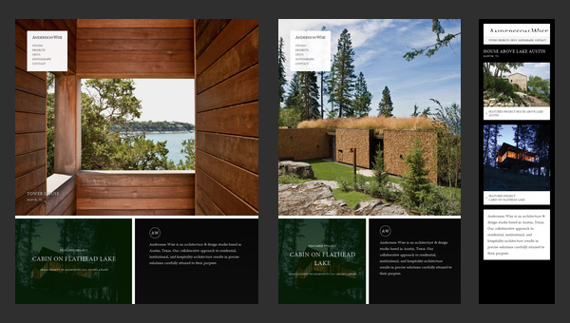
Being dedicated to an architecture and design studio it doesn’t surprising that the main focus of the website are photos that showily represent skills, experience and clients of the company.
The landing page includes 3 main sections, each of which is based on image background. The flexibility solution helps to effectively form a proper structure for every standard screen size, creating a pleasant content flow for readers.

Stephen Caver
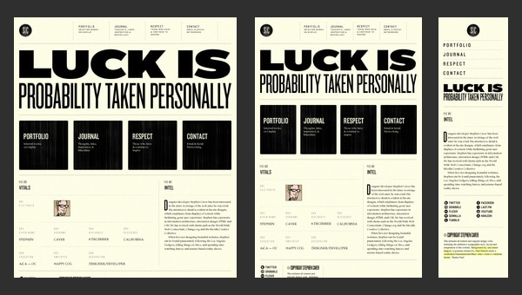
Stephen Caver has a topnotch website when it comes to responsiveness. You will definitely ask, what so special in it. The answer is simple, take a closer look at the front page and you will see; it consists of
- huge welcoming message dished up with a help of a rough typography;
- set of huge blocks that is a duplication of the main menu on the top;
- regular layout for blogging.
So as to say, 3 essential aspects that can be found on every website. The designer gives us a hint of how typography, grid-style markup and blog section should change according to device screen dimensions.

Sparkbox
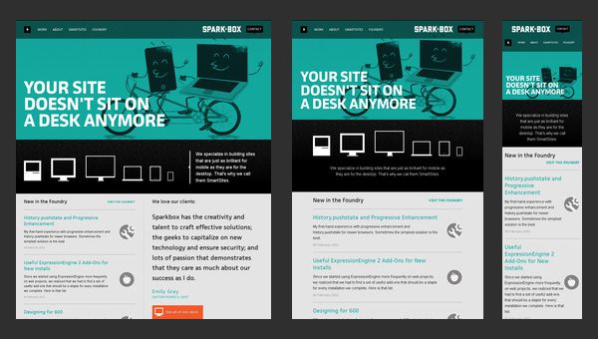
Sparkbox demonstrates a basic structure of a corporate website. The layout is pretty simple; it is based on a standard, commonly-used set of horizontal stripes that present data in a non-intrusive manner. Such structure is really easy to adapt to various screen sizes. The sequential arrangement of blocks deprived of embellishments undergoes changes quite smoothly and effortlessly, giving users a nice-looking and well-organized layout.

Food Sense
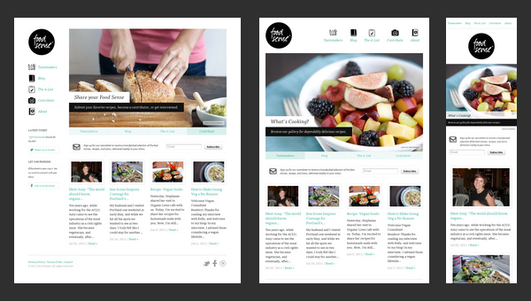
Transformation from a regular left-sided blog-style magazine layout populated with numerous yummy pictures to an elementary block-by-block layout – here is how the main process of adaptation looks like in this website.
However, there is nothing supernatural; it is believed to be a typical solution to a great deal of projects that want to attract online readers from mobile web, win over new audience, and at the same time, save the website’s aesthetics from a visual overload.

The Boston Globe
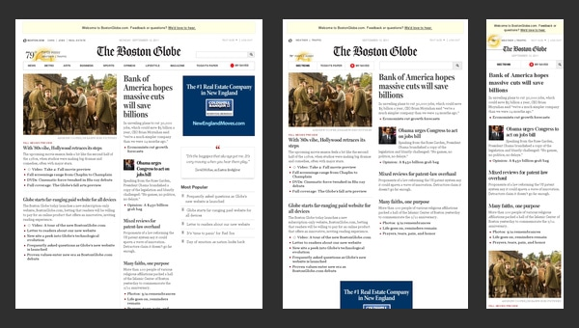
The Boston Globe is an excellent example of a well-thought-out news-related website that is based on a responsive layout. The website takes on a conventional approach that is helpful for those who are eager to run its own frequently updated online magazine.
Though as befits, at first sight it seems that the website has a complex, slightly messy outward that is really hard to handle, actually the solution is really primitive. The designer has wisely split all the information into 3 columns, the amount of which decreases according to screen size, slowly but surely passing stages of displaying data in 2 columns and finally in one; in this way you will be also able to set a necessary order of showcasing your blocks.

Think Vitamin
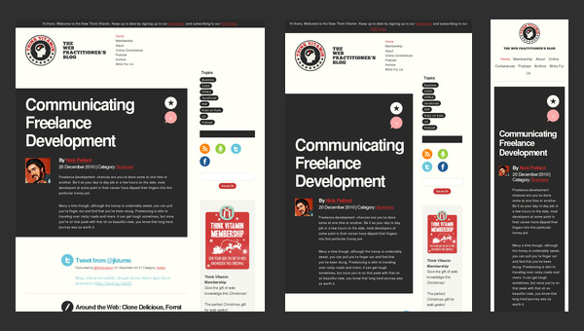
To be honest, Think Vitamin can’t boast of anything particular concerning its blog design. It has the same markup as everyone else’s. It has 1 main column with a right-sided widgetized sidebar, a header populated with navigation, a logotype and a search bar, and a footer that presents information via set of blocks.
However, the team not just mindlessly uses a responsive framework as a base; they also actively muster support from some styling elements. Thus, a contrasting color palette helps to distinguish content blocks and some functional elements such as social media and ads, enhancing visual perception for mobile users and reinforces readability.

Sasquatch! Music Festival
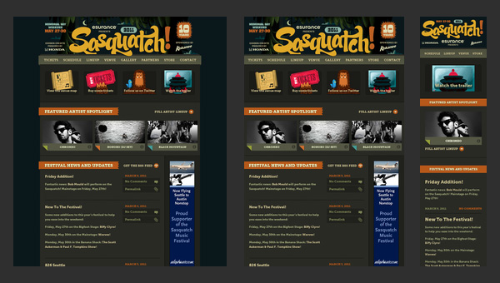
Sasquatch! Music Festival has to deal with a lot of multimedia content including videos and dynamic effects that in addition is spiced up with some artistic hand-written lettering and fantastic graphics. So for the team, it is quite a challenge to display everything correctly on mobiles and tablets.
Nevertheless, the responsive behavior here is well elaborated. It neatly touches every detail, creating a visually pleasing appearance that doesn’t lose its charm of originality and creativity even on small screens.

Internet Images
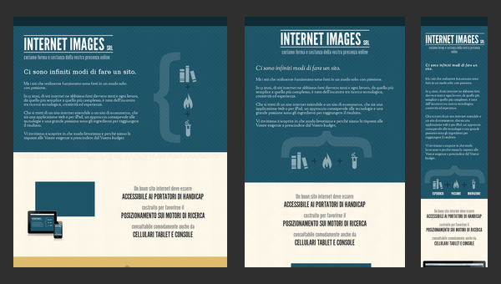
This is another clean well-organized website that is based on a flexible horizontal stripe layout. The responsiveness here is also effectively bolstered by a color differentiation that visually separates one logical block from another.
Such simple yet powerful combination helps to increase readability chiefly on small devices where, as a rule, everything is presented as a one continuous data stream that, because of an inherent monotony, is able to easily destroy all the piquancy and decrease readers’ interest.

Staffanstorp
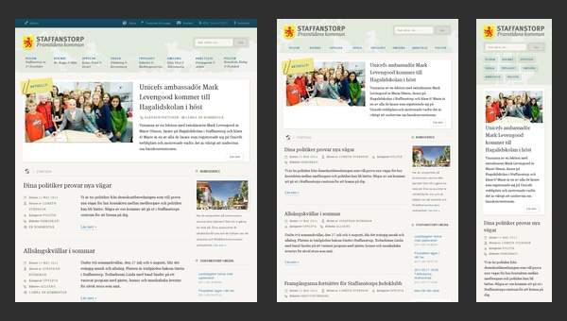
Here, an ability of a beautiful adaptation to smaller screens as well as to bigger ones brings such benefits as
- perfect readability regardless of devices that display your website;
- well-structured appearance for increasing information hierarchy;
- easily conveying messages to readers that mostly leverage tablets and mobiles.
Though the blog designs do not differ from others, yet its desire to satisfy current web requirements takes it at the whole new level.

Seminal Responsive Web Design Example
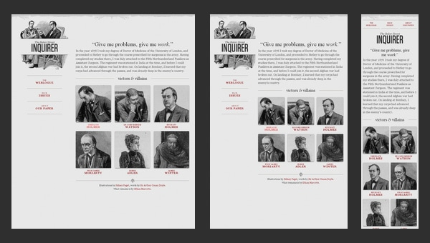
As the nameplate implies, the website serves as a perfect example of responsive design. It even has a proper title “A Flexible Grid”, so it becomes clear that everything here is riding on rules of graceful degradation. As expected, the team pays more attention to an ideal data presentation rather than to aesthetics, so styling goes into the shadows.
The demo page includes navigation, a text block, grid-style area, and even illustrated logotype, so to speak covers a minimum of integral elements. The team showcases how sizes of logical divisions and arrangement should properly change in order to provide users with an excellent experience on portable devices.

Naomi Atkinson
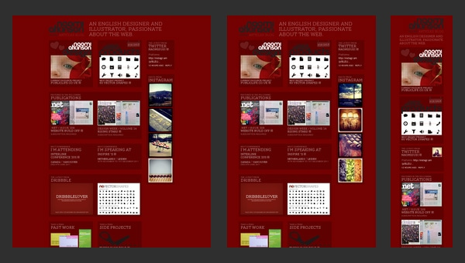
Naomi Atkinson leverages a mosaic-style layout for the front page. This solution is widely-used among those who want to immediately shed a light upon its artworks by creating online portfolios.
The website is worth mentioning not because of its design, since, to put it mildly, it leaves much to be desired but due to its functional side that is quite intelligent. The designer employs irregular grid that nicely transforms into a correct grid once you start minimizing your browser window. And that’s not all; metamorphoses are supported by pleasant effects that add dynamics and attractiveness to the project.

Forefathers Group
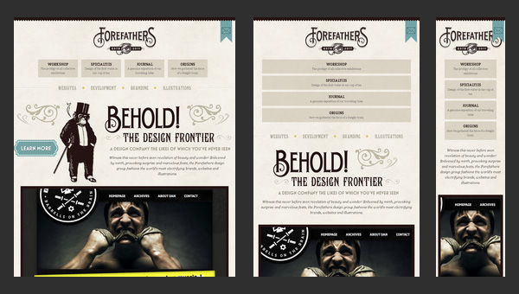
What can you say about this website? It certainly conveys a distinct, quite overwhelming impression with its matchless, sophisticated design. The team has not stinted on the artistry that manifests itself in various moments.
The website charms with its incredible retro-style typography, fantastic hand-drawn illustrations, textured background, and amazing graphics; and these all embellishments skillfully co-work with textual content that takes up a special place in the design.
So as you can see, the team has to take into account lots of details in order to turn the website into a comfortable place that will satisfy needs online visitors that surf the website via various pocket devices.

Spigot Design
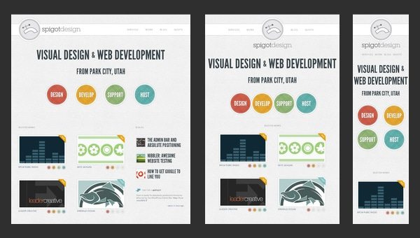
Here, the responsive behavior should leave an imprint not only on a standard layout that includes grid-style and line-by-line data presentation but also on intro video, dynamic graphics and of course, menu.
Bearing everything in mind, the team is managed to provide an online audience with an elegant design spiced up with some charming effects and full of whitespaces that nicely reflect data regardless of screen dimensions.

New Adventures In Web Design Conference 2012
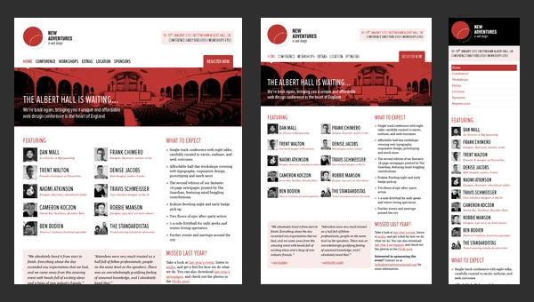
Being based on a flexible grid allows the organization to win over as many potential visitors as it is possible. And in this case, this quality not only contributes to the appearance of the website but also unobtrusively supports the event that it publicizes. Since the website is dedicated to a web design conference, it is highly desirable to demonstrate regular users that the team is aware of current web requirements and rigidly sticks to them. So building a website with all specifications is an important move towards success.

Illy Issimo
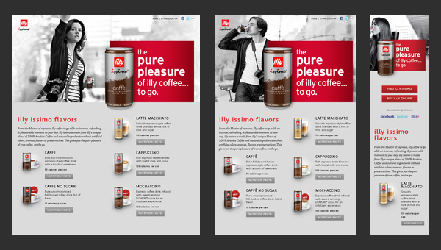
The responsiveness is an essential feature of every high-quality promotional website that understands rules of attraction. Illy Issimo got the hang of it and used a flexible grid in order to
- provide a pleasant user experience;
- extend a targeted audience;
- draw in potential customers that use small devices.
So as a result, its advertising campaign is certainly out in front.

Arrrrcamp Conference
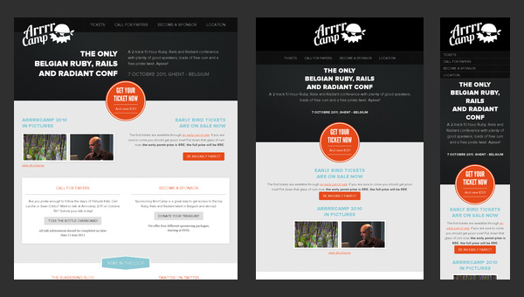
The website focuses more on text rather than on multimedia. Thus, the large part of the website is based on a white monotone background that nicely underlines text and some trendy “ghost” buttons.
The front page undergoes changes once you resize your browser window; it ably supports all resolutions starting from 1920px and ending up with 240px that is really convenient since Ruby-lovers definitely know how to use tablets and mobiles in search of necessary stuff such as conferences in internet.

Robot or Not?
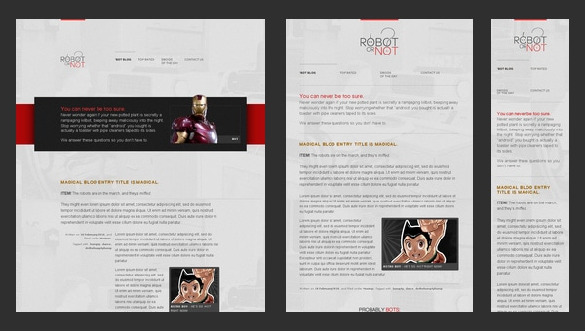
Robot or Not? is a demo website that puts a flexible grid in action.
Featuring an equal mix of textual and multimedia data that takes up the whole browser screen (as is often the case) and stripping away all the decorations and creative styling, the team tries to make from the regular page an excellent example for newbies that want to vividly understand basic transformations that happens with the layout when it adapts to various screen dimensions.

Earth Hour
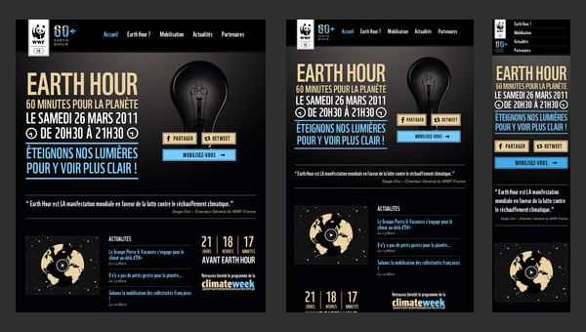
Earth Hour is a really advanced and complex website that is filled with lots of multimedia including both videos and eye-catching photos. Moreover, it is also an online infographic that utilizes some beautiful graphics and smooth transitions in order to draw attention to the issue.
Unfortunately, the adaptation is not well-crafted and fully elaborated, since the website suffers from some inconsistencies starting from tablet version, to say nothing of displaying on a much smaller devices such as mobiles.

Teixidó
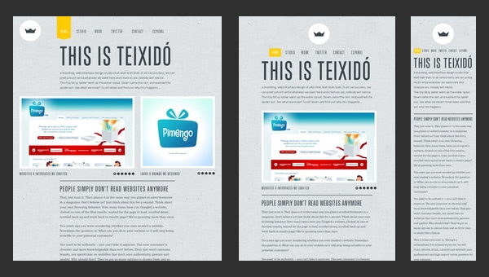
The creative team resorts to an ingenious approach of using textures, fantastic drawings and illustrations in order to effectively set its company online and make it look unique and eye-catching.
An artistic side is absolutely stunning. How about an ability to skillfully adapt to competitive environment? Here is also all present and correct. Though the website is static, there are no magnificent effects or dynamic zest, yet the responsive behavior dramatically contributes to the users’ experience, saving the day.

Ribot
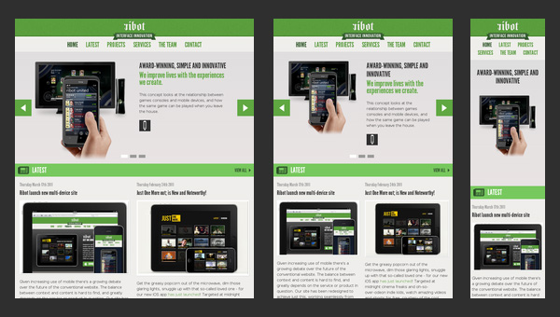
Ribot is a high-end digital design studio which specializes in mobile, tablets and beyond – as the title says.
The key words here are mobile and tablets, it means that the team concentrates on creating designs that will be suitable for namely such devices, so it’s not surprising that the website design itself also easily blends into screens of such gadgets, nicely displaying information and providing regular online visitors with a proper way of exploring company’s services and possibilities.

Deren Keskin
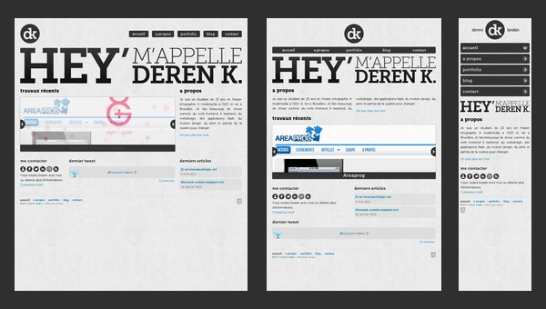
Deren Keskin has a compactly arranged, clean online portfolio that obviously resorts to a rule that every web page should occupy only browser screen, even blog falls under this requirement.
The same goes to modified (according to responsive scheme) layouts, so everything is compressing until the whole structure perfectly fits into a screen regardless of its dimension. Furthermore, the designer is managed to save all the proportions and relationships between integral components in order to save and carefully identify the previously set priorities of some elements.

Sweet Hat Club
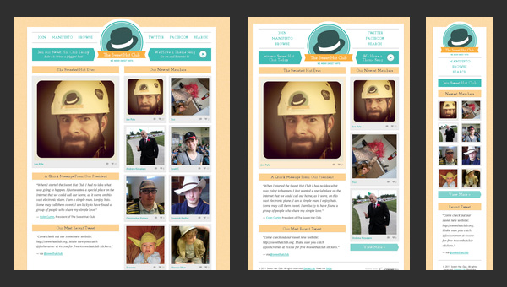
Much like the previous example, the content is tightly packed together. The newspaper-style layout is aimed to predominantly feature images since the website is an online club of those who like to wear hats.
The textual filling here is quite optional, so the responsive grid should chiefly take care of properly modifying image sizes and fitting them into new dimension. What is worth attention here is that even the mobile version of a website includes 2 columns as the original one.

Glitch
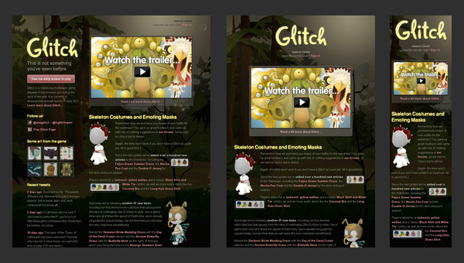
At the present time the website is closed. The home page includes some information about the previous project activity, helpful links and characteristic illustrations. This is only one static web page that is reminiscent of the old days.
However the non-working status in no way affects the responsive behavior that is inherent to the website. Even now, being out of service, it continues to complying with web requirements and formally notifying users about its current status whether they stumble upon the website sitting at his computer or using a cell-phone.

dConstruct
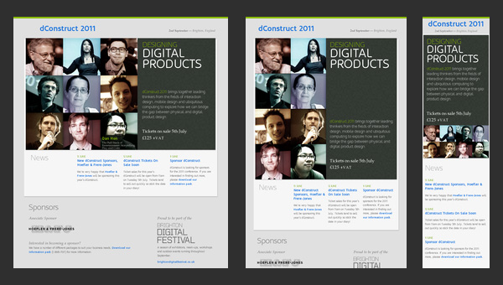
dConstruct is a website dedicated to conference and workshops that take a look at perceptions of technology and culture. Though the design is quite primitive, yet the informative side is really well-thought-out. Thus, the front page draws your attention to only 3 main moments:
- speakers and workshops’ teachers;
- description about the event;
- sponsors.
Those are the main things that worry potential visitors and need to be instantly highlighted.

Adaptive Web Design
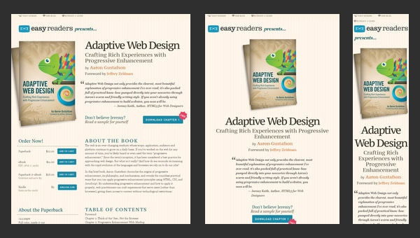
As the nameplate implies, the website is concentrated on adaptive issues. To be more precise, this is a promotional website that advertises a book that will answer all you questions.
So it’s quite predictable that the developer leverages it as a tool for showcasing its skills through providing users with a representative example of how should a regular website behave when users come to it from various devices.

Authentic Jobs
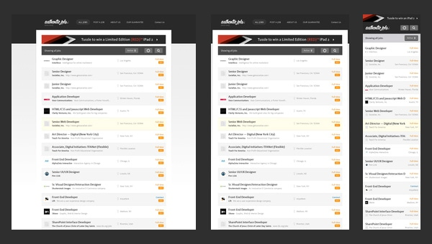
Authentic Jobs is an online directory that is aimed to unite employers with job seekers. It traditionally displays data via a list-style layout that is quite elegant and easy to handle when it comes to adding versatility via incorporating responsive behavior.
The transformation does not cause much trouble, since the structure stays the same; the only thing that undergoes changes is a sidebar which is moved down the hierarchy by giving way to more relevant and priority data.

Five Simple Steps
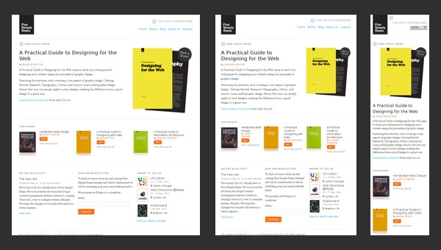
The website of Five Simple Steps has a clean appearance that features only some kind of valedictory speech and a list of helpful stuff from those who previously run this website.
Staying responsive till the end is a good rule of etiquette, and the company is perfectly conscious of this. Even being closed, the website continues to meeting current web requirements and supplying its mobile and tablet readers with a perfect readability.

Splendid
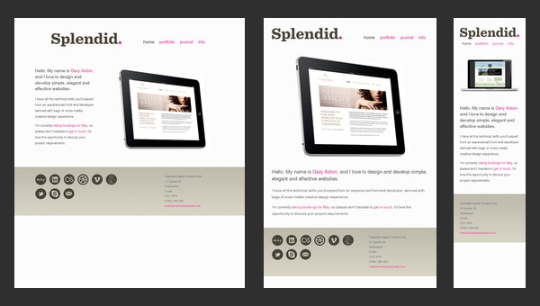
Splendid is a simple online portfolio that emphasizes users’ attention on artist skills and experience. You will not find neither fantastic illustrations nor ingenious effects; the designer takes a minimal approach in order to present himself, and it definitely stands in a stark contrast to other sophisticated creatives’ websites.
In this particular case, the minimal design doesn’t mean minimal functionality. The artist feels that the responsive design is and will be the primary focus, so he takes care about a proper adaptation to huge and small screens.

Ryan O’Rourke
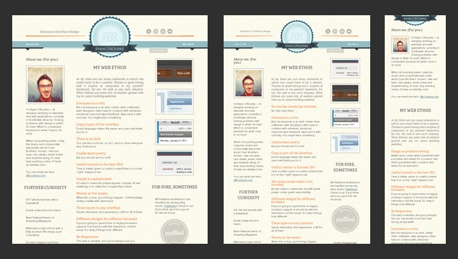
When you run into online portfolio of Ryan O’Rourke, it seems that the designer is guided by the wise phrase “brevity the soul of wit” and realizes it literally. Minimalism, minimalism and again minimalism…there is only one web page that features one sentence, email and small gif animation that shows off his activity. However much like the previous example, the website is based on a responsive framework that makes the website ready for mobile web audience.

FlexSlider
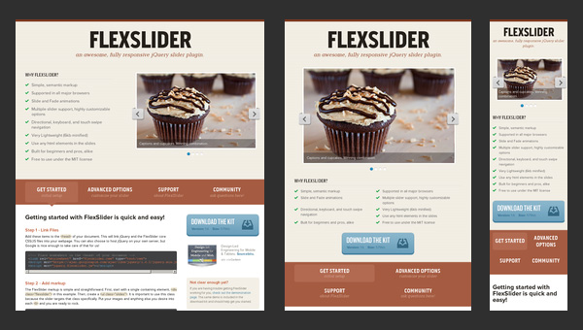
FlexSlider is a lightweight jQuery slider from WooThemes with simple semantic markup and numerous valuable features that was created to become your reliable companion for an ideal image showcase on every popular device.
Nevertheless, the web page that promotes the product, unlike the slider itself, is not as adaptive as it should be. Unfortunately, the team has missed this point that really disappoints.

El Sendero del Cacao
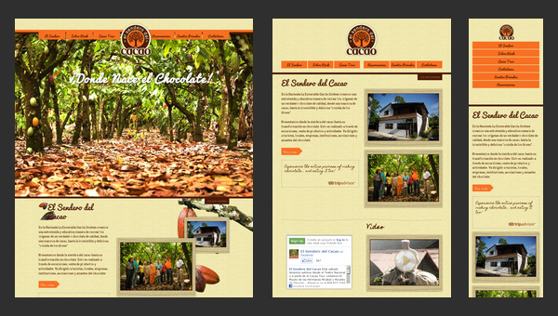
El Sendero del Cacao has a visually-appealing website with a calm and warm atmosphere that is achieved with a help of soft coloring, spectacular images and appropriate graphics. Moreover, thanks to such integral features as
- responsive layout;
- cross-browser compatibility;
- easy navigation;
- multi language support.
the website is able to unobtrusively force users to indulge in an enjoyable pastime.

Do Lectures
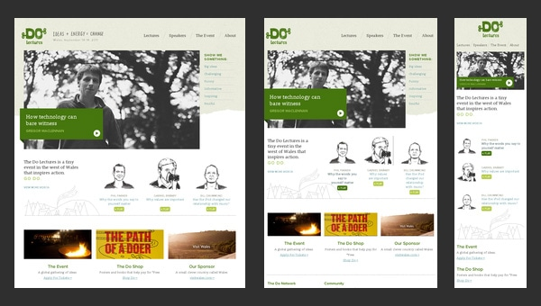
Do Lectures is a regular blog that makes use of a 3-column format layout that effectively copes with lots of news and posts populated with images. The website has an old-timey feeling because of its conventional markup and lack of any dynamic elements.
Coming with the retina support, the website looks fantastic on huge desktop and notebook screens, whereas on small tablet and mobile screens everything is not so rosy. The responsiveness, unfortunately, is not fully thought-out here, leaving users of mobile web with ill-suited horizontal scroll bars.

St Paul’s School
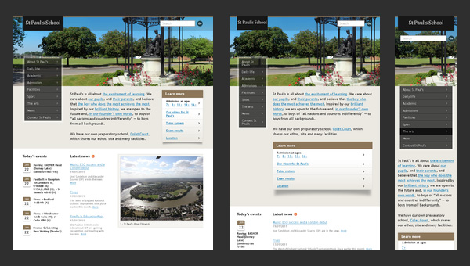
Nowadays, a great deal of educational institutions has their own websites. Even the official page of the St Paul’s School is not lagging behind others, having a website with
- an appropriate discreet appearance;
- highly informative home page;
- comprehensive navigation;
- and of course, mobile and tablet friendliness.
And concerning schools, it is really something. Having a fully adaptive well-crafted website that not only reveals necessary information but also has a pleasant design supported by flexible grid looks like a jump above its head.

Naomi Atkinson Design
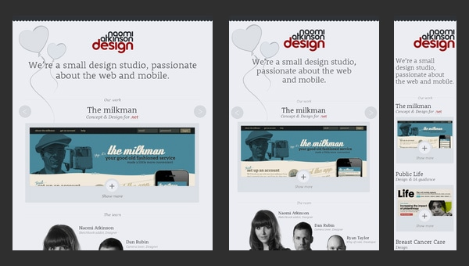
Naomi Atkinson Design is a small passionate UK-based design studio that has a tightly-packed together website. The team employs a boxed-style layout with centered content diluted with minimalism that is aimed to:
- briefly but efficiently display data;
- instantly catch the viewers’ focus and draw attention to portfolio items;
- provide users with a handy instrument for quick feedbacks.
Moreover, such layout is really easy to turn into responsive one, so it’s quite beneficial solution.

Ben Handzo Photography
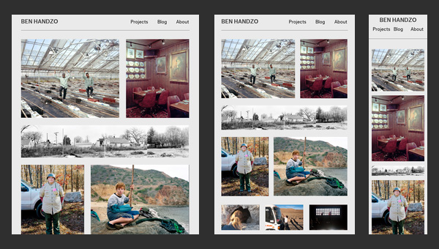
After casting a mere glance at the website, it becomes clear that the artist is simply obsessed with photos. The home page of his online portfolio is packed with images; there is absolutely no text, with the exception of navigation and small panel placed on footer. Moreover, being bolstered by a responsive grid that handle all the inconsistencies occurring during adaptation to smaller screens, the website brings benefits not only to the owner but also to online visitors by giving them a chance to enjoy spectacular works no matter where they are.

Stunning CSS3 Media Queries Example
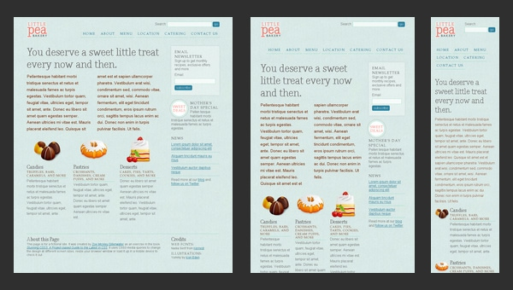
As you have already noticed this is another website in our collection that is dedicated to responsive solutions called media queries that are highly popular among developers nowadays.
Of course, the design, styling and semantics are quite primitive here, however, they are not highlights; the flexible grid that plays a role of a solid foundation for this project is a true star here. The website serves as a mere example that graphically formulates the rules of graceful degradation for a standard 4-column layout.

Nordic Ruby Conference
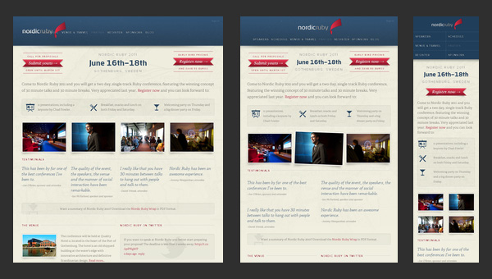
Nordic Ruby Conference’s official website conveys a distinct sense of something really interesting should happen. Such features as:
- clean overall design;
- textured solid color backdrops;
- well-formatted layout;
- informative home page;
allows a pleasant, and at the same time, professional atmosphere prevails on the website. The responsive grid that is used as a base makes the presentation of the event available for a wide range of internet users.

Halifax Game Jam
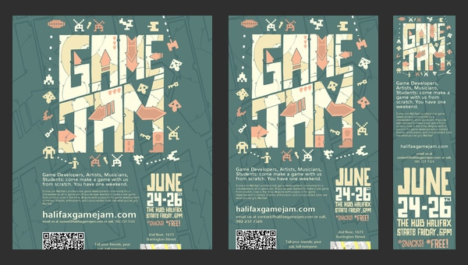
Halifax Game Jam has a powerful artistic vibe due to its ingenious flyer-inspired home page that features a mind-blowing illustration and highly original backdrop.
Of course, the creative design helps to make your website to stand out from the crowd, but how about basic web requirements that need to have complied? The team has also thought this through, and supplied the website with:
- solid surface;
- responsive layout;
- proper optimization for browsers.
even despite of having only one page.

Diablo Media
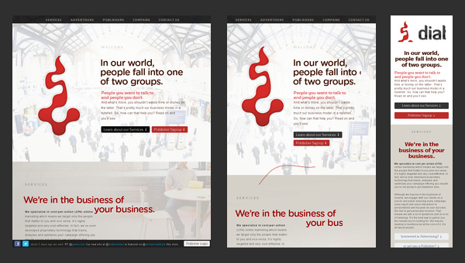
The team has obviously built the website with current trends in mind. There you can find
- a hero area that greets newcomers;
- smooth effects;
- slide out highly comprehensive navigation;
- flat-style graphics.
They also did not miss an opportunity to add flexibility as well as supply it with some extra features that are necessary for website’s well-being in a competitive internet.

ASU Online
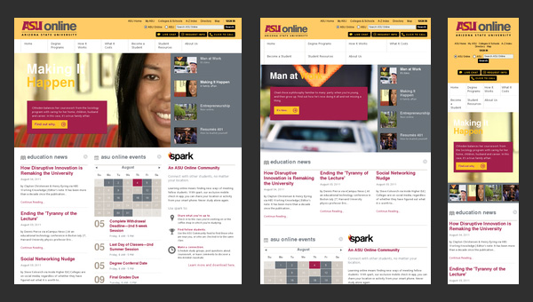
ASU Online is not reliant on an incredible design to be memorable. Being a website dedicated to a local university, it has a quite modest design that, by the way, goes perfectly well with a site’s mission. The front page depicts everything that is needed to effectively familiarize visitors with an establishment.
As far as functionality is concerned, the website sticks to such core features as:
- responsiveness;
- seo optimization;
- cross-browser compatibility.

3200 Tigres
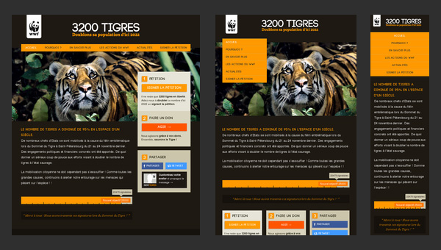
When your task is to inform about the acute problem and draw as many attention as it possible, establishing a proper online foundation is a must have. The WWF like no other knows the rule of the game, so it’s not surprising that 3200 Tigres (one of its child websites) is pulled by such essential features as:
- modern flat style design;
- optimal information hierarchy;
- responsive layout.

Kings Hill Cars
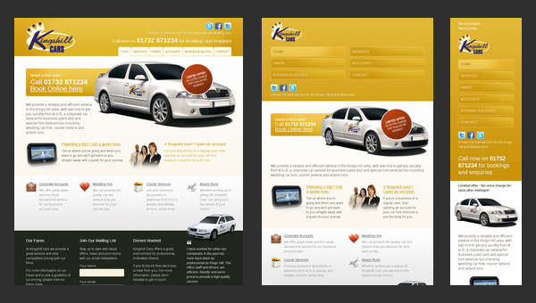
Kings Hill Cars is an official website of a company that provides taxi services. The landing page tries to cover everything that can be of use for potential clients.
Despite the fact that the website design is outdated and quite unremarkable, it is fully adaptive. And the last feature is more than enough to increase the conversion rates for company whose targeted audience, as a rule, comes from a mobile web.

8 Faces
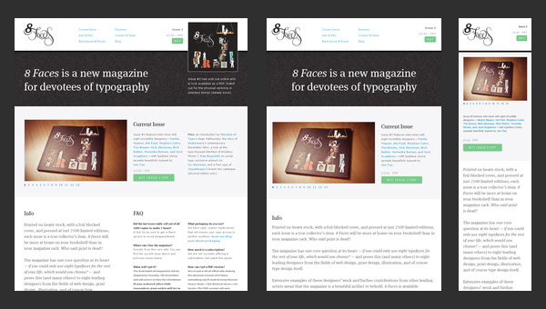
8 Faces is a printed magazine that forces its readers to speculate about typography, asking only one but tricky question:” If you could use just eight typefaces, which would you choose?”
The official website as befits is aimed to achieve a maximum exposure for its product with a help of
- clean elegant design;
- wide-screen image slider;
- ability to gracefully fit the content into smaller screens.

Asbury Agile
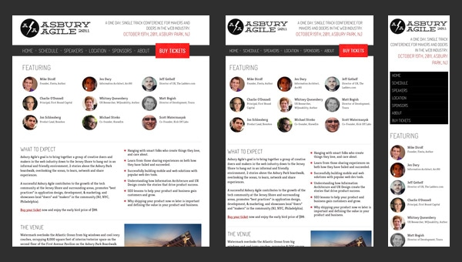
Asbury Agile is a conference for web professionals. As we have grown accustomed, when the event concerns web technologies and includes some high-end professionals, the official website not only has to look modern and up-to-date but also stick to some strict specifications such as
- seo friendliness;
- responsiveness;
- browser optimization.
like Asbury Agile official website do.

Alsacréations
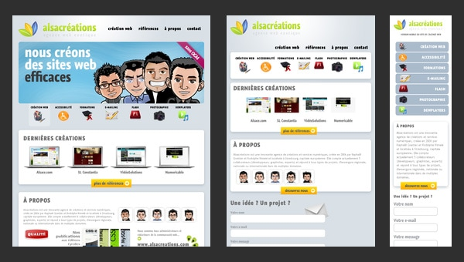
Alsacréations is a French-based web agency that has a regular online portfolio.
Though it seems that the website craves for some kind of a “facelift” since the design definitely comes from the past with its glossy icons and boxes with shadows, however, it has one huge advantage over some others; it is based on an adaptive grid that slightly changes the attitude to it, making us (I mean potential customers) believe that at least the base of your project will meet current requirements.

Sleepstreet
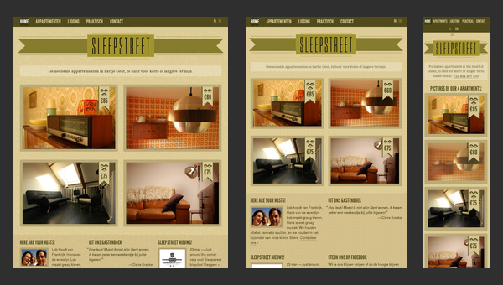
Sleepstreet is a fully responsive website that is really pleasing to the eye, even when it is displayed on your cell-phone. Moreover, it can boast of such features as
- a grid-style layout for showcasing various rent options;
- a retro appearance for creating a warm and cozy home-like atmosphere;
- a multi-language support for covering a wide range of potential customers.
The responsive behavior embraces lots of aspects. Being fully adaptive doesn’t mean solely being mobile and tablet friendly, it also involves proper display on huge desktop and notebook screens. Moreover, this feature is no longer optional; every website, whether it is an online portfolio of an artist or a regular school web page, has to quickly and efficiently react on changes related to the screen sizes. There are different ways of sorting out this issue, however we are here not to shed a light upon these techniques; we just want to demonstrate how ordinary websites, which flood the internet, are capable of gaining benefits from being responsive.
https://designmodo.com/responsive-design-examples/

Responsive websites: 30 examples and 5 best practices
Design
September 24, 2020

Responsive web design helps create seamless user experiences across all platforms and devices. Here are 5 best practices and 30 responsive website examples.
Responsive design should be standard practice for UX designers. Designing great user experiences for your users means that you must provide a seamless experience that meets their needs – and those needs can change depending on the device they’re using.
That’s why getting your head around all things responsive web design can inspire you to create better designs for the people who matter most: your users.
We’re going to run through 30 awesome responsive website design examples so that you can get inspired to start making your own prototypes. We’ll also go over some good-to-know best practices when designing them with your prototyping tool.
Table of Contents
- What is responsive website design?
- Responsive design: 5 best practices
- 30 responsive website examples

What is responsive website design?
Responsive design is a response (pardon the pun) to the proliferation of screens and devices that we’re increasingly reliant upon in the 21st century. Responsive design aims, at least, to answer the problem of multiple screen sizes and create a unified system across all types of device, whether it’s a traditional desktop or a tiny smartphone.
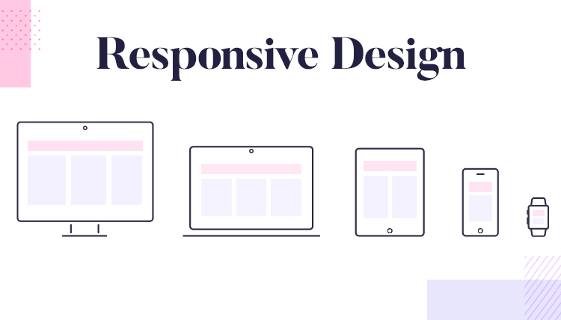
What this means is having a consistent user experience regardless of what you’re using to view it. Whether you’re firing up a website on your iPhone or your laptop, you should be able to access the content you want, suited to your needs in that moment.
It’s UX designers who have to deal with these constraints so that they’re able to design appropriately – neglecting this can really hinder the user experience of your website or mobile app.
Imagine using your phone to browse your favorite website only for elements to be scattered all over the screen, calls to action in the wrong place or typography that’s way too big. Not fun, right? Responsive design is the solution to these common problems.
Looking for a full guide to responsive design? Try our Introduction to Responsive.
In brief, responsive design means that your web page should look good, be easy to use and work on any device at any resolution.

Responsive design: 5 best practices
Getting down to brass tacks, when designing your responsive website there are a few important aspects to always be aware of. Here are our five best practices for responsive web design.

1. Responsive vs fluid layouts
Both responsive design and fluid design tend to be used interchangeably when talking about mobile-first design, but the truth is, they aren’t the same. As we mentioned above, responsive design uses fixed units of pixels to define the breakpoints at which the content of the UI adapts to scale upwards or downwards. Fluid design, on the other hand, uses percentages to automatically resize the content based on the screen you’re viewing it with.
You might think fluid design sounds handy, however, you should err on the side of caution with it. This is because fluid designs can look strange depending on the size of the browser or the device. For example, if the screen is too small, the content may become cluttered or difficult to read. If the screen is too large, certain elements may start to look stretched or distorted.
Justinmind's website prototyping tool is perfect for creating responsive websites. You can even create screens for multiple devices in the same prototype!
For a design that adapts with the best user experience possible, or if you’re designing for multiple different screens, we recommend you choose responsive design over fluid design. You’ll want to take the responsiveness into account right from the beginning, even when you’re just creating the website wireframe of the product.

2. Use at least three breakpoints
Breakpoints are points in the CSS of a website which alter how content appears on different screen resolutions. These are normally designed using min-width and max-width values in responsive design, which refer to the minimum or maximum width of pixels across a screen or for elements.
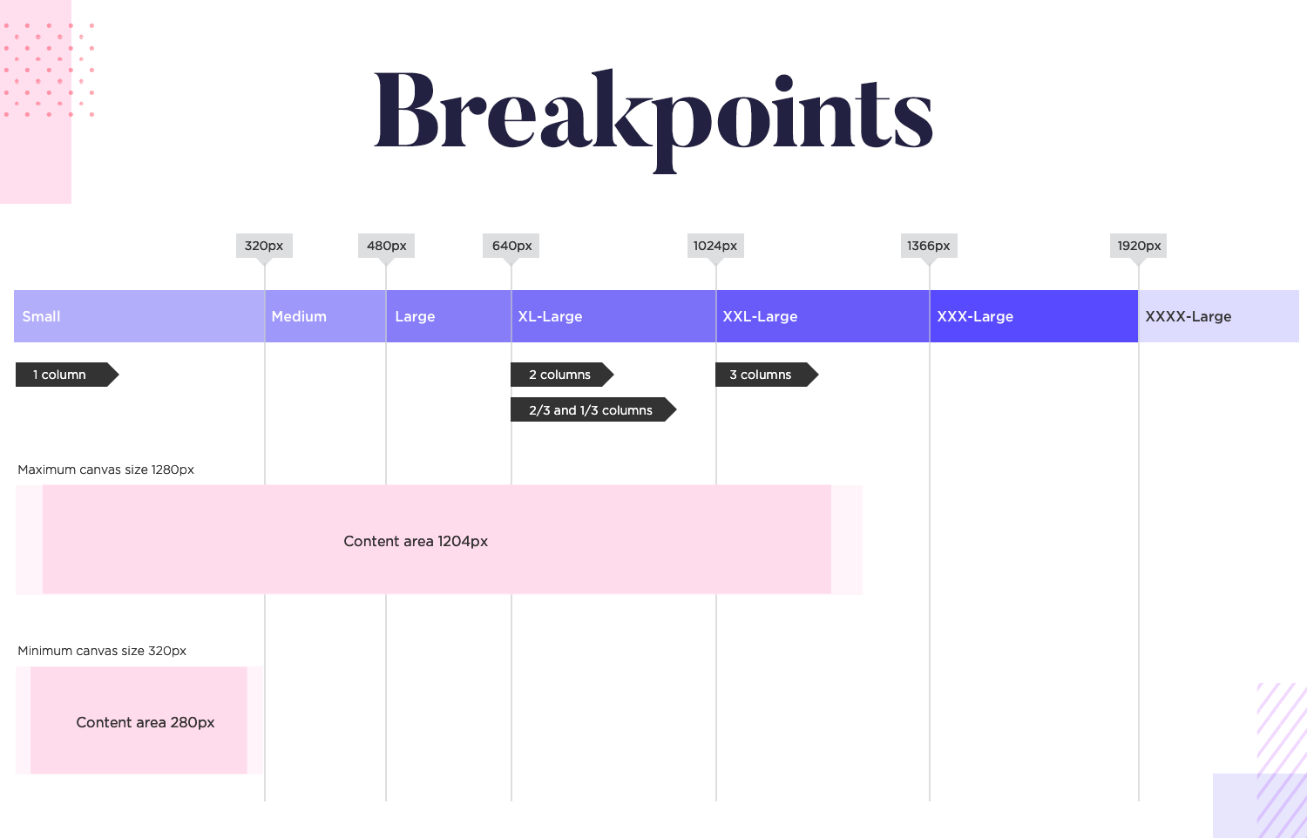
Nick Babich outlines that most responsive websites will need at least three or four breakpoints to work properly. Take any responsively designed website and resize it in your browser. You’ll see that depending on the size you scale it to, the content will adjust accordingly.
The breakpoints are usually broken down for mobile devices, tablets and desktop views, although you can have more so that you’re covering all bases for greater device flexibility.

3. Start with min-width breakpoints
As we mentioned above, there will be a min-width and a max-width for each breakpoint that you use in your responsive web design. When designing using the mobile-first approach, which is recommended, a good rule of thumb can be to start designing from each min-width of your three breakpoints.
This way, you’re designing the screens for your smaller devices and adding more content and UI elements as the screens get larger. Remember: it’s always easier to scale upwards rather than downwards.

4. Prioritize content
Responsive design revolves around content. Assuming you’re adopting the recommended mobile-first approach, that means you should prioritize important content for mobile and add more content as the screen size increases.
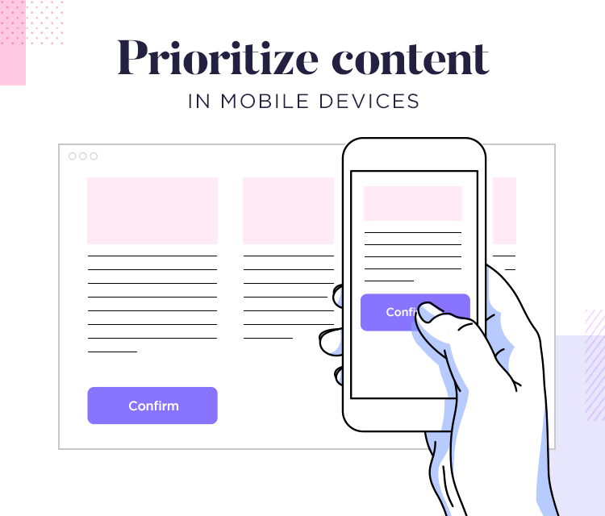
According to Interaction Design Foundation, mobile users tend to prefer shorter, simpler interactions. This means they’ll be looking for more specific content. Hiding content and revealing when necessary can help solidify that seamless user experience. Sometimes, though, you must just have certain content on a website so using collapsible and expandable menus can work in your favor here.

5. Take buttons seriously
Button design is paramount when it comes to responsive design. A button might be easy to click on a desktop, especially with the help of a mouse. But what about a tablet? Or a mobile phone? The finger doesn’t have the sharp precision of a mouse.
Links and other clickable areas come under this umbrella, too. If the click area is too small you may end up frustrating your users. The average finger tap is 44×44 pixels, according to Apple’s Human Interface Guidelines. For better usability, accommodate users by making sure your buttons and clickable areas are well adjusted for this average.

30 responsive website examples
Check out post on wireframe examples for more design inspiration!

1. An Event Apart
An Event Apart, the interaction design conference, creates a seamless transition from their main website to their mobile site.
They have opted to maintain much of the same layout across most platforms, with the tablet version being the same as the desktop – and it works. This is because they chose to display the content in a bold font against a white background for clarity and when resized, the information can be easily scrolled through.
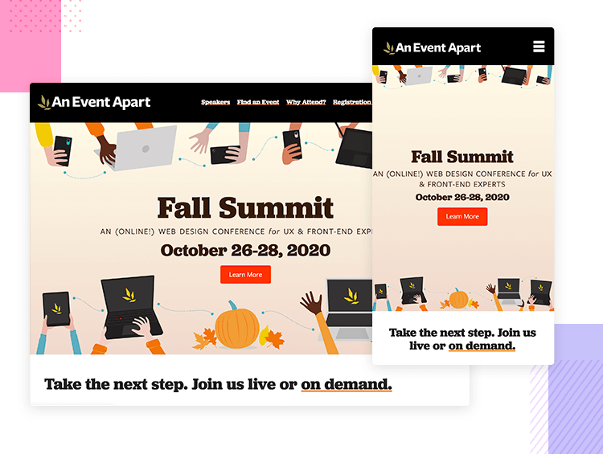
The only real change is that for the mobile version, the breadcrumbs at the top are collapsed with a hamburger menu which is clearly indicated with the word “menu”.

2. New York City Ballet
New York City Ballet makes use of video on all its platforms which gives users a taste of what to expect from going to one of their shows.
The tablet and desktop website share many similarities which help create a consistent user experience across all of their websites and the mobile experience isn’t hindered either.
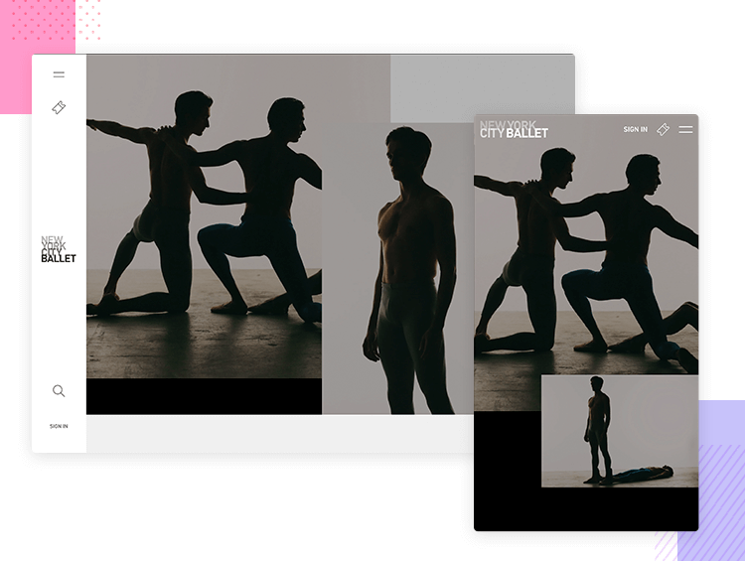
The navigation bar stays the same throughout but the show information is removed for the mobile experience, maintaining only the call to action.

3. Paper Tiger
Paper Tiger is a design agency based in New Jersey and its website goes to show how when the type of images and typography used is considered in respect to space, the same style can be maintained.
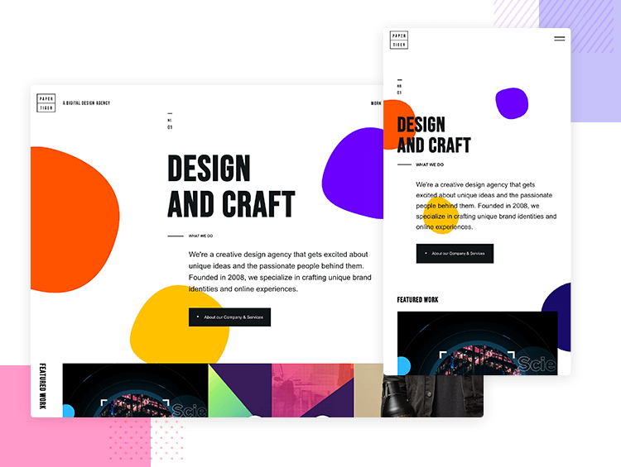
What you get with this website is clean, adaptable typography with optimal use of line spacing along with bold visuals and dynamic animations that can be seen across all platforms, creating a fun and whimsical experience no matter the device you’re using.

4. Wired
Wired prioritizes content on all platforms, ensuring that users get to the information and articles they want quickly.
A good example of this would be if we compare the mobile version with the desktop and tablet. The former is drastically simplified so as not to dazzle the user and takes advantage of the constrained space to present the “Top Stories” before anything else.
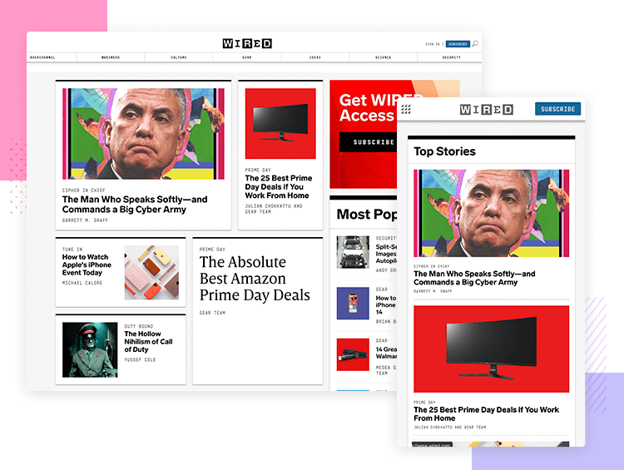
In general, the smooth navigation and easy to find social buttons make sharing articles by Wired a breeze.

Start designing responsive web apps today. Unlimited projects!
Download Free
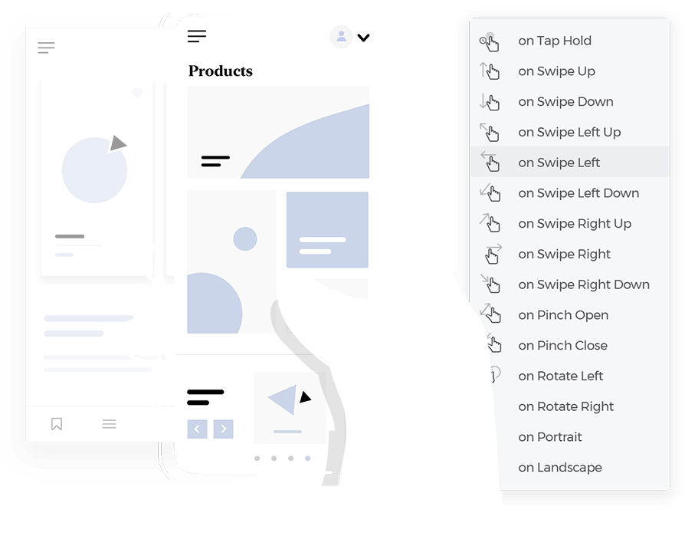

5. Victoria & Albert Museum
The V&A museum of art and design combines eye-grabbing imagery, typography and color schemes which not only complement each other, but also work well across different platforms.
It whips out the infamous hamburger menu on its mobile device.
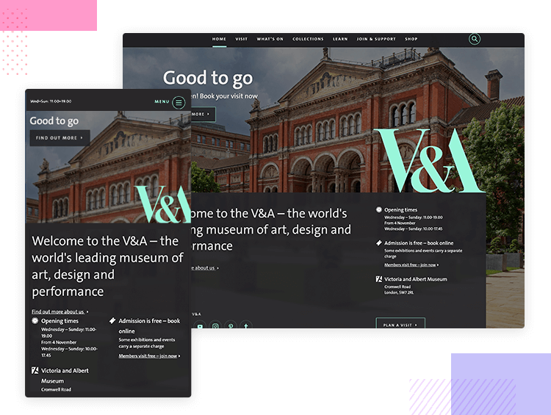
To counter the menu’s infamy, V&A have opted to couple it with clear copy, letting users know where they can find the navigation options.
The mobile version also prioritizes vital information, namely the opening hours and this can be seen with a point size.

6. Popular Science
Popular Science gives you a great user experience no matter which device you’re using.
Content takes center stage, as you’d expect, and with responsive imagery and clean typography, Popular Science successfully creates a responsive website that’s easy to read and use.
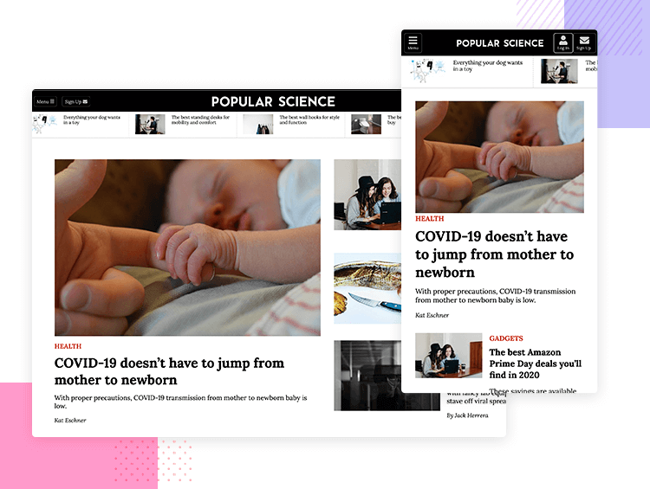
The information on this website is presented in such a way that all of its content can be easily scaled down across a broad range of devices.

7. Swiss Air
The airline Swiss Air maintains its bold call to actions on all platforms, so users can get their hands on the best flights and deals regardless of the device.
The mobile and tablet version of the website resize appropriately to the size and resolution of the screen without losing any important content and is very usable, easy to navigate and practical.
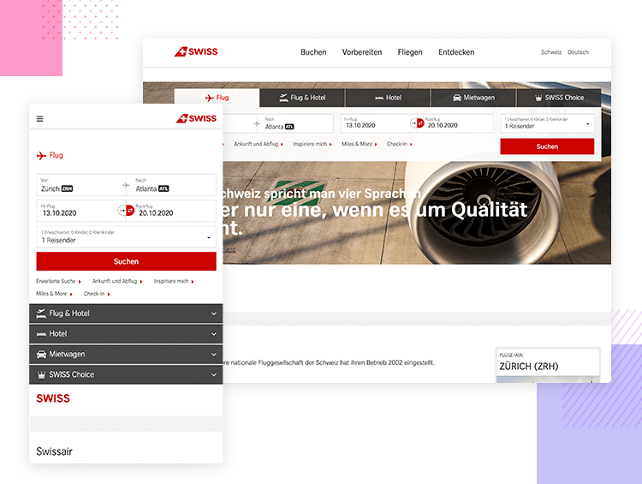
Changing the grid on the main website and tablet version to rows on the mobile version was also a sensible choice.

8. Spigot Design
Spigot Design offers web design and development with a fully-personalized service. Its website boasts a captivating hero video with an on-trend semi-transparent color layer over the top. It works perfectly, irrespective of which device you happen to be viewing it on.
Furthermore it’s a website that brings the user a simple and intuitive experience which is not sacrificed on smaller platforms with vertical scrolling panels.
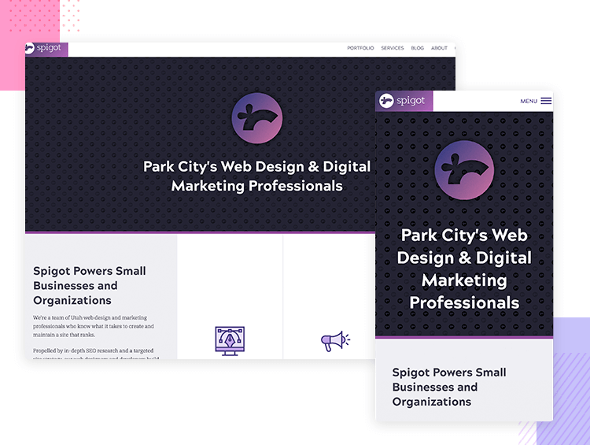
Consideration has also gone into the use of easily visible buttons on smaller devices; the two CTAs buttons are still the first things the user sees, and the hamburger menu button conveniently moves down to the bottom horizontal row so that it can be easily tapped with a thumb.

9. MGSM
Fashion brand MGSM specializes in the latest trends in its market but it’s also on top of its game in terms of web design.
They make great use of the background hero photo, something that’s generally make or break. It’s high definition, bold and loud, like the fashion it’s trying to convey and works perfectly when scaled down to a smaller resolution.
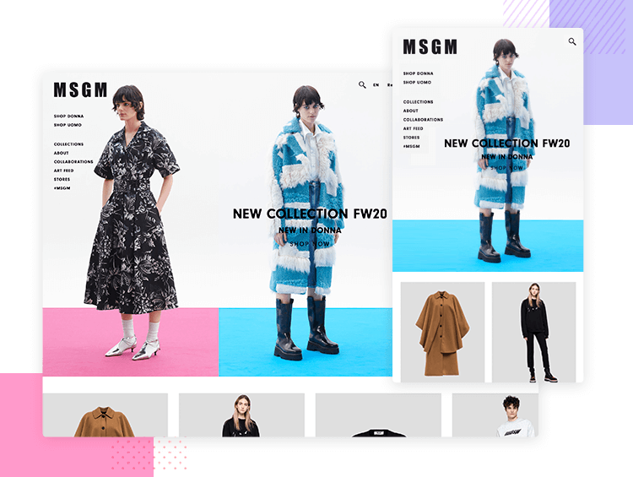
Content wise, the most important thing for its users to see are obviously the product ranges, which are still viewable on smaller platforms where the menu options have been collapsed – a smart move to avoid overloading the user.

Start designing responsive web apps today. Unlimited projects!
Download Free

10. Design Made in Germany
German design website DMIG 5 boasts striking sketch imagery with a color scheme that contrasts perfectly along with an aesthetically appealing Sans Serif typeface.
This imagery and typography both gel into a perfectly synchronous parallax scrolling experience for the user and manages to maintain this effect when scaled down to smaller versions.
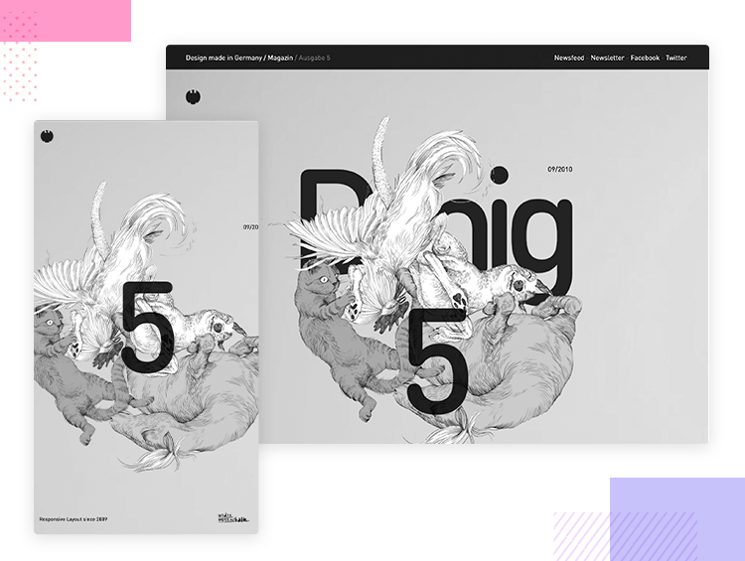
The website title is interestingly reduced from “DMIG 5” to just “5” when resized or viewed on a mobile device meaning that the designers really thought about the amount of detail in smaller resolutions and how that would impact the user experience.

11. More Hazards More Heroes
This folk duo from Nashville have chosen the best design possible for their responsive website.
Eye-catching typography coupled with a high content prioritization approach means that the user gets a lot out of what is essentially a very simple site.
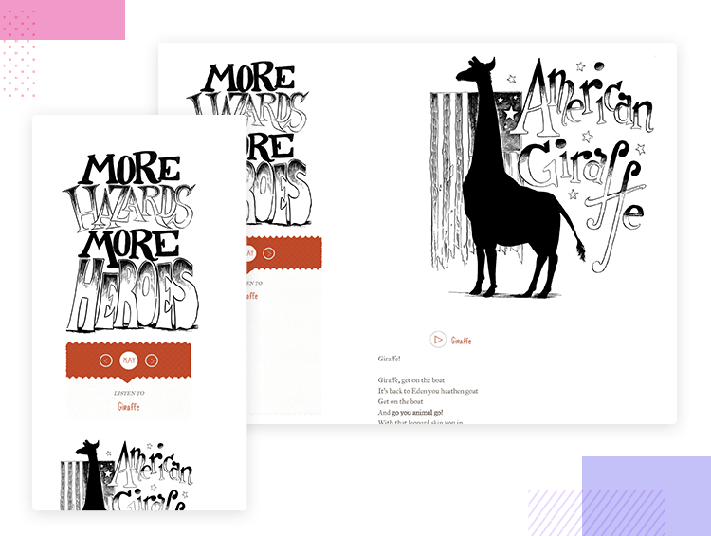
In the scaled-down version of this website, only the most important content becomes visible, such as the ability to immediately begin streaming the band’s music, the CTA to download their album, followed by a short bio.

12. Smashing Magazine
Design website Smashing Magazine screams out loudly in red – it’s a minestrone of fun, clickable elements and content.
The richness of content, however, doesn’t stop the user from getting a clear view of everything and the site is easy to navigate, even when its size is reduced.
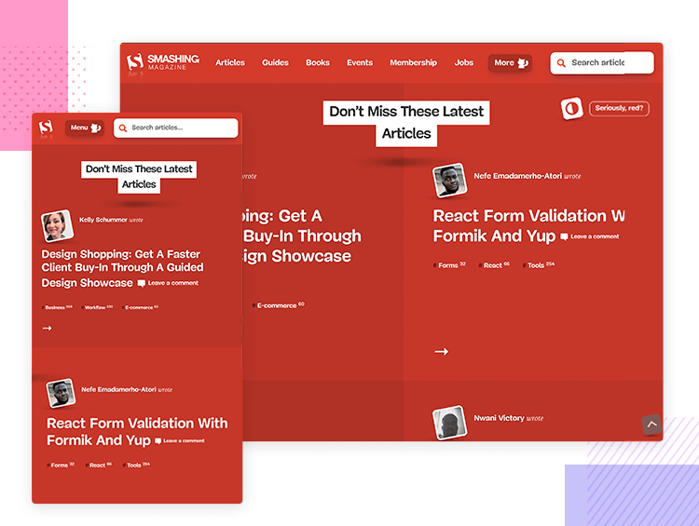
This is achieved through adequate use of spacing and typography; the typeface size and position of the content was clearly developed with an awareness of the page size.
The “Topics” button changes to a “Menu” button as a solution to condensing the breadcrumb elements and kills two birds by leading into the “Topics” section.

13. Flow Festival
When you visit the website of a music festival, the first thing you want to see is the line-up. Who’s playing?
Flow Festival, which takes place in Finland, has a website which does exactly that, combining a minimalist design with large text against a white background and large photos to advertise exactly what matters to the user – the artists.
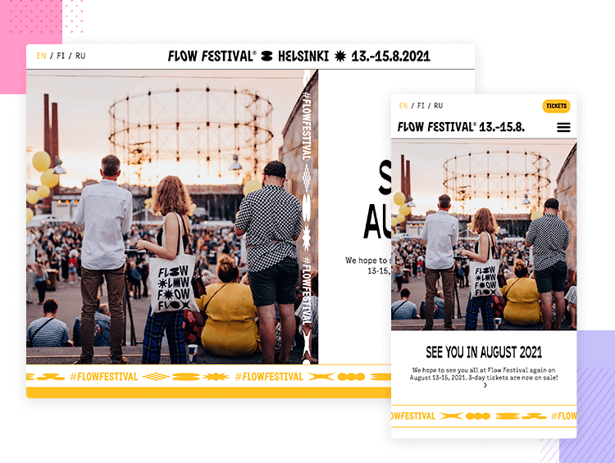
The sections of the site are divided using a visually pleasing dynamic moving text, bringing back the kitsch Marquee design of the 90s. On the small-screen version, this is taken down a notch so as not to overcrowd the screen.

14. Magic Leap One
Magic Leap One is all about creating augmented and virtual reality for its users and the website is all about showing that off. And it does it remarkably well with a unique, highly interactive experience that is maintained across all platforms.
The user is treated to a rich and detailed graphical display when scrolling up and down through the website, with a design technique that feels similar to parallax scrolling but with an extra dimension.
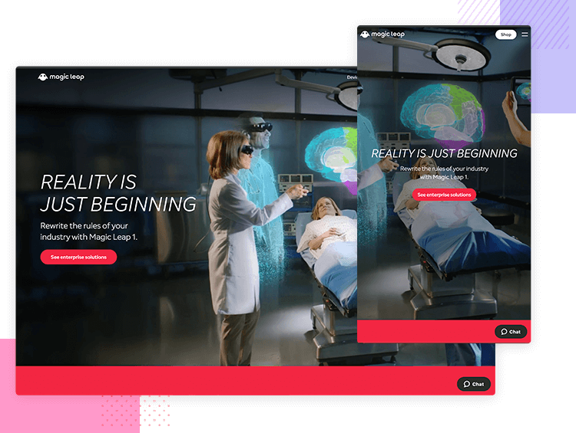
Aside from impressive graphics, the website’s design also takes into account the smaller but equally important details, such as the “scroll down” text which exists on the larger desktop resolution to guide the user, but is omitted from the mobile screen where scrolling would come more naturally.

15. Dropbox
Dropbox has done an excellent job of tailoring down its website to suit smaller devices. The desktop version boasts a sleek aesthetic with grid and image colors that complement each other.
What’s more is that the first image rotates on the the mobile version to fit the tighter space. On top of this, some of the grid colors also change for the mobile version, prompting a change of font color so that the page remains readable.
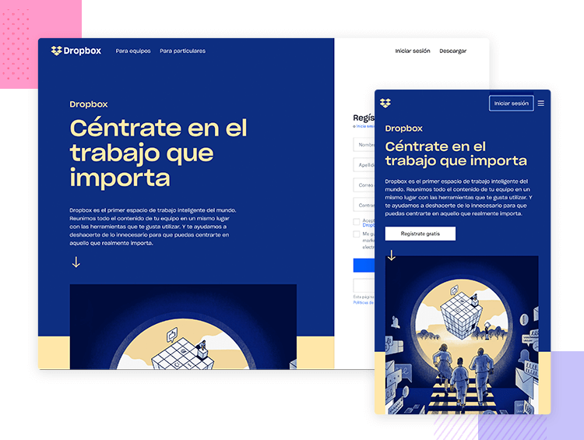
A further solution to the lack of space on the mobile version is that instead of having the signup form pop up on the right side of the screen, it is instead hidden behind a CTA.

16. GitHub
GitHub demonstrates what’s important to show the user when it comes to business and conversion goals. For example, when you land on their desktop and tablet versions, among the first things you notice is a description of what GitHub offers.
Beside the description is a form where the user can sign up to GitHub, even though there is another signup call to action on the menu bar. This provides the user ample opportunity to complete the action if they are slightly more distracted with the extra content and elements on display on larger resolutions.
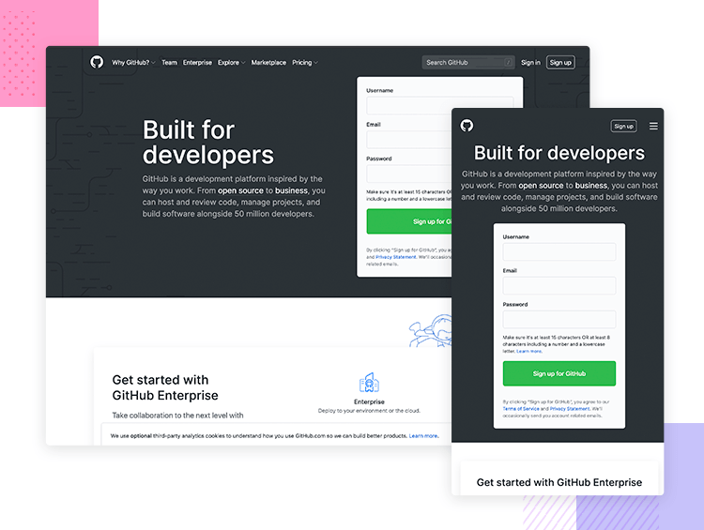
However, when scaled down to the mobile resolution, the signup form is removed. More than likely because the signup button is more visible on the top bar, where it sits next to a hamburger menu icon which wraps up all the different menu options to make the UI more compact and neat.

17. Shopify
On the Shopify menu bar, we can see two groups of options. They group the main menu options to the left which revolve around the fundamental operation and navigation of Shopify. To the right is another group that has less to do with navigation and functionality within the site, such as logging in, signing up and learning about pricing and a CTA for starting a free trial.
However, at the tablet and mobile resolutions, we see that these options are stowed away under a hamburger menu icon to declutter the screen. What’s interesting is the fact they still managed to highlight that the menu options form two distinct cognitive groups by separating them with a dividing line.
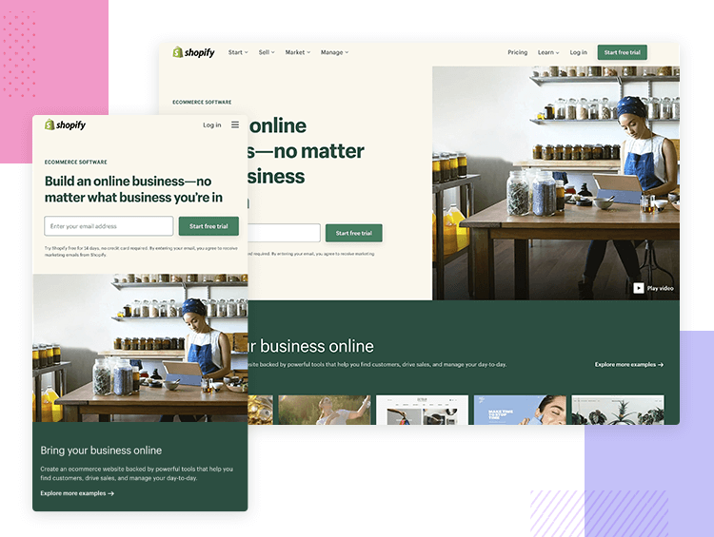
Interestingly enough, they also include a third group which comprises the navigation options at the footer, in case users are less likely to scroll down to see them on a mobile device.

18. Dribbble
Design community, Dribbble hides its menu options behind a hamburger menu on the left. There seems to be a lot of divided opinion in the design community about the side of the screen where the hamburger menu should go. According to Android Material design, hamburgers should go on the left, while many designers argue it should go on the right because it suits the thumb zone of the majority of users who are right-handed.
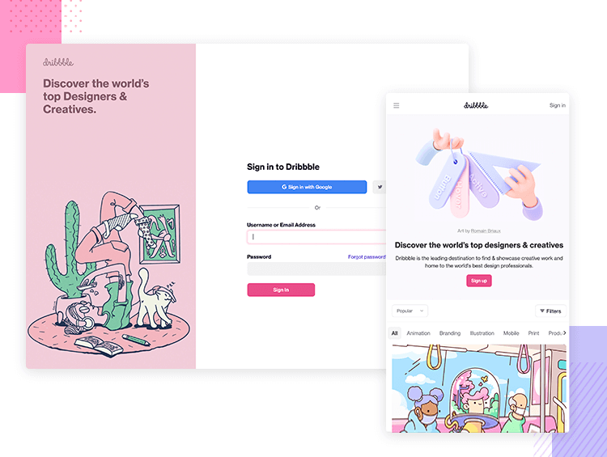
However, the hamburger being fixed to the left of the screen does make sense, in Dribbble’s case. Consider that most users, when they land on Dribbble, tend to search for specific design categories. It now makes a lot of sense to reserve the right hand side for the filter bar!
We also think that dribbble is a great example of transitioning from multiple columns down to just one for the mobile versions.

19. Slack
Slack also groups its menu options into a hamburger menu for the tablet and mobile versions of its website. And what we see is also a reduction of the number of CTAs to “Try for Free”. Instead of two CTAs above the fold, in the mobile and tablet views these are replaced by one large button that nearly takes up the full width of the screen.
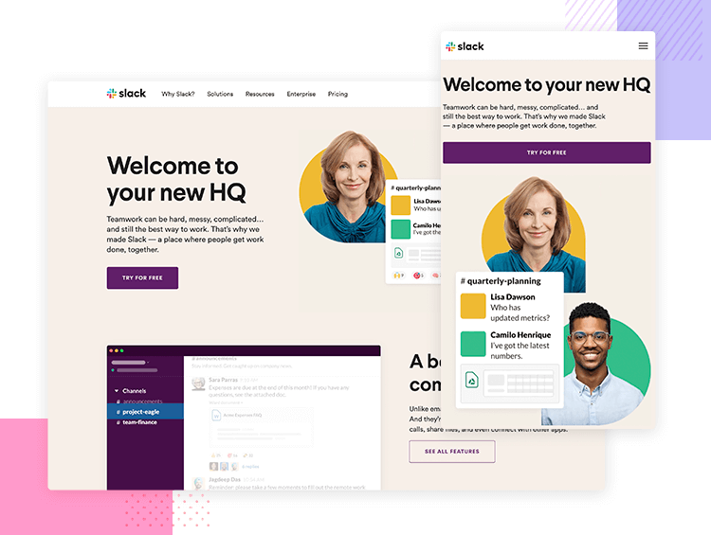
Their webpage content is compressed into one column on mobile, with text paragraphs following images and even the line of company logos that use their services gets compressed to form three lines.

20. CSS Tricks
What we find interesting about CSS Tricks is that, for their popular monthly content, they use a carousel for both the desktop and responsive versions of their website.
Oddly enough, on the mobile version, this carousel actually provides a more comfortable experience. On the desktop you’re required to use a scrollbar to swipe the content, something which most UX-UI designers are trying to avoid today.
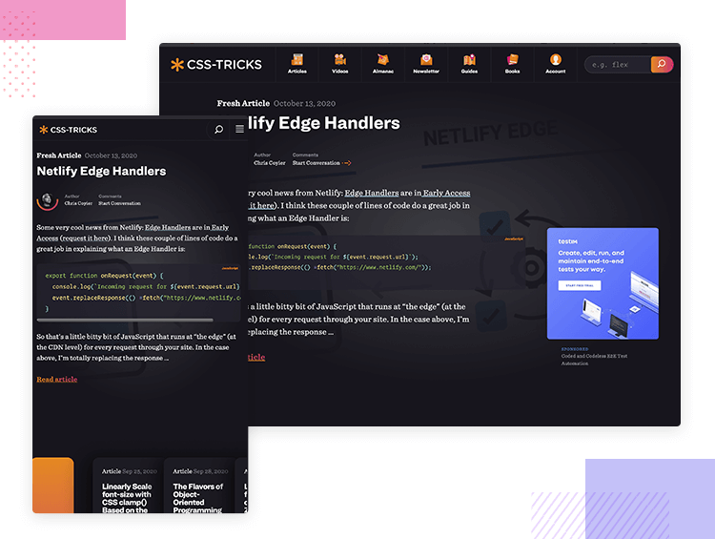
In this case, there could be better options out there than the carousel to display the postcards. On top of an awkward UX when it comes to web users, carousels have been known to cause problems ranking in Google’s SERPs.
However, the fact that they chose not to display ads at all in the mobile version is a nice touch. After all, the content that is necessary on the mobile version takes up most of the screen real estate.

21. Deux Huit Huit
Normally, having moving elements on the mobile versions of a website tends to be less frequent and static elements often prevail. This makes sense given there is much less screen real estate to play around with, and moving elements on a smaller screen can be too distracting and jarring.
However, Web design agency, Deux Huit Huit, are a great example of how you can still retain subtle movement in scaled-down versions of your website while providing the same user experience.
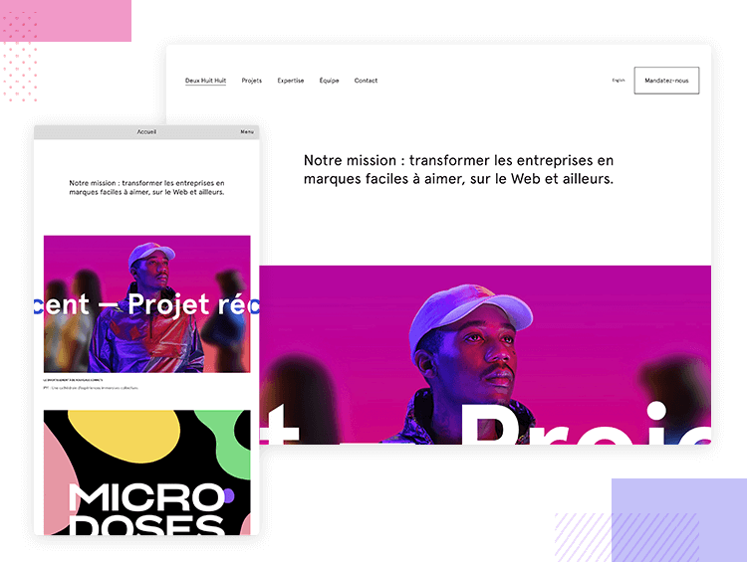
The text on the hero image still moves and their GIFs are still GIFs. However, when scaled down, they hide their menu options literally behind the word “Menu” which functions as a button. Including tappable text in mobile versions can be a bit counterintuitive to mobile users, but still, we appreciate the initiative.
Another aspect we’re not keen on is that, on the mobile version, they chose to banish the “Hire Us” CTA in the menu as a mere option near the bottom which doesn’t do it any justice. This example shows that it’s important to take content hierarchy and business goals into account when designing your responsive website.

22. Rally Interactive
Rally Interactive is an example of a responsive website that attempts to provide the user with the ultimate seamless experience between the mobile and desktop versions of their website. The hamburger menu is the exact same on the desktop version as it is on mobile. The images are the same and pretty much all of the content – including the back to top button – is the same. The only thing that changes on the mobile version is that the two-column text shifts to one column.
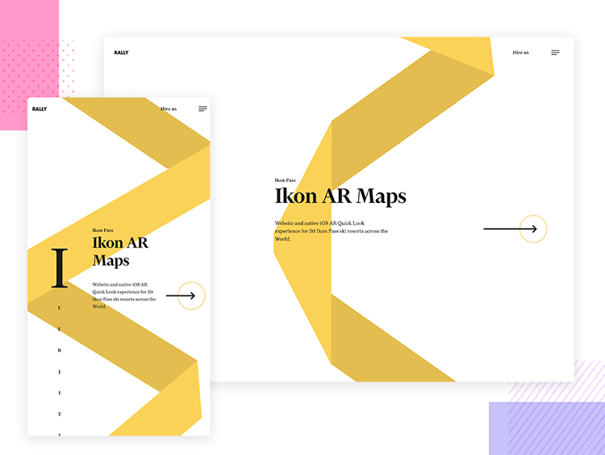
Could a desktop user have the same experience on a mobile device? The answer is yes. Is having exactly the same experience a good thing? The jury is out on that one. Hiding the menu options behind a hamburger on the desktop version doesn’t always make sense, depending on your website’s business and usability goals. Many UXers maintain that the extra screen real estate should be used to display these options, which leads to improved discoverability.

23. VML Digital Marketing and Advertising Agency
VML Digital Marketing and Advertising Agency’s responsive website goes from a three-column layout to a single column once it gets scaled down to smaller resolutions. However, most of the content stays the same. Even the hamburger menu remains the same as the desktop version, like in the example above with Rally Interactive.
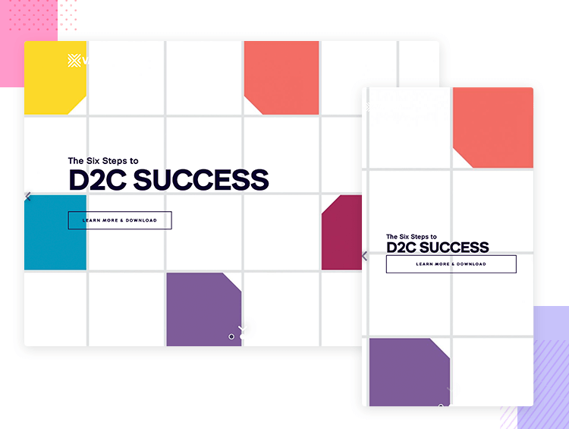
However, while everything works well in the mobile version, we would consider an overhaul of the button design in the mobile version. Even though everything scales down nicely, the button design is a little too minimal and doesn’t look clickable. On the desktop version, there is a highlight transition effect when the mouse hovers over them. On the mobile version, however, the effect is not seen until the user taps.

24. Forefathers Group
Forefathers Group is a design studio that obviously puts a lot of thought and effort into the desktop design of their website. The first thing the user is greeted with when they land on the desktop version is a silent hero video of some puppet designers hashing out their daily lives in the studio.
However, all this is lost when the website is scaled down to mobile resolutions, with the hero video being replaced instead by the logo, which doesn’t quite do justice to the hard work that they put into their puppetry. Although it’s hard to capture the delight of a puppet’s movements in a static image, we can’t help but think that even that might have been a more visually appealing solution.
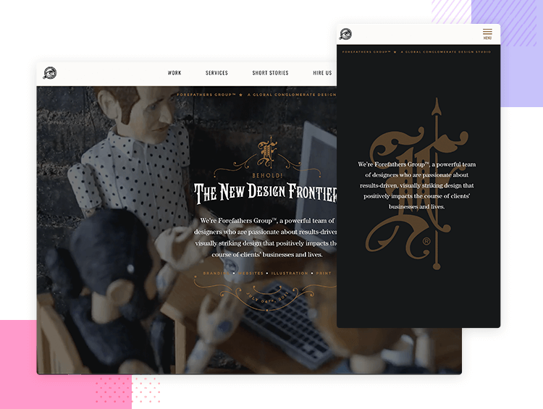
Having said that, their scaled-down design is clean and works from a functional point of view, making it a great responsive website example. The only problem with functionality is that the social buttons completely disappear on the phone and tablet versions of their website. A bold move that has us on the fence.

25. Naomi Atkinson
Often parallax scrolling tends to be the reserve of web design, mainly because it’s very difficult to get right on mobile. This is often due to lack of screen real estate; having too many moving layers in the UI can distract or confuse the user and render the navigation unclear. As a result, many websites normally become static once scaled down to their mobile versions.
However, Naomi Atkinson’s website is a great example of how to make parallax scrolling work on mobile devices. When scaled down to cell phone resolution, the parallax scrolling that shows off their projects provides exactly the same pleasant experience as the web version. The buttons move in unison with the content as the user scrolls the page, so they are easy to click on.
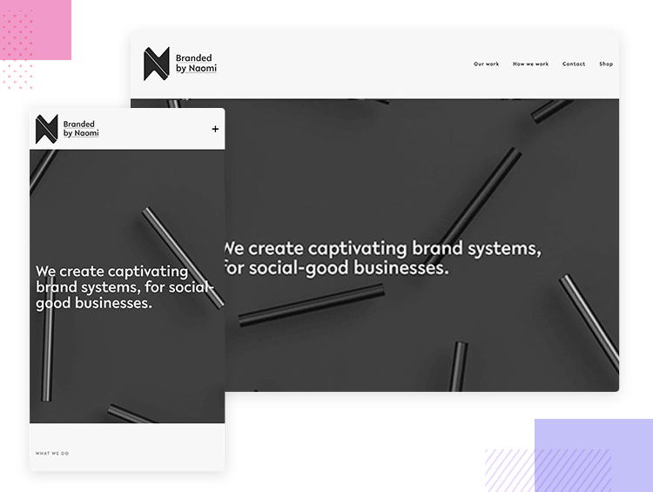
However, if we had one gripe about this responsive website example, it would be the use of the + icon to store menu options instead of a hamburger menu. Generally, using icons that agree with most users’ mental models takes preference over style. That’s not to say you can’t innovate on the design of a hamburger icon. Nonetheless, using a + icon to open a menu is a no-go for us when that icon is used for so many other actions, such as increasing volume, brightness, or contrast or adding items to lists.

26. 1987 Masters
1987 Masters is an event production company based in Los Angeles. Even though their domain name features “1987” (1,987 masters or the year 1987?) their website seems to draw on a style more akin to 70s design, with a trippy scope that follows the cursor around the screen. This cursor is somewhat distracting and slightly nauseating at the best of times.
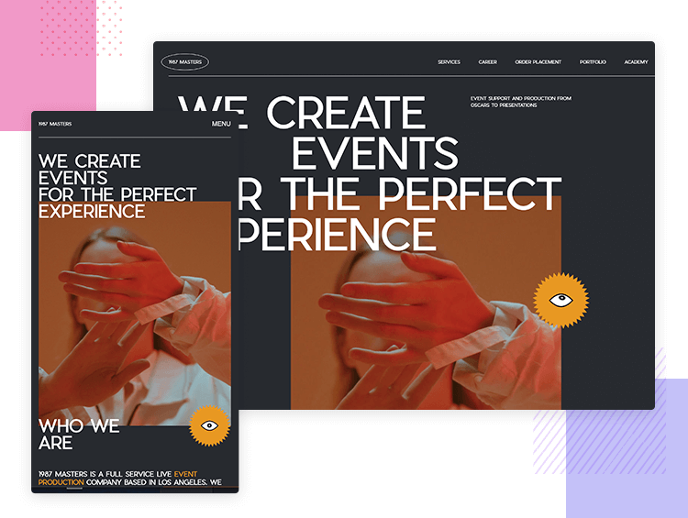
However, this disappears completely in the mobile version, images and text are shifted into a single column and the oversized bold print becomes bite-sized. Even though the overall design of the website is subjective, there’s no arguing that it is fully responsive and provides a great experience to mobile users.

27. BeDance School
BeDance School is a responsive website template from Muffin Group. It’s colorful, it’s eye-catching, and ticks most of the boxes when it comes to a captivating UI design. And it’s mostly responsive too: each element, image and text paragraph scales down nicely according to its place within the predetermined content hierarchy.
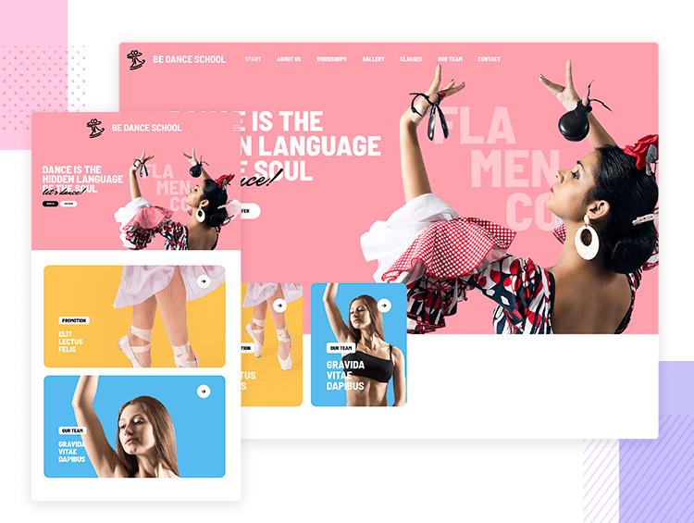
However, one thing that is amiss is that the call to action buttons for “About Us” and “Our Offer’ don’t resize adequately when scaled down to cell phone and tablet view. Remember, the average fingertip span measures about 44×44 pixels! But it’s not just that these buttons are difficult to click on the mobile version, but the CTAs are also near-impossible to read!

28. Starbucks
Starbucks is a great responsive website example – simple, eye-catching responsive design done right. There’s no fancy parallax, but it gets the job done equally well with static but colorful imagery of their seasonal product line. One dilemma they might have had though is that their product “menu”, which also happens to be a menu option, is bundled up into a hamburger menu when the design is scaled down.
Why might this be a problem? You guessed it! Because many users don’t expect to see an option for “Menu” when they open up the hamburger menu. However, Starbucks obviously knew their users well enough to realize that they would “get it” that in this case, they are obviously talking about its product menu and not the website menu!
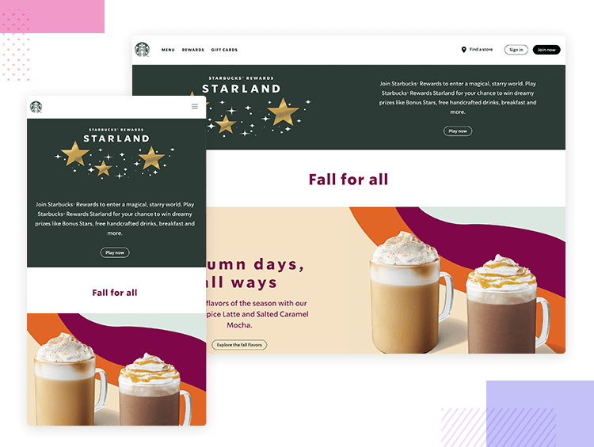
Another noteworthy aspect is their approach to content hierarchy when scaling down their content for smaller resolutions. For example, a paragraph describing their Rewards Visa Card appears to the left of an image of the card on the desktop version. Normally, when two columns are scaled-down, the content on the right tends to go below that on the left. However, in this case, the image shifts position to above the description. This setup lets them show off the card before the text.

29. Paravel
You’ll be blown away by this one. Trent Walton, a jack-of-two-trades designer, and programmer actually created a website whose layout barely changes at all. The only differences seen are multiple to single column shifts on the info and search pages.
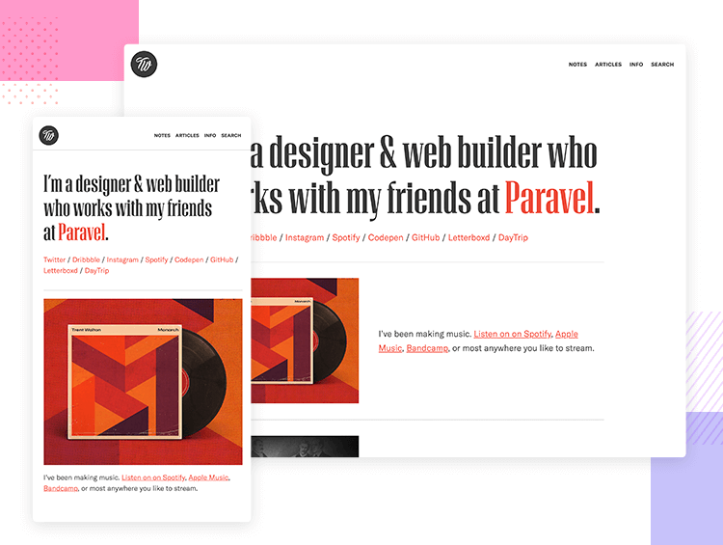
And even those changes are merely about shifting text columns below images. Many designers wish their design projects were that easy! However, if the content and the design approach allow, like in this case, then providing a cloned experience on mobile and tablet versions might well be the easiest and most cost-effective solution. The most important thing is that your responsive design provides the same great UX across all devices.

30. The Scott Resort
Hotels often have fancy, regal or prestigious UI designs in an attempt to convince users of the luxuries that await if they make a reservation. The Scott Resort creates a seamless experience that sees everything, once scaled-down, work the same way as when it is viewed on the desktop version.
One impressive aspect of this responsive website example is that it shows how even the most intricate design patterns, when paired with attention to detail can work when designing for mobile-first. For example, the header text the user sees (Find yourself here) and the CTA button to watch the video overlap the hero video, and the button is transparent.
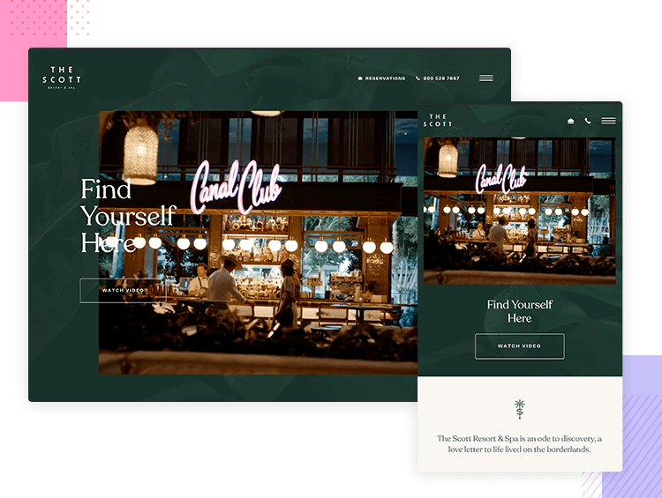
When scaled down to smaller resolutions, the text and button maintain the same style but shift below the video, showing that the designers took priority when it comes to space and usability. However, the button design should ideally look more clickable.

The wrap up - responsive website examples
Responsive design is a really versatile approach to designing. There are plenty of ways to display content and part of the fun of UX design is figuring out how to deliver that content in a way that doesn’t discriminate depending on the device it’s displayed on. At first, you may feel trapped by the constraints but responsive design is about making magic within those constraints.
https://www.justinmind.com/blog/examples-responsive-website-design/

Fundamentos de web design responsivo
Como criar sites que atendam às necessidades e recursos do dispositivo em que são exibidos.
— Atualizado
- Defina a viewport (janela de visualização)
- Reimensione o conteúdo para a viewport
- Use media queries (consultas de mídia) CSS para responsividade
- Como escolher breakpoints (pontos de interrupção)
- Visualize breakpoints de media queries no Chrome DevTools
O uso de dispositivos móveis para navegar na web continua a crescer num ritmo astronômico. Mas esses dispositivos costumam ser limitados pelo tamanho da tela e exigem uma abordagem diferente de como o conteúdo é organizado na tela.
O web design responsivo, definido originalmente por Ethan Marcotte em A List Apart, atende às necessidades dos usuários e dos dispositivos que eles estão usando. O layout muda com base no tamanho e nas capacidades do dispositivo. Por exemplo, num telefone, os usuários veriam o conteúdo mostrado numa coluna única; um tablet já poderia mostrar o mesmo conteúdo em duas colunas.
Existe uma infinidade de tamanhos de tela diferentes em celulares, "phablets", tablets, desktops, consoles de jogos, TVs e até mesmo wearables. Os tamanhos de tela estão sempre mudando, por isso é importante que seu site possa se adaptar a qualquer tamanho de tela, hoje ou no futuro. Além disso, os dispositivos possuem recursos diferentes com os quais interagimos com eles. Por exemplo, alguns de seus visitantes usarão uma tela sensível ao toque. O design responsivo moderno considera todas essas coisas para otimizar a experiência para todos.

Defina a viewport #
As páginas otimizadas para uma variedade de dispositivos devem incluir uma meta tag viewport no cabeçalho do documento. Uma meta tag viewport fornece ao navegador instruções sobre como controlar as dimensões e o redimensionamento da página.
Para proporcionar a melhor experiência, os navegadores móveis renderizam a página numa largura de tela de desktop (geralmente cerca de 980px , embora isso varie entre dispositivos) e, em seguida, tentam fazer o conteúdo parecer melhor aumentando os tamanhos das fontes e redimensionando o conteúdo para caber no tela. Isto significa que os tamanhos das fontes podem parecer inconsistentes para os usuários, que podem ter que dar um duplo-toque ou beliscar para aplicar zoom com a finalidade de ver e interagir com o conteúdo.
<!DOCTYPE html>
<html lang="en">
<head>
…
<meta name="viewport" content="width=device-width, initial-scale=1">
…
</head>
…
Usando o valor meta viewport de width=device-width instrui a página a corresponder à largura da tela em pixels independentes de dispositivo. Um pixel independente de dispositivo (ou de densidade) é uma representação de um único pixel, que na realizada pode consistir de muitos pixels físicos, numa tela de alta densidade. Isto permite que a página readapte o conteúdo para corresponder a diferentes tamanhos de tela, seja ele renderizado num pequeno telefone celular ou num grande monitor de área de trabalho.
Veja este exemplo no Glitch.Veja este exemplo no Glitch.
Alguns navegadores mantêm a largura da página constante ao girar para o modo paisagem e fazem zoom em vez de refluir o conteúdo para preencher a tela. Adicionar o valor initial-scale=1 instrui os navegadores a estabelecer uma relação 1:1 entre pixels CSS e pixels independentes de dispositivo, independentemente da orientação do dispositivo, e permite que a página aproveite a largura total do modo paisagem.
Cuidado
Para garantir que os navegadores mais antigos possam analisar corretamente os atributos, use uma vírgula para separar os atributos.
A auditoria do Lighthouse Não tem uma tag <meta name="viewport"> com width ou initial-scale pode ajudá-lo a automatizar o processo de certificar-se de que seus documentos HTML estão usando a meta tag viewport corretamente.

Garanta uma viewport acessível #
Além de definir uma initial-scale, você também pode definir os seguintes atributos na viewport:
- minimum-scale
- maximum-scale
- user-scalable
Quando estabelecidos, eles podem desativar a capacidade do usuário de ampliar a viewport, trazendo causar problemas de acessibilidade. Portanto, não recomendamos o uso desses atributos.

Reimensione o conteúdo para a viewport #
Tanto em desktops quanto em dispositivos móveis, os usuários estão acostumados a rolar os sites verticalmente, mas não horizontalmente; forçar o usuário a rolar horizontalmente ou diminuir o zoom para ver a página inteira resulta numa experiência do usuário ruim.
Ao desenvolver um site para celular com uma meta tag viewport (que define as dimensões da janela de visualização), é fácil criar acidentalmente conteúdo de página que não cabe na janela de visualização especificada. Por exemplo, uma imagem exibida com uma largura maior do que a viewport pode fazer com que a janela de visualização role horizontalmente. Você deve ajustar esse conteúdo para caber na largura da janela de visualização, de modo que o usuário não precise rolar horizontalmente.
A auditoria do Lighthouse O conteúdo não está dimensionado corretamente para a viewport pode ajudá-lo a automatizar o processo de detecção de conteúdo que extrapola a janela de visualização.

Imagens #
Uma imagem tem dimensões fixas e se for maior do que a janela de visualização ela irá forçar o aparecimento de uma barra de rolagem. Uma maneira comum de lidar com esse problema é dar a todas as imagens uma max-width de 100%. Isto fará com que a imagem encolha para caber no espaço que tem, caso o tamanho da janela de visualização seja menor do que a imagem. No entanto, como a max-width, em vez da width é de 100%, a imagem não se estenderá além de seu tamanho natural. Geralmente é seguro adicionar o seguinte à sua folha de estilo para que você nunca tenha problemas com imagens forçando o aparecimento de uma barra de rolagem.
img {
max-width: 100%;
display: block;
}

Adicione as dimensões da imagem ao elemento img #
Ao usar max-width: 100% você está redefinindo as dimensões naturais da imagem, no entanto, você ainda deve usar os atributos width e height na sua tag <img> pois os navegadores modernos usarão essas informações para reservar espaço para a imagem antes de carregá-la, o que evitará deslocamentos no layout à medida em que o conteúdo é carregado.

Layout #
Como as dimensões e largura da tela em pixels CSS variam amplamente entre dispositivos (por exemplo, entre celulares e tablets, e até mesmo entre celulares diferentes), o conteúdo não deve depender de uma largura de viewport específica para renderizar bem.
No passado, isto exigia elementos de configuração para definir o layout em porcentagens. No exemplo abaixo está mostrado um layout de duas colunas com elementos flutuantes, dimensionados usando pixels. Uma vez que a viewport é menor do que a largura total das colunas, somos obrigados a rolar horizontalmente para ver o conteúdo.
Veja este exemplo no Glitch
Usando porcentagens para as larguras, as colunas sempre se mantêm proporcionais ao contêiner. Isso significa que as colunas se tornam mais estreitas, em vez de criar uma barra de rolagem.

As técnicas modernas de layout CSS, como Flexbox, Grid Layout e Multicol, tornam a criação dessas grades flexíveis muito mais fácil.

Flexbox #
Este método de layout é ideal quando você tem um conjunto de itens de tamanhos diferentes e deseja que eles se encaixem confortavelmente em uma ou mais fileiras, com itens menores ocupando menos espaço e itens maiores ocupando mais espaço.
.items {
display: flex;
justify-content: space-between;
}
Num design responsivo, você pode usar o Flexbox para exibir itens como uma única linha ou agrupados em várias linhas conforme o espaço disponível diminui.
Leia mais sobre o Flexbox.

CSS Grid Layout #
O CSS Grid Layout (layout de grade) permite a criação direta de grades flexíveis. Se considerarmos o exemplo flutuante anterior, em vez de criar nossas colunas com porcentagens, poderíamos usar o layout de grade e a unidade fr, que representa uma parte do espaço disponível no contêiner.
.container {
display: grid;
grid-template-columns: 1fr 3fr;
}

O CSS Grid Layout também pode ser usada para criar layouts de grade regulares, com tantos itens quantos couberem. O número de faixas disponíveis será reduzido conforme o tamanho da tela diminui. Na demonstração abaixo, temos tantas cartas quantas cabem em cada linha, com um tamanho mínimo de 200px.

Leia mais sobre o CSS Grid Layout

Layout multicolunas #
Para alguns tipos de layout, você pode usar o Multiple-column Layout (Multicol), que pode criar várias colunas responsivas com a propriedade column-width Na demonstração abaixo, você pode ver que colunas são adicionadas se houver espaço para outra coluna de 200px
Leia mais sobre Multicol

Use media queries (consultas de mídia) CSS para responsividade #
Às vezes, você precisará fazer alterações mais abrangentes no seu layout para suportar um determinado tamanho de tela do que as técnicas mostradas acima permitem. É aqui que as media queries se tornam úteis.
Media queries (consultas de mídia) são filtros simples que podem ser aplicados a estilos CSS. Eles facilitam a mudança de estilos com base nos tipos de dispositivo que renderizam o conteúdo ou nos recursos desse dispositivo, por exemplo, largura, altura, orientação, efeito hover e se o dispositivo está sendo usado como uma tela sensível ao toque.
Para fornecer diferentes estilos para impressão, você precisa informar um tipo de saída que possa incluir uma folha de estilo com estilos de impressão da seguinte maneira:
<!DOCTYPE html>
<html lang="en">
<head>
…
<link rel="stylesheet" href="print.css" media="print">
…
</head>
…
Como alternativa, você pode incluir estilos de impressão em sua folha de estilo principal usando uma media query:
@media print {
/* print styles go here */
}
Também é possível incluir folhas de estilo separadas no seu arquivo CSS principal usando a sintaxe @import, @import url(print.css) print;, no entanto, esse uso não é recomendado por motivos de desempenho. Veja Evite importações de CSS para mais detalhes.
Para web design responsivo, estamos basicamente pesquisando os recursos do dispositivo a fim de fornecer um layout diferente para telas menores ou quando detectamos que nosso visitante está usando uma tela sensível ao toque.

Media queries baseadas no tamanho do viewport #
As media queries (consultas de mídia) nos permitem criar uma experiência responsiva onde estilos específicos são aplicados a telas pequenas, telas grandes e em qualquer lugar entre os dois. O recurso que estamos detectando aqui é, portanto, o tamanho da tela e podemos testar o seguinte.
- width (min-width, max-width)
- height (min-height, max-height)
- orientation
- aspect-ratio

- Todos esses recursos têm excelente suporte pelo navegador, para obter mais detalhes, incluindo informações de suporte do navegador, veja width, height, orientation e aspect-ratio no MDN.
A especificação chegou a incluir testes para device-width e device-height. Mas eles foram descontinuados e devem ser evitados. As propriedades device-width e device-height testavam o tamanho real da janela do dispositivo, o que não era útil na prática já que pode ser diferente da janela de visualização para a qual o usuário está olhando, por exemplo, se o usuário redimensionou a janela do navegador.

Media queries baseadas na capacidade do dispositivo #
Dada a variedade de dispositivos disponíveis, não podemos presumir que todo dispositivo grande seja um desktop ou notebook comum, ou que as pessoas só usem uma tela sensível ao toque num dispositivo pequeno. Com algumas adições mais recentes à especificação de media queries, podemos testar recursos como o tipo de ponteiro usado para interagir com o dispositivo e se o usuário pode passar o mouse sobre os elementos (efeito hover).
- hover
- pointer
- any-hover
- any-pointer
Experimente visualizar esta demonstração em diferentes dispositivos, como um computador Esses recursos mais recentes têm um bom suporte em todos os navegadores modernos. Descubra mais nas páginas MDN para hover, any-hover, pointer, any-pointer.

Usando any-hover e any-pointer #
Os recursos any-hover e any-pointer testam se o usuário tem a capacidade de passar o mouse sobre um alvo (hover) ou usar esse tipo de ponteiro mesmo que não seja a maneira principal de interagir com o dispositivo. Tenha muito cuidado ao usá-los. Forçar um usuário a mudar para um mouse quando ele estiver usando uma tela sensível ao toque não é uma atitude muito amigável! No entanto, any-hover e any-pointer podem ser úteis se for importante descobrir que tipo de dispositivo o usuário possui. Por exemplo, um notebook com tela sensível ao toque e um trackpad devem corresponder a ponteiros de baixa e alta precisão, além da capacidade de hover.

Como escolher breakpoints (pontos de interrupção) #
Não defina breakpoints (pontos de interrupção) com base em classes de dispositivos. Definir breakpoints com base em dispositivos, produtos, nomes de marcas ou sistemas operacionais específicos que estão em uso hoje pode resultar em um pesadelo de manutenção. Em vez disso, o próprio conteúdo deve determinar como o layout se ajusta ao seu contêiner.

Escolha os principais breakpoints, inicialmente aos poucos e ampliando depois #
Projete o conteúdo para caber numa tela pequena primeiro e, em seguida, expanda a tela até que um breakpoint se torne necessário. Isto permite que você otimize os breakpoints com base no conteúdo e tenha que manter o menor número possível deles.
Vamos explorar o exemplo que vimos no início: a previsão do tempo. O primeiro passo é fazer com que a previsão pareça boa numa tela pequena.

Em seguida, redimensione o navegador até que haja excesso de espaço em branco entre os elementos e a previsão simplesmente não pareça tão boa. A decisão é um tanto subjetiva, mas uma dimensão acima de 600px é sem dúvida larga demais.

Para inserir um breakpoint em 600px, crie duas media queries no final de seu CSS para o componente, uma para usar quando o navegador tiver 600px ou menos e outra para quando ele for mais largo que 600px .
@media (max-width: 600px) {
}
@media (min-width: 601px) {
}
Finalmente, refatore o CSS. Dentro da media query para uma max-width de 600px, adicione o CSS destinado a telas pequenas. Dentro da media query para uma min-width de 601px adicione o CSS para telas maiores.

Escolha breakpoints menores quando necessário #
Além de escolher os principais breakpoints quando o layout muda significativamente, também é útil fazer ajustes para pequenas alterações. Por exemplo, entre os principais breakpoints, pode ser útil ajustar as margens ou padding de um elemento ou aumentar o tamanho da fonte para deixá-la mais natural no layout.
Vamos começar otimizando o layout da tela pequena. Nesse caso, vamos aumentar a fonte quando a largura da viewport for maior que 360px. Em segundo lugar, quando houver espaço suficiente, podemos separar as temperaturas altas e baixas para que fiquem na mesma linha, em vez de uma em cima da outra. E também vamos aumentar um pouco os ícones de clima.
@media (min-width: 360px) {
body {
font-size: 1.0em;
}
}
@media (min-width: 500px) {
.seven-day-fc .temp-low,
.seven-day-fc .temp-high {
display: inline-block;
width: 45%;
}
.seven-day-fc .seven-day-temp {
margin-left: 5%;
}
.seven-day-fc .icon {
width: 64px;
height: 64px;
}
}
Da mesma forma, para telas grandes, é melhor limitar a largura máxima do painel de previsão para que não consuma toda a largura da tela.
@media (min-width: 700px) {
.weather-forecast {
width: 700px;
}
}
Otimize o texto para leitura #
A teoria clássica da legibilidade sugere que uma coluna ideal deve conter de 70 a 80 caracteres por linha (cerca de 8 a 10 palavras em inglês). Portanto, cada vez que a largura de um bloco de texto ultrapassar cerca de 10 palavras, considere adicionar um breakpoint.

Vamos dar uma olhada mais a fundo no exemplo de postagem do blog acima. Em telas menores, a fonte Roboto com 1em funciona perfeitamente resultando em 10 palavras por linha, mas telas maiores requerem um breakpoint. Nesse caso, se a largura do navegador for maior que 575px, a largura ideal do conteúdo é 550px .
@media (min-width: 575px) {
article {
width: 550px;
margin-left: auto;
margin-right: auto;
}
}

Evite simplesmente ocultar o conteúdo #
Tenha cuidado ao escolher o conteúdo a ocultar ou mostrar, dependendo do tamanho da tela. Não esconda conteúdo simplesmente porque ele não cabe na tela. O tamanho da tela não é uma indicação definitiva do que o usuário pode desejar. Por exemplo, eliminar a contagem de pólen da previsão do tempo pode ser um problema sério para quem sofre de alergia na primavera, que precisa de informações para determinar se pode sair de casa ou não.

Visualize breakpoints de media query no Chrome DevTools #
Depois de configurar seus breakpoints de media query, você vai querer ver como seu site se apresenta com eles. Você pode redimensionar a janela do navegador para acionar os breakpoints, mas o Chrome DevTools tem um recurso integrado que facilita a visualização da aparência de uma página em diferentes breakpoints.

Para visualizar sua página em diferentes breakpoints:
Abra DevTools e ative o Modo de Dispositivo. Isto abre no modo responsivo por default.
Para ver suas media queries, abra o menu Modo de Dispositivo e selecione Mostrar media queries para exibir seus breakpoints como barras coloridas acima de sua página.
Clique numa das barras para visualizar sua página enquanto a media query está ativa. Clique com o botão direito numa barra para ir para a definição da media query.
https://web.dev/responsive-web-design-basics/

7 responsive design best practices you need to know in 2020
By Christine Austin
In 2020, the number of global smartphone users is projected to total 3.5 billion, marking a 9.3% increase from 2019.
96% of Americans now own a cellphone of some kind, with 81% of those cell phones being smartphones.
More and more, people are browsing the web on their phones out of convenience as opposed to sitting down at their desktop or laptop computer — and there’s data to back it up.
In the third quarter of 2019, mobile devices (excluding tablets) generated 51.5% of global website traffic. This is huge.
Most of us are already mobile-optimizing our websites, but that doesn't necessarily mean what you have is meeting your users' needs.
To make sure your website is up to standards, here are the seven must-know responsive design best practices that will help you make sure your websites offer top-level experiences across all devices in 2020!
Free Assessment: Website Performance Assessment

1. Minimize and prioritize
Constrained by size, mobile devices simply don’t offer the most real estate to work with when it comes to content and imagery.
When you think of a desktop website page, there is a natural desire to break down the information we need to display into ‘sections’. Think of these sections as paragraphs in a news article. This way you're easily able to break down and read each part of the page without confusion.
Using Slack as an example, I outlined the different sections of their homepage they have to illustrate what this looks like.
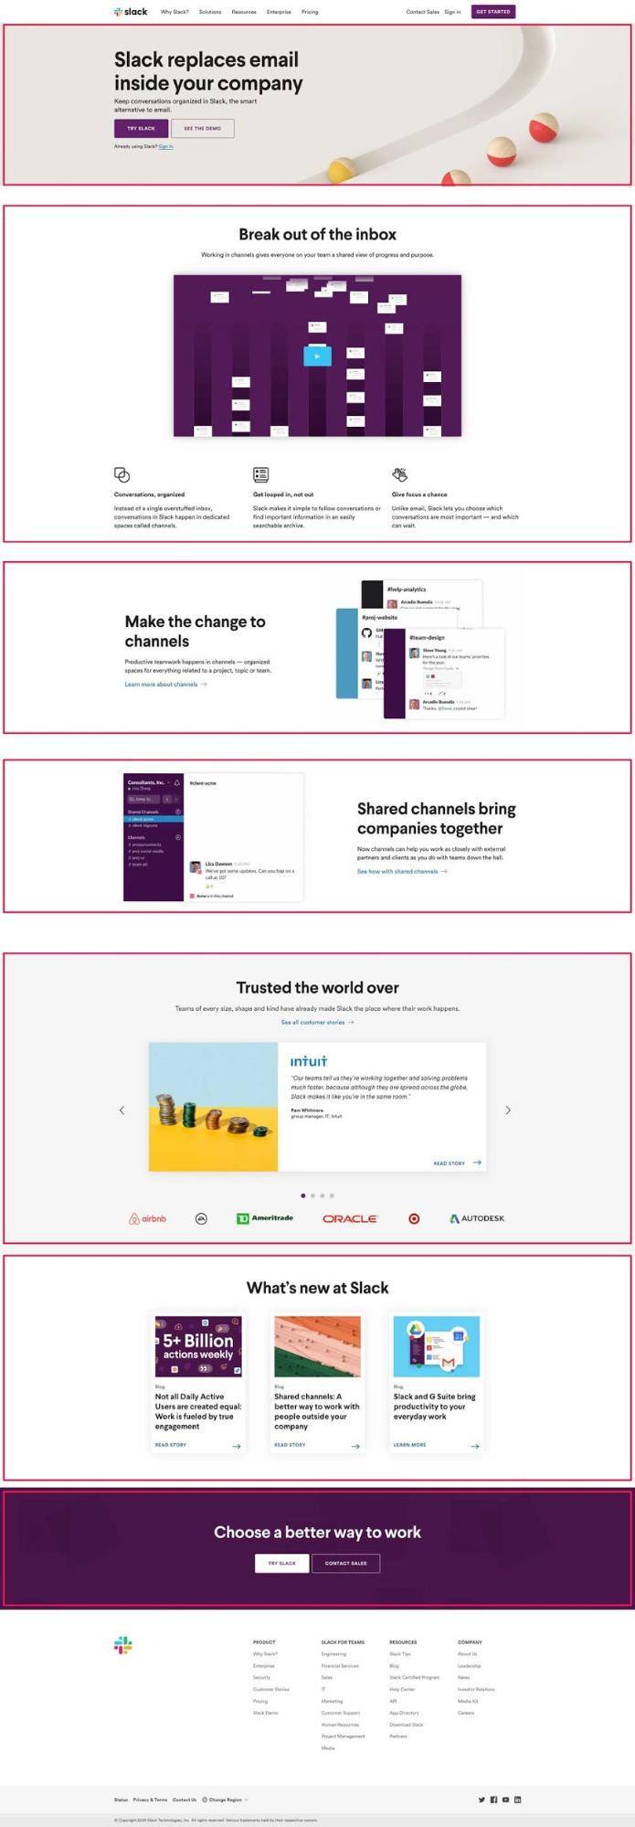
These sections really allow the content to breath nicely on desktop, but on mobile, you need to make sure these sections are re-organized in a way that doesn’t overly increase the length of the page.
In situations where you have smaller sections next to one another, like in Wistia’s homepage down below, you can shift the four blocks stacked on top of one another.
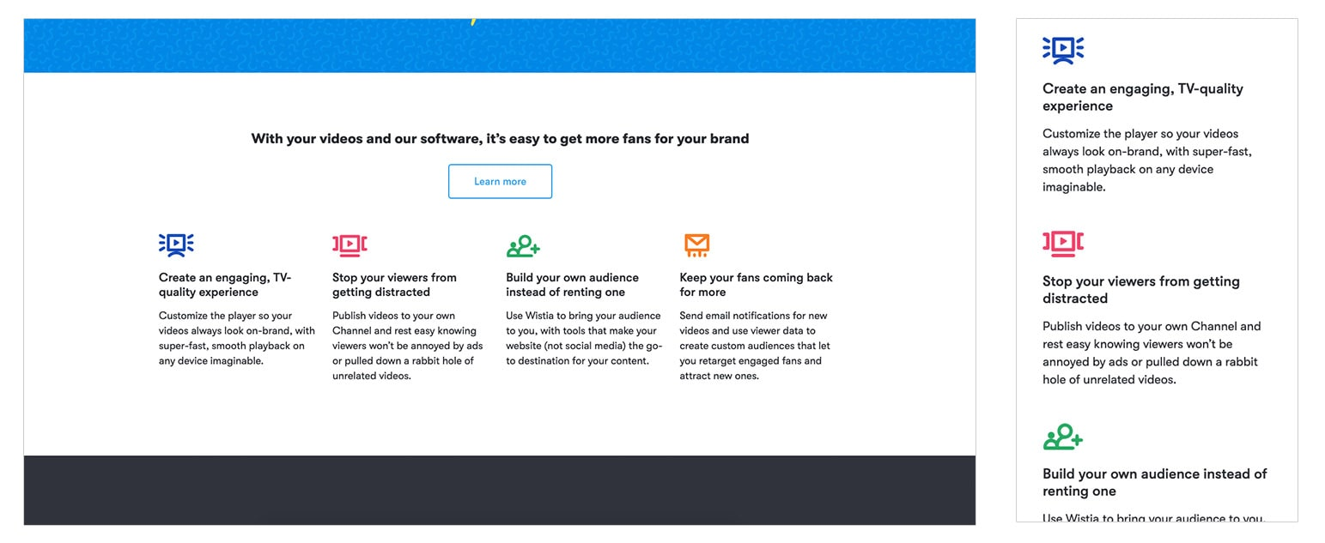 Source: Wista
This technique works well for less interactive or detailed sections like this. But what if this section has 15 blocks, or specific interactions that only happen when you hover?
If you tried to scale it down like the previous example, the page will be significantly longer and those ‘hover’ effects won’t work anymore (since you’re not exactly using a mouse to navigate on your phone).
It’s situations like these that have pushed people to approach their website with a mobile-first mindset. This means that you put your mobile users’ needs first and foremost.
You're not creating a desktop website and removing functionality that makes the site less intuitive on mobile. You first strategize what the best experience is on mobile, then adapt it to a desktop layout where you can figure out if you want to enhance the experience because you have advantages with space.
Although this is the ideal scenario, you may not be in a position to do a full website redesign and follow this approach. In the meantime, try to offer the best experience you can by optimizing what desktop to mobile is like.
Review some of your most important or top-performing pages — this could be your home page, service pages, or product pages. Then, compare their performance on mobile and desktop (using tools like Google Analytics); look at time on page, heatmaps for scrolling and tapping, conversion rates, etc. This will help give some benchmark data to how they currently perform.
Then, take some time to review the pages you selected and try answering yes or no to help evaluate whether or not there may be a little TLC needed:
- Are certain sections taking up more than four times the space they did on desktop?
- Do certain interactions not work as well on mobile as they do on desktop?
- Are font sizes hard to read on mobile? Do you find yourself squinting?
- According to your heatmaps, are users scrolling the same or similar distances when compared to desktop?
- Are users getting stuck somewhere, causing their time on page to be significantly lower?
Once you identify your problem areas, you can then begin to come up with solutions. Should you hide certain sections? Do sections need to be shortened to fit better on mobile screens? Are there other ways you can arrange sections so they still accomplish the same goal?
To brainstorm specific solutions, work with your designer to dig into these questions to help set you onto the right path to revamping your site's mobile layout.
Once you strategize what you need to do, you can develop these solutions on some of the most popular sections of your site. This gives you the opportunity to test whether or not they improve your metrics.
Once you feel you have sufficient data, you can implement those solutions across as many areas of your site as you can.

Who’s doing this well: ESPN
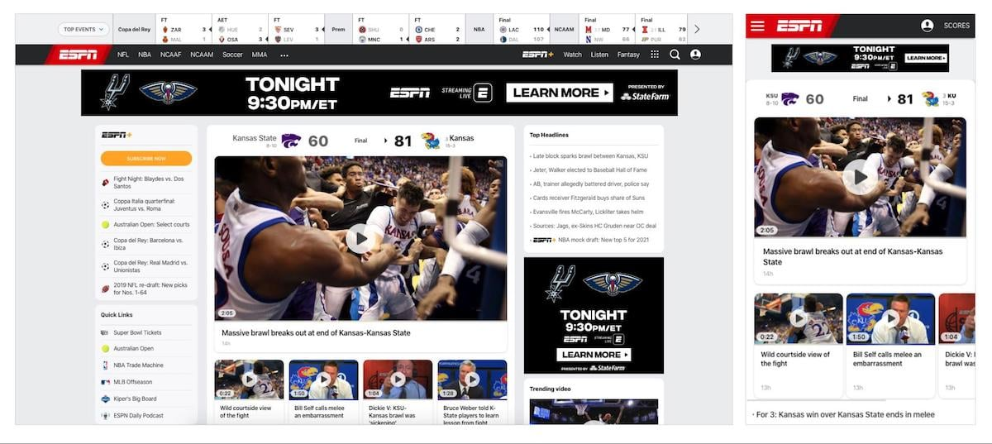
Since ESPN is a sports news website, the site has a ton of information to offer on the homepage.
On the desktop site, there’s room for this embellishment, but on the mobile site, not so much.
On mobile (on the right, above), you’ll notice the center desktop section is the first thing you’ll see. The four videos below the main headline are now a part of a slider, rather than being stacked on top of one another.
Those ‘quick links’ to other parts of the site that are on the left column are no longer visible. And they’ve chosen to consolidate certain sections to make the page shorter.
As you scroll down, you’ll notice they start to arrange information in a more specific order based on what users are likely to want. For example, below the videos they insert the list of top stories, rather than going right into the larger blocks of featured articles.
It’s tactics like this that will help you organize your mobile hierarchy strategically so you give your users the most valuable information first.

2. Make your bottom of the funnel call-to-action (CTA) easy to find
Your business website likely has a particular main call-to-action you want your users to complete. Maybe it’s to purchase a piece of software, schedule a consultation, or sign up for your app.
To drive people to complete this goal, you likely have a main call-to-action featured in your navigation and throughout your site, especially on desktop.
If you're tracking your CTAs, you’ll probably notice your navigation button is one of the primary ways people make it to that gateway page where they would convert. So naturally, it’s pretty critical to have that button there at all times.
One of the opportunities people overlook is making sure that their main CTA is clear and easy to find on mobile. Let’s take a look at Brightedge for example.
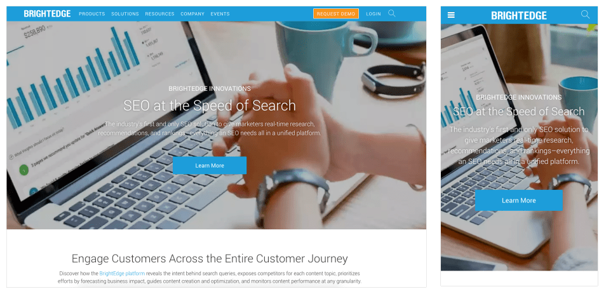
Brightedge has a really awesome website that very clearly articulates what their product does and the value it offers to its users. On closer inspection of their website on mobile, though, notice how their large ‘request demo’ CTA is no longer in the navigation.
I’d recommend being careful about removing your navigation CTA on mobile. Doing this naturally makes it that much harder for your mobile visitors to find that page.
I recommend keeping it consistent on mobile and making room for it. If you absolutely can’t, then you should at least try to get that button into the hamburger navigation and get it as visible within the screen as possible without the need to scroll.
That way, the button is still a frequently visited area of your site.

Who’s doing this well: Salesforce
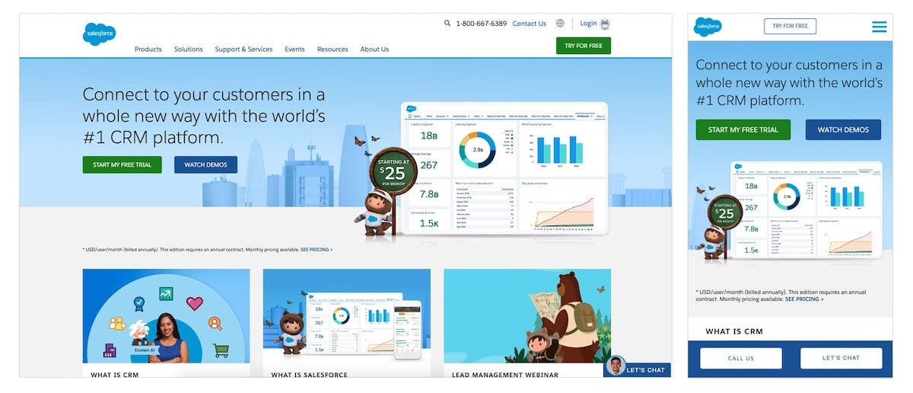
Salesforce keeps its ‘try for free’ button in the navigation bar throughout all devices, but only changes its position and color.
They also have two additional CTAs at the bottom of the screen to either call them or chat with them.
But if you're a business who doesn't need those ‘chat’ and ‘call’ CTAs, but needs a way to promote your site's main CTA (because you can’t fit it in the navigation area), you could implement a similar bottom bar layout where you instead place that main CTA.
I also have to give Salesforce bonus points for the CTA’s interaction. Rather than taking visitors to a separate page with a form (which it does on desktop), the form slides out from the right side of the screen on mobile, similar to a hello bar, keeping visitors on the page.
This is beneficial because the user isn't forced to wait for an entirely separate page to load, which on mobile, can be problematic due to bandwidth or internet speed. It simply helps the user complete the desired action faster.

3. Use scalable vector graphics (SVGs)
SVGs or Scalable Vector Graphics are a must-have for any responsive design that is utilizing illustrations or icons. Unlike image files (JPG/PNG), SVGs are infinitely scalable.
You can rest easy knowing that any icon or graphic will remain ultra-sharp across all experiences without having to ever worry about resolution or pixelation.
This results in a consistently polished look no matter how the site is being viewed.
Furthermore, SVGs often have a smaller file size, which helps your site load faster. Nobody wants to sit on their phone and watch an image buffer because of how large it is.
(SVG on the left, PNG on the right)
To clarify, this file type is not an option for normal photography, it's only available for computer-generated graphics.

Who’s doing this well: HubSpot
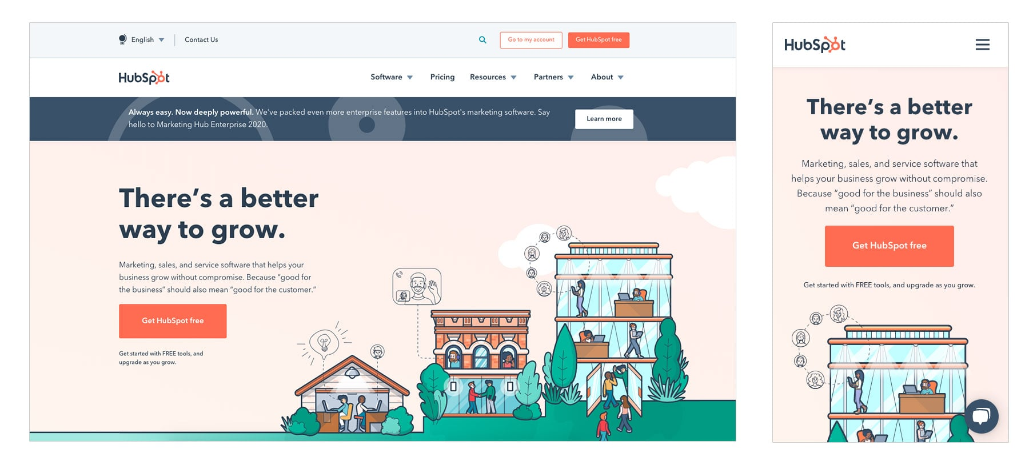
HubSpot’s site relies on intricate illustrations on almost every page.
If these were saved as PNGs, they could easily be five times the size due to the amount of detail, the number of colors being used, and the large dimensions necessary.
Best of all, these images look crisp, regardless if you are viewing them on desktop or mobile.

4. Standardize clickable areas and buttons
On mobile, buttons and links will be tapped by a human finger, not by a precise mouse click — so interactive areas need to have larger area to accommodate this difference.
How large do they need to be? Well, that’s dependent on the user, but on average, it’s recommended that any clickable element on a mobile device be at least 48 pixels in height.
This means you need to optimize for buttons, form inputs, inline links on blogs, card layouts, navigation links and more.
You’ll probably find that its hardest to abide by this rule on inline links, such as ones in blog articles. If you find your users struggling to tap on links, you could try this technique that increases the clickable area surrounding them (Note: This solution does need a developer to help out).
This will help ensure that there are fewer errors in navigation through your website, in turn minimizing potential frustration, and keeping the viewer engaged.

Who’s doing this well: Vidyard

Vidyard does an excellent job keeping any important clickable areas large enough so your thumbs aren’t fumbling around.
In the images, you’ll notice Vidyard actually increases the size of its two buttons in the hero section, rather than keeping them the same size. The three blocks right below the hero are also fully clickable, as opposed to only making the different color text with the arrow clickable.
Similar purposeful elements like this are applied throughout most of the site, making it easy to navigate around.

5. Responsive imagery
Different devices have different image size needs.
A desktop page may need an image 1200px wide at full resolution, while the mobile version of that page may only need that image at 400px wide.
That’s effectively a third of the physical size, which roughly translates to a third of the file size as well. That’s an important thing to keep in mind.
The old way of doing things was to load the large resolution (1200px) image, and then just use that same file across all device platforms — but these large files can slow your site load time down dramatically.
For an optimal responsive experience, it’s best to use two different versions of the same image for mobile and desktop.
For example, on mobile, we’re only using (or “calling up”) the 400px image we need, rather than the large 1200px image, which would be shrunk down to 400px once loaded.
Compound this on a page with several images and you can end up with a noticeably faster loading experience, especially if the mobile site is being loaded on cell service and not wifi.
There are some pretty in-depth articles that go over how to accomplish this so you can designate the image you want to show at particular screen sizes.
If you’re using website pages with HubSpot to build your site, you’re in luck! HubSpot actually enables automatic image resizing on content by default.
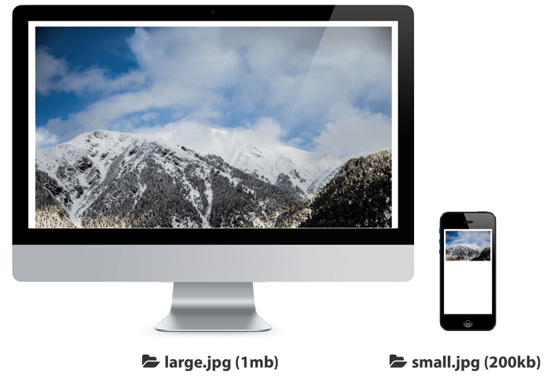

Who’s doing this well: Adobe
Unlike other examples, the visual for this one is going to be a little more code-focused so you can see an example of what this technique looks like.
Below is the code used to produce an image on Adobe’s website. You’ll notice there are several ‘.jpg’ files separated onto different lines.
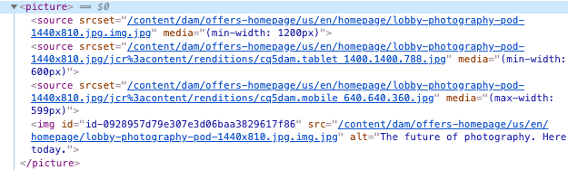
Each of these JPGs represents an image two show at different screen sizes; you can tell by the ‘media’ tag that's associated with each ‘source’ object.
The result is that different size images will show at different specified device dimensions. Depending on your web page, you may find you need more or fewer image variations.

6. Think typography
It’s important to consider the legibility of your site across all platforms and devices, but on mobile, you need to be much more attentive to your users' readability needs.
If people can’t read your value proposition or any of your content, for that matter, they most likely won’t stick around.
You want to make sure the content is easy to read and truly optimized for the device size so visitors aren’t left squinting.
This also means taking note of the typefaces you’d like to use on your site, and whether they’d make for good or bad legibility on small screens.
Remember to balance the headings and body font sizes for the size of the device too. You don’t want your font sizes to feel drastically different from one another to the point where it feels awkward and unnatural to read.
I’ve also written a whole blog article on how to discover the right font sizes for desktop and mobile that I recommend diving into to help get more specific to font sizing rules.

Who’s doing this well: IMPACT
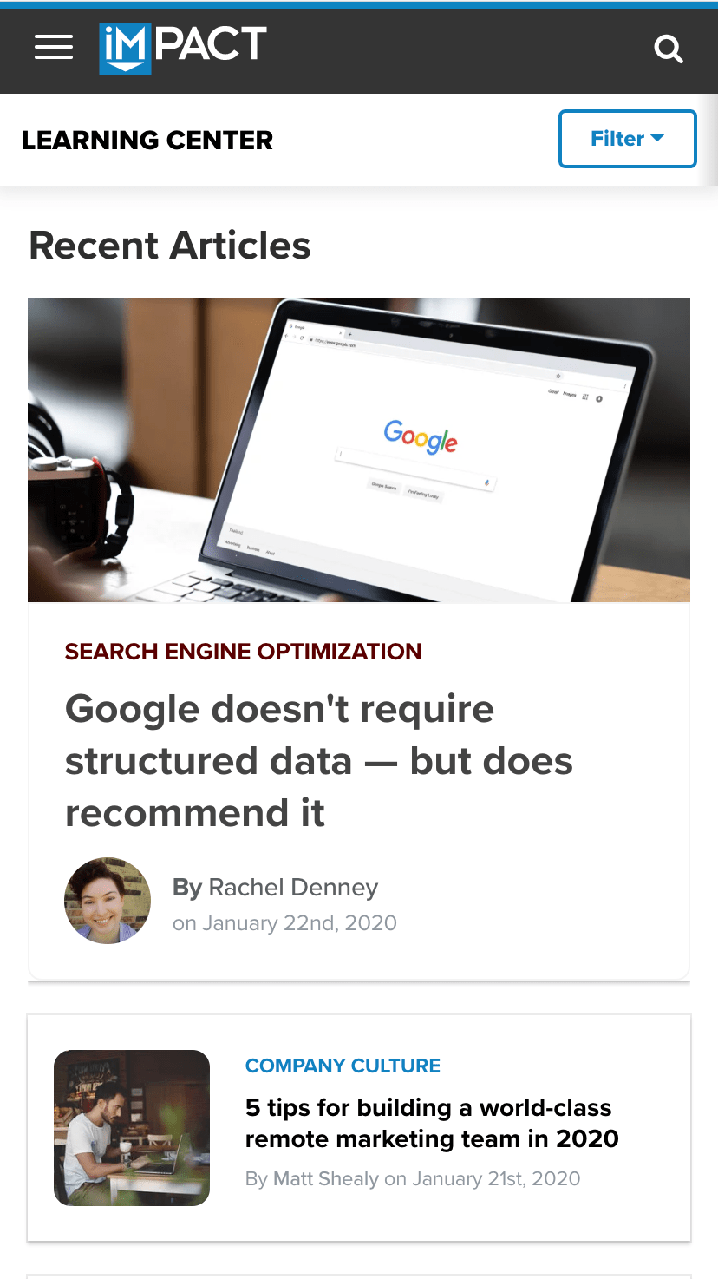
I know, I know...a little unorthodox to include ourselves in here as an example, but we’re constantly testing and tweaking our font sizes based on what we’re hearing from our visitors, so I simply couldn’t help it!
The headings create a great hierarchy on pages where text reigns. On the blog listing page, the top level hierarchy is given to the blog titles so visitors are able to quickly skim them as they look for what to read.
The inner articles also have font sizes that are large enough to fit a decent amount of content in view while still being readable.
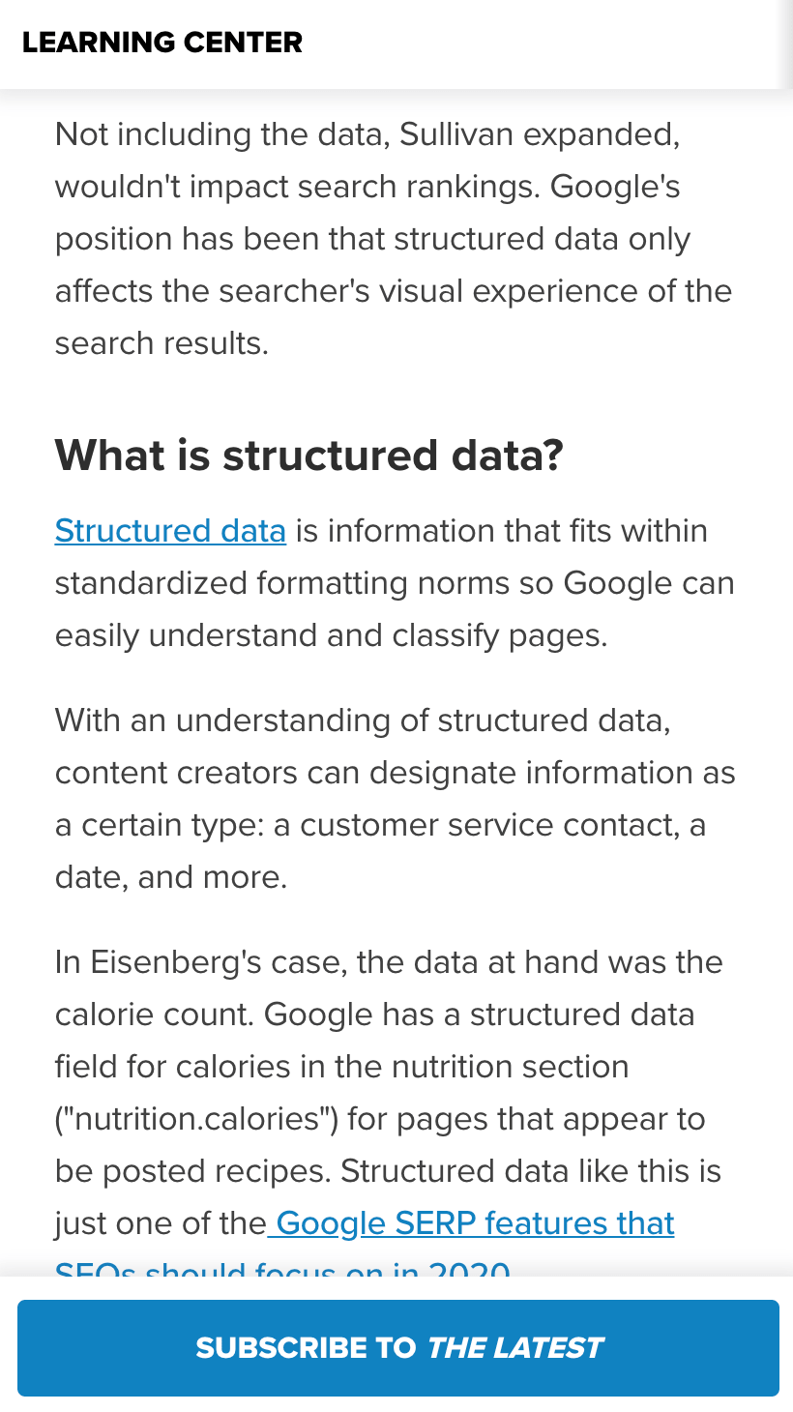
While we could have made the font size 14px to fit more content in view, a large portion of readers simply won’t be able to read the articles that clearly. The larger font and spacious line height also mean you aren’t struggling to find what line is next.

7. Take advantage of device features
On smartphones, you have the ability to do a variety of diverse tasks. You can make calls, send messages, and open apps — all directly from the browser.
Take advantage of these capabilities on your website to not only enhance your mobile experience for users but even increase conversions and encourage action.
For example, while on a desktop site, you may list the phone number. On the mobile version of that site, you may want to list the phone number inside a button or clickable area that it will automatically prompt a call when clicked.
This idea can also be applied to email addresses, opening a new message in an email app with an auto-filled recipient when clicked.
Social media icons can also be coded in such a way that, when clicked, they will open directly in the app as opposed to a mobile browser.
All of this can make it tremendously easier for your visitors to connect and communicate with you.

Who’s doing this well: United Methodist Homes

Sometimes it just feels good to call and speak to someone right off the bat when you want to get information. UMH (a client of ours) recognized this, and utilized mobile device features to bring this convenience to their mobile site.
What they did was take their phone number, put it inside a clickable button, and placed it right under their navigation on mobile.
With the addition of a small amount of simple code, now when it's tapped on a mobile device, it will ask the user if it’s okay to call that number. Once accepted, the device starts a call automatically. No fiddling with a pen and paper, or trying to remember the number to dial it in.

Responsive design today
In 2020, all of this is mandatory if you want to have a well-optimized website for your users. It's possible that half of your website traffic is coming from mobile; it is not an option to alienate them by giving them a sub-par mobile experience.
By auditing your site with these responsive design best practices in mind, you’ll be able to determine if your site is truly fit for the modern, mobile-first age we live in, or if you need to make some changes.
Maybe a full redesign is in order to make your site a responsive superstar. Still not sure? Let’s talk! We’re happy to help you figure things out for this year and beyond.

Responsive Design: Best Practices and Considerations
The market share for mobile and desktop browsing is about 50/50. For designers, this means responsive design is more important than ever, as users expect a seamless experience across all platforms and screen sizes.
Responsive websites are websites that adapt to all screen sizes and resolutions, not only on desktop but also on mobile, tablet, and sometimes even TV.
According to Statista, mobile traffic was responsible for 52.64% of all global traffic in 2017, meaning that a website not well optimized for mobile devices is losing out on approximately half of its traffic. By the end of 2018, it’s expected that the global traffic share for mobile devices will grow to 79%, which is an exceptional increase.
Businesses without a mobile website are falling behind at an alarming rate, because 8 in 10 visitors will stop engaging with a website that doesn’t display well on their device. It’s way too easy for users to hit the back button and try a rival business instead, and Google even ranks websites that are not responsive lower in their search.
You can take Google’s mobile-friendly test here.
Does any of this mean that mobile is more important than desktop? No. 83% of mobile users say that they should be able to continue the experience on desktop if they wish.
Take a look at this mobile-optimized version of eBay vs. what it would look like if it weren’t mobile-optimized. Would you even consider the non-optimized version?
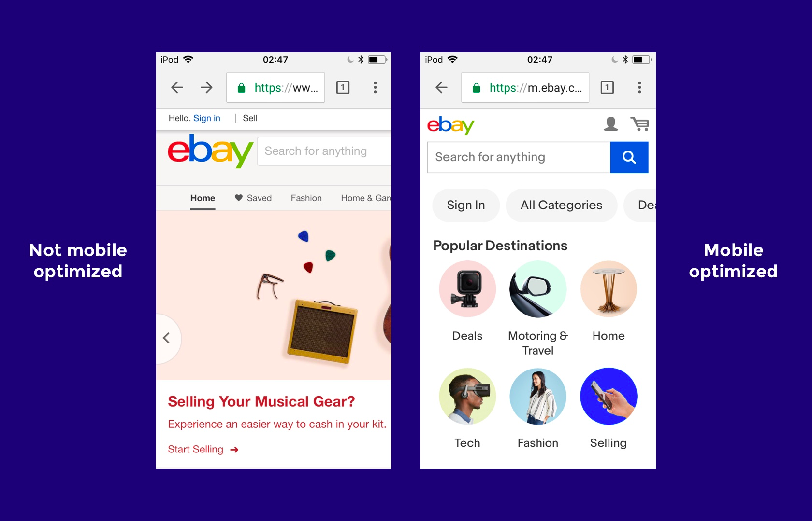
In order to design websites that can compete on today’s internet, web designers must be experts at responsive web design (RWD). Where should they start?

A Mobile-first Approach to Responsive Web Design
Mobile-first web design means designing the mobile website first and working up to the desktop version. There are a number of reasons why this approach works well.
- Mobile websites have more usability concerns (this is mostly due to the lack of screen real estate), so it’s practical and more efficient for the primary focus to be on mobile design.
- It’s easier to scale up the mobile version than it is to scale down the desktop version (again, because of the lack of space on mobile websites).
- Mobile-first web design helps to reevaluate what’s visually and functionally necessary.
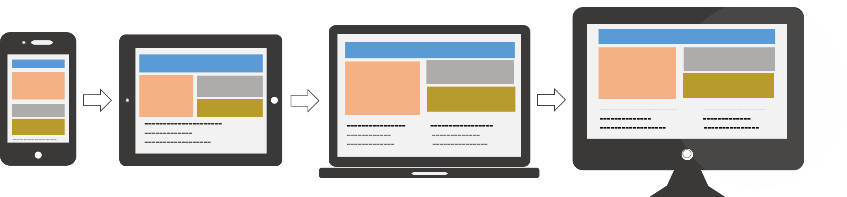Usabilla)
Designing a website as a mobile-first responsive site forces designers to ask a number of important questions because there is less screen real estate to work with. Here are the questions that need to be asked:
- Is this feature/function really necessary?
- How can we design something minimalist for mobile first that will later scale up well for desktops?
- Is this visual effect worth the time that it takes to load on mobile?
- What’s the primary objective, and what visual elements help users achieve it?
We’ll take a look at some responsive web design examples in a moment. For now, let’s talk about which devices, screen sizes, and web browsers are relevant today.

What Screen Resolutions Are Relevant for Responsive Web Design?
Here are the most common screen resolutions across mobile, tablet, and desktop users worldwide. As you can see, there is a wide range of resolutions, so neither mobile, tablet nor desktop is dominating the market share right now—what this tells us is that designers should consider all of them when thinking about responsive web design.
- 360x640 (small mobile): 22.64%
- 1366x768 (average laptop): 11.98%
- 1920x1080 (large desktop): 7.35%
- 375x667 (average mobile): 5%
- 1440x900 (average desktop): 3.17%
- 720x1280 (large mobile): 2.74%
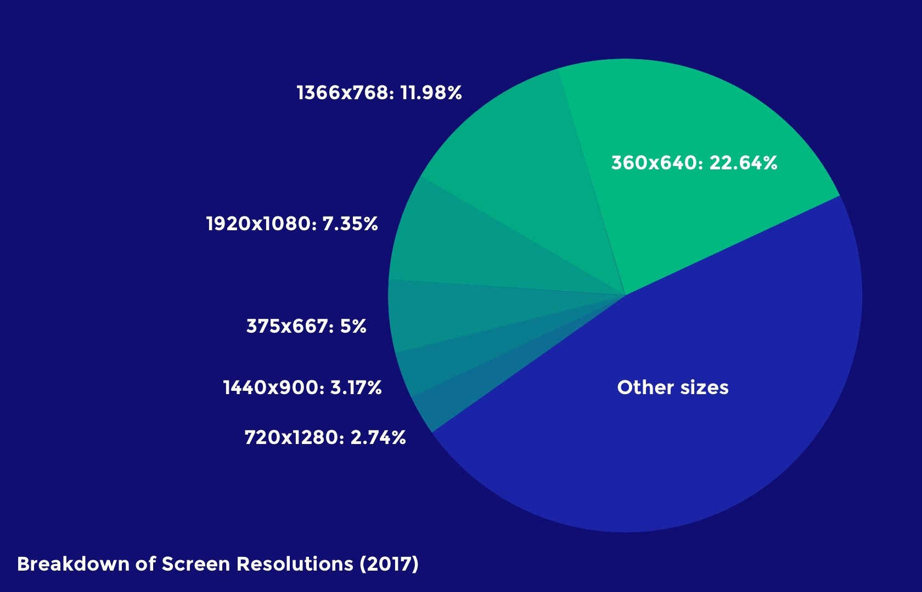
Just as with device breakdown, we should segment the data by location to match the user demographics (or anticipated user demographics) of our target audience. It’s also worth catering to resolutions that are gaining popularity, because while some screen sizes are currently not that common, they may be in the future. This will help responsive designers craft futureproof UX that will work even when the market share changes.
For example, 360x640 resolutions (which correspond mostly with Samsung devices using Android) have risen by 5.43% in the last year. Designers can use valuable insights like these to decide on key responsive breakpoints before starting a website design.

What Web Browsers Are Popular Today?
Responsive web design is about offering a seamless experience on any device, and since different web browsers render web pages in different ways, websites must be tested to ensure that they’re compatible with a variety of mobile and desktop web browsers.
Even though making a website scale to the correct responsive breakpoints is primarily the responsibility of a web developer, it’s the web designer that decides exactly how a responsive website will adapt to various screen sizes in order to create an optimal user experience.
Here’s a worldwide breakdown of web browser market share for mobile and desktop.
- Chrome: 55.04%
- Safari: 14.86%
- UC Browser: 8.69%
- Firefox: 5.72%
- Opera: 4.03%
- Internet Explorer: 3.35%
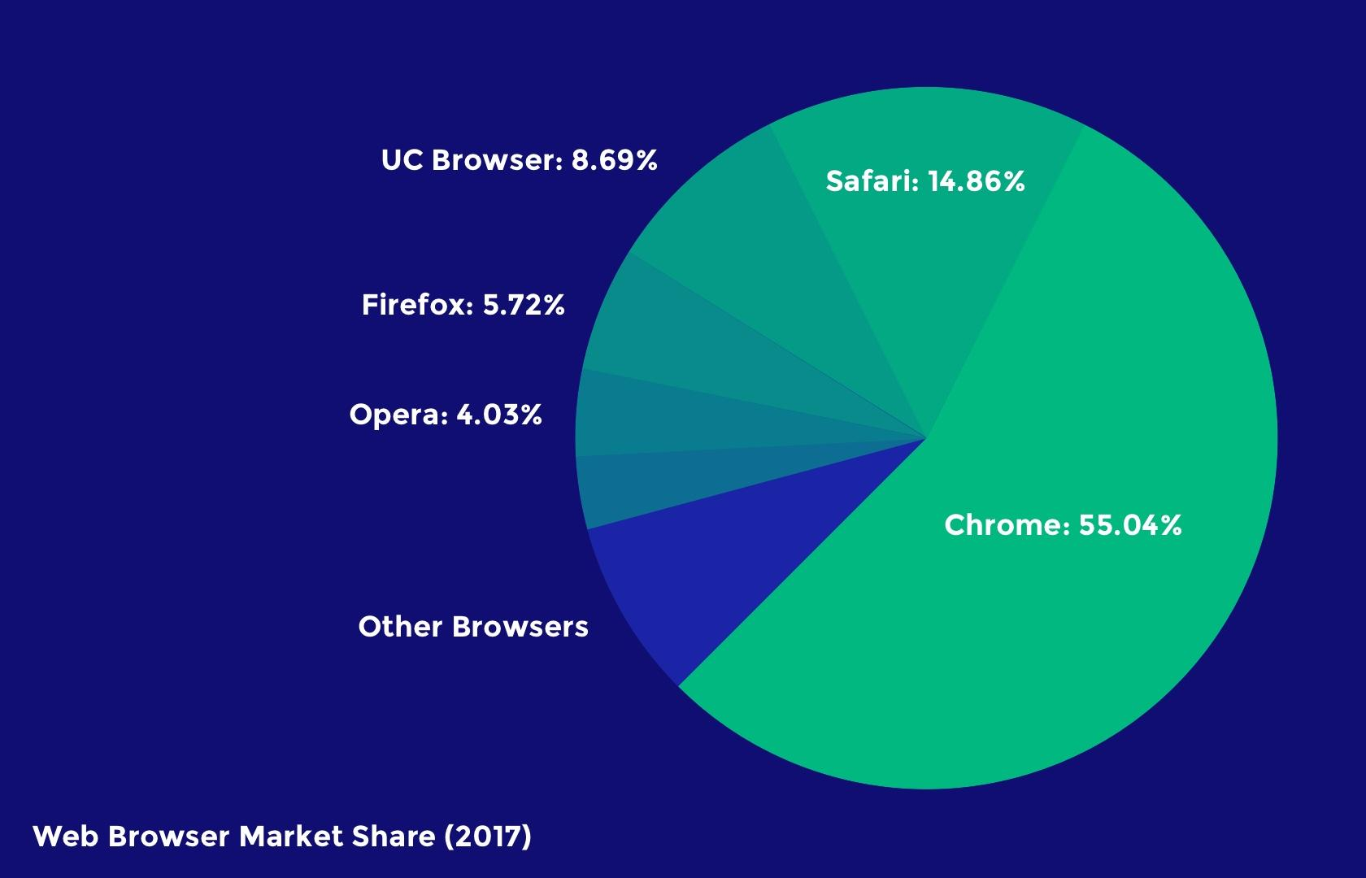
Responsive design isn’t just about “making everything fit”—it’s also about adapting to the capabilities of the device hardware and web browser as well as the device resolution. One example of this could be that, while Google Chrome supports the CSS property overscroll-behavior: (which defines what happens when the user scrolls too hard towards the edge of the viewport), it’s not supported in any other web browser.

Responsive Design Best Practices

Eliminate Friction
As mentioned earlier, a mobile-first approach to responsive web design will help designers evaluate what’s really necessary in order for the user to achieve their main objective.
As we build up to the tablet version (and later the desktop version), we can then begin to think about secondary objectives and the microinteractions, user flows, and CTAs (calls to action) that make those user objectives achievable. What’s more important is that we focus on the primary objectives of the user first and eliminate any unnecessary friction that aids neither the primary nor the secondary objectives.
A primary objective could be the purchasing of a product, whereas the secondary objective could be signing up for a newsletter (which could lead to a purchase later).
Here’s a terrific example of eliminating friction: Since mobile user interfaces are typically harder to navigate, it would be best to switch to a one-page checkout for mobile eCommerce stores and only enable multi-step checkout for desktop eCommerce stores.

Design for Thumbs
Responsive web design is tricky in the sense that users will interact with the desktop website via clicks but the mobile version via taps and swipes. There are physical differences as well. Desktop users typically have their computers on a surface, whereas mobile users hold their devices in their hands. These differences significantly change the way mobile UI designers design tap targets and other important UI elements with which users interact.
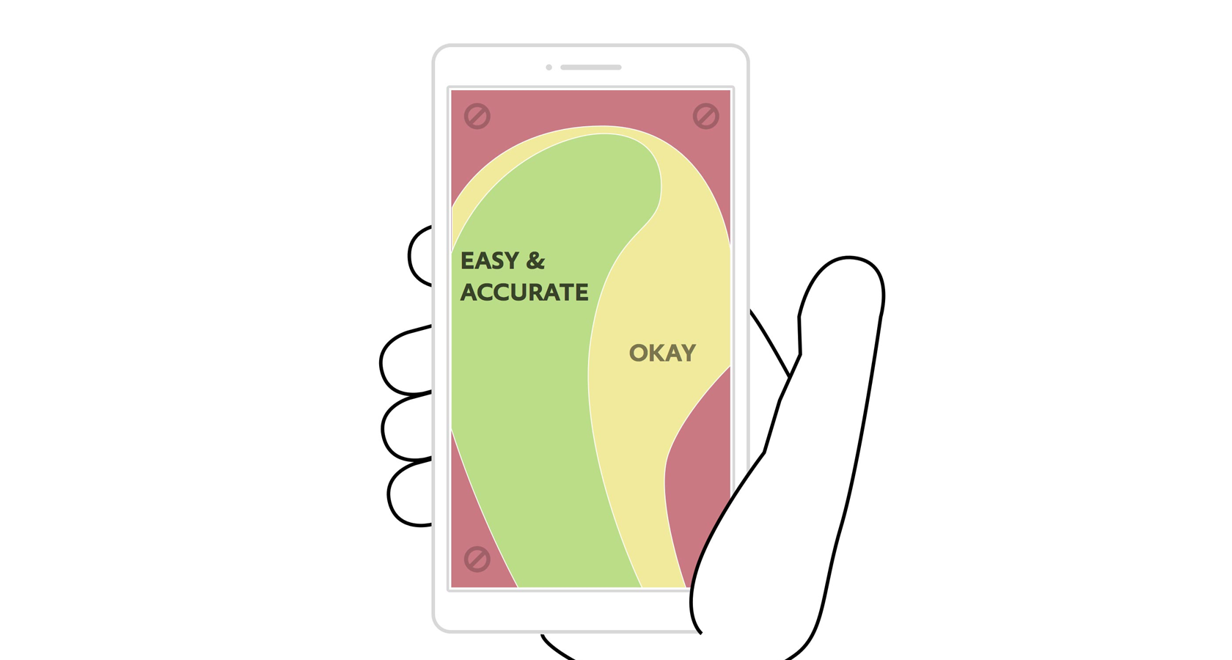A List Apart)
Let’s take a look at some examples:
- People typically expect the main desktop navigation to be at the top; however, on mobile, it should be at the bottom. Thumbs don’t reach the top comfortably.
- Other interactive elements should also be easy to reach. This means keeping them in the center of the screen because it’s more difficult for thumbs to reach the sides and corners of device screens.
- So that they can be tapped with ease, important links and CTAs should have a height of at least 44px (smaller tap targets are bad for usability).
Recommended reading: The Fundamental Guide to Mobile Usability.

Take Advantage of Mobile Devices’ Native Hardware
Mobile hardware (like the device camera, or GPS services) isn’t specifically reserved for native apps, and as mentioned earlier, responsive web design isn’t just about “making everything fit.” It’s also about adapting to the capabilities of the device. In the case of mobile web design, since mobile devices have easy to use cameras, some microinteractions—such as data input—are actually easier on smaller screens as long as websites are taking advantage of the available native hardware.
Let’s take a look at some examples:
- Credit/top-up card scanning (because forms are often tricky on mobile)
- Photo-sharing on social media, because the media is already on your device
- Two-factor authentication (because you’re already on your mobile device)
- Quickly checking stocks/analytics (because mobile apps simplify information)
- Performing a web search with voice (because hands-free is easier than typing)

Make Layouts Fluid/Adaptive by Default
Not every user will have their desktop browser maximized. This means that while designers need to consider the responsive breakpoints of the devices that users are using today, they also need to account for what happens in between those breakpoints.
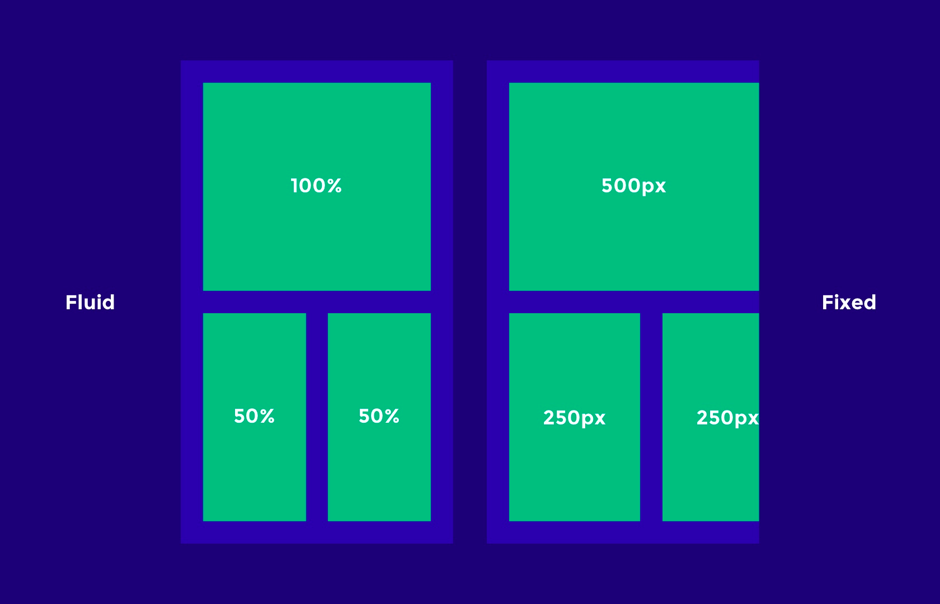
Responsive breakpoints should be used to “reflow” the layout and content to a new device, but to account for all the sizes in between (just in case), layouts need to be otherwise fluid (that is, they naturally adapt/stretch as the browser resizes).
Keep these tips in mind when designing fluid/adaptive layouts:
- Percentage units will allow elements to be fluid.
- Setting minimum and maximum widths can enable the “but don’t go smaller/bigger than this” scenario.
- SVG image formats can be scaled up and down without losing quality, and are resolution-independent (as opposed to JPGs and PNGs, which are not).

Don’t Forget About Landscape Orientation
We talked about specific responsive breakpoints earlier, but we also need to consider that those mobile viewports can be displayed in landscape orientation as well. While implementing a fluid layout will technically make the content adaptive, losing a fair chunk of the portrait viewport can be a hindrance to the usability and accessibility.
Navigations are usually safe (sometimes they’re better, actually, since users typically navigate landscape orientation with two thumbs), but scrolling becomes significantly harder, which is less than optimal since the user is required to scroll more on landscape.
Designers may want to consider designing for landscape breakpoints as well; for instance, tiled elements that stack vertically on mobile could be displayed as a slider with left and right navigation buttons, meaning the user doesn’t have to scroll.

Remember, Typography Can Be Responsive Too
Even though UX designers typically use pixel units to design websites, on the actual web, one point doesn’t necessarily equal a pixel anymore, because different devices have different resolutions. The iPhone X, for example, has 458 PPI (Pixels Per Inch), so where pixel sizes are getting smaller, we’re able to achieve crisper graphics in the same physical space (Apple calls this “Retina” technology, and Android calls it “hDPI”).
This means that a 16px font size, for instance, would look bigger or smaller on some devices depending on its resolution. Web developers will typically use em units to define font sizes, which are a type of responsive unit where 1em is equal to 1 point.
Design handoff tools like Zeplin, Sympli, Marvel, and InVision can help designers collaborate with developers on matters that are a joint responsibility. While designers execute the design, and developers execute the code, as a whole the product design workflow is a team effort that requires solid communication.

Responsive Design Performance Optimization Tips and Best Practices
Responsive web design isn’t just about how it looks but also about how it acts and feels. Adapting websites so that they load faster on the intended device is equally important.

Lazy Load Non-vital Images and Videos
Images and videos are what make up a large chunk of the total download size of a website, but you don’t need to load them all at once. There are two scenarios where the rendering of media can be delayed: Below-the-fold content can be loaded as the user scrolls below the fold, and render-blocking media should be made to download only after the layout and content has downloaded. This practice is called lazy loading, where the loading of heavy, non-important elements is delayed to improve page performance.

Conditional Loading
Some website elements are not intended for mobile users, or at least aren’t worth the extra cognitive load. We want our mobile websites to be simple, so it makes sense to hide elements in certain scenarios. That being said, we have to make sure that we aren’t wasting browser resources and bandwidth by loading these elements even when they’re hidden; hence, it’s best practice to only include these elements in certain conditions.
Once again, a developer can achieve this with code; however, designers can improve page performance by communicating the conditions of when and where certain elements should and shouldn’t exist.

Responsive Images
As mentioned earlier, some devices display more pixels per inch, which can result in images becoming blurry if they’re not exported at the correct resolution. Depending on the resolution of the device, some will require images at double (@2x), triple (@3x), and even quadruple (@4x) the size. Web browsers now support the <picture> element, which chooses the correct image resolution depending on the device.
Designers crafting responsive websites can tailor images to the correct device by making sure to export at all the resolutions used on today’s devices (if you’re unsure, ask your developer—communication is key when it comes to responsive web design).
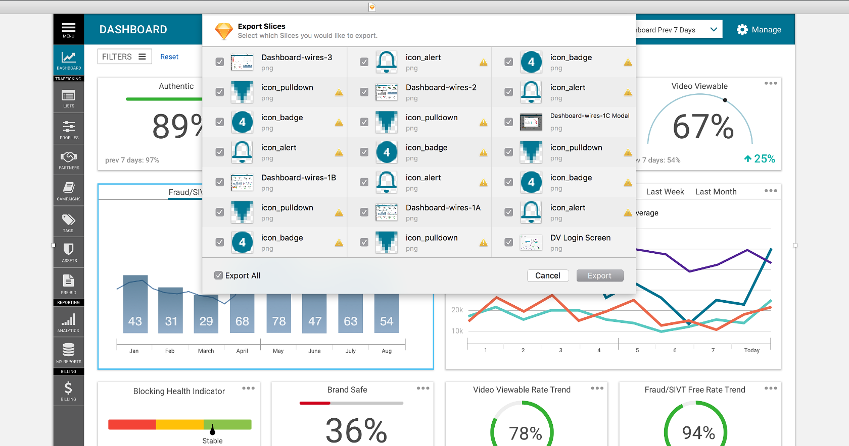

Conclusion
Wireframing can help to iron out the creases early in the design process, and this works well when taking a mobile-first approach to responsive web design. Perhaps there’s a responsive breakpoint that needs some extra attention, or maybe there’s a concept that just isn’t effective in terms of mobile responsiveness. It’s better to find the bumps in the road sooner rather than later (i.e., before adding visual aesthetics).
Modern design tools like Adobe XD, Marvel, and InVision enable teams to test prototypes on real devices, discuss feedback in context, and generally collaborate as a team until the layout works in all scenarios.
Employing a lean UX workflow where responsive design is driven by internal testing and feedback will ensure that the user experience works seamlessly across all platforms and screen resolutions before being presented to a real user for the first time.
• • •

Further Reading on the Toptal Design Blog:
- Responsive Design Is Not Enough, We Need Responsive Performance
- Introduction to Responsive Web Design: Pseudo-Elements, Media Queries, and More
- One Size Fits Some: A Guide to Responsive Web Design Image Solutions
- Mobile UX Design Constraints, Best Practices, and Working With Developers
- UI Design Best Practices for Better Scannability
https://www.toptal.com/designers/responsive/responsive-design-best-practices

